# **Spring Microservices Application**

1. **eureka-server:** This application is developed to register all the microservices. So that every microservice can communicate with each other without knowing their IP address of the microservice.
2. **gateway-service:** A gateway is a single-entry point into the system, used to handle requests by routing them to the corresponding microservice.
3. **member-mgmt-service:**
4. **donation-mgmt-service:**
5. **gateway-service:**

We are gonna create a Spring Boot multi module project as shown in the diagram below

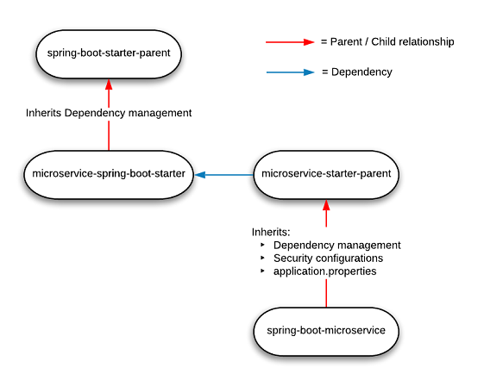

## **Config-server**

This application is used to externalize properties or resource files out of server where the values of those resources vary during runtime – usually different configurations that will differ in each environment.

1. Create the config server – It will point to config server git repository and will provide the access of the all the properties to its related microservice.
2. Create the config server git repo – It will maintain the application.properties of the microservices.
3. Update the microservices to point config server – To make changes in the new or existing microservice so that it can access its application .properties using config server.

### **A. Create the config server**

* Create Spring Boot Project



* Click on next



* **Select the dependencies: Spring Cloud Config – Config Server and Click on Finish.**



* **Import the project in eclipse.**



* Dependencies already imported can be seen in pom.xml but need to update with the following changes
  + Spring Cloud Config server: This dependency is required to configure the config server along with dependency management circled in blue colour in the below picture.
  + Spring Boot Starter Parent: update the version - 2.2.4.RELEASE highlighted in yellow colour.
  + Spring Cloud version: upgraded to Hoston.SR4. It is highlighted in yellow colour.
  + Maven Jar Plugin Version: After the above updates, pom is giving compiler error in pom.xml so downgraded version of maven jar plugin to 3.1.1. It is highlighted in yellow colour.

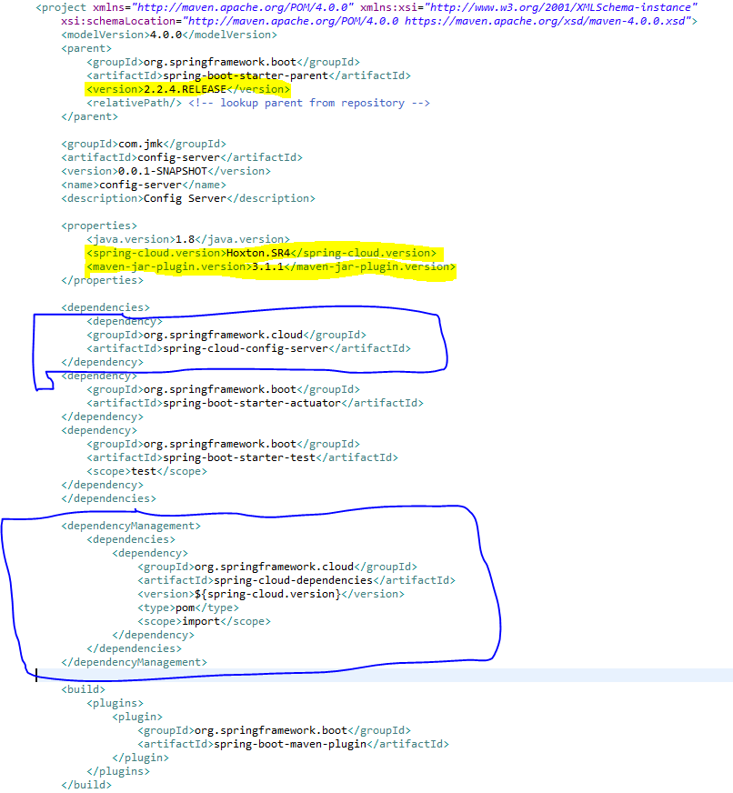

* **Enable the annotation @EnableConfigServer**



* **Update the application.properties with the git repository will be created in this section after this step.**



### **B. Create the config server git repo**

The next essential step is to create a local git repository. It can easily be converted to a remote repository later by configuring its URL in the properties file. We will place the external property file [configuration], which will be used by the Config server microservice to provide the external configuration of properties.

* Make sure you have git shell installed in your machine and you can run git bash from command prompt. To verify it open command prompt and type git, if it recognizes the command then you probably have the git prompt installed, if not please follow git website, download and install as per the instruction.
* Now Create a directory **bjjd-config-server-git-repo** in location: C:\Users\rkbansal\git\bjjd-config-server-git-repo
* Create microservice name wise folder in **bjjd-config-server-git-repo**. For example:



* Structure of any project can be seen:



* Let’s look into any properties file. For e.g. application.properties of people-mgmt-service



* Open the command prompt and go to the **bjjd-config-server-git-repo** in location: C:\Users\rkbansal\git\bjjd-config-server-git-repo
  + Git Command to initialize the git repository:
    - git init
  + Git command to add the code in the git repository:
    - Git add .
  + Git command to commit the code in the git repository:
    - Git commit -m “Initial Commit”



* After creating the git repository, it can be imported in Eclipse as GIT repository and as a General Project.



* Import as a General Project



* This project can be seen in eclipse



* Point the git repo from Config Server

Update the application.properties in the src\main\resources directory of spring-config-sever project and add below lines.



* To verify the Config server configuration, run the Config Server application and check the following URL:
  + URL to check the dev properties of people-mgmt-service : <http://localhost:8888/people-mgmt-service/dev>



* + URL to check the prod properties of people-mgmt-service : <http://localhost:8888/people-mgmt-service/prod>



### **C. [Optional]Move the local config server git repo to GitHub**

1. After performing the step B.
2. Follow the below steps to create the remote, empty folder/repository in GitHub named:
   1. Login to your GitHub account.
   2. At the top right of any GitHub page, you should see a '+' icon. Click that, then select 'New Repository'.
   3. Give your repository a name--ideally the same name as your local project. If I'm building a **bjjd-config-server-git-repo**  application, its folder will be called '**bjjd-config-server-git-repo**' on my computer, and ' **bjjd-config-server-git-repo**' will be the GitHub repository name as well.
   4. Click 'Create Repository'. The next screen you see will be important, so don't close it.

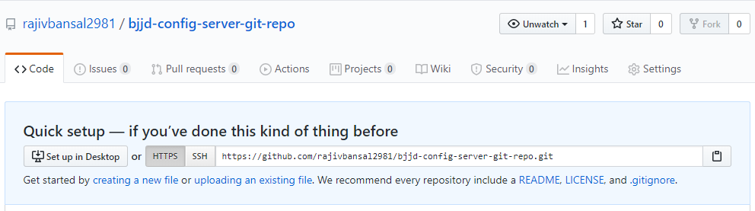

1. Connect your local project folder to your empty folder/repository(https://github.com/rajivbansal2981/bjjd-config-server-git-repo.git) on GitHub
   1. Go back to your project in the terminal/command line.

cd C:\Users\rkbansal\git\bjjd-config-server-git-repo

* 1. In your terminal/command line, type git remote add origin [copied web address]

git remote add origin <https://github.com/rajivbansal2981/bjjd-config-server-git-repo.git>

* 1. Push your branch to GitHub and provide user id and password when prompted

git push origin master

* 1. Go back to the folder/repository screen on Github that you just left, and refresh it you should see your files there.

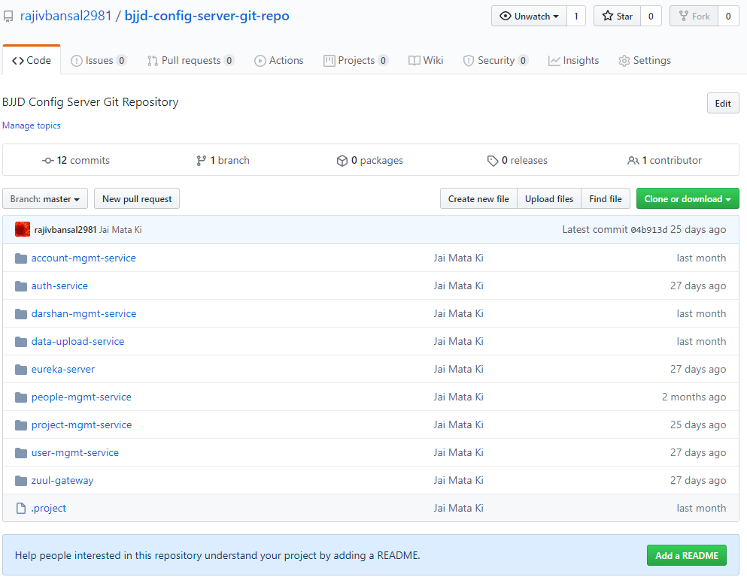

1. To update the application.properties of project: config-server and enable the git URI path for GitHub

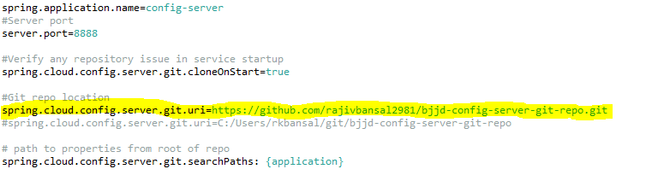

4. Connect your l

### **D.Update the microservices to point config server**

In this step, we need to make changes in the new or existing microservices so that it can access its application.properties using config server.

**For example:** people-mgmt-service

**Perquisite:** people-mgmt-service’s pom should be updated with the following changes:

* + Spring Cloud Starter Config: This dependency is required to connect to the Config Server
  + Spring Boot Starter Parent: update the version : 2.2.4.RELEASE highlighted in yellow colour.
  + Spring Cloud version: upgraded to Hoston.SR4. It is highlighted in yellow colour.
  + Maven Jar Plugin Version: After the above updates, pom is giving compiler error in pom.xml so downgraded version of maven jar plugin to 3.1.1. It is highlighted in yellow colour.
* Need to make the changes in pom.xml of people-mgmt-service





* Moved the main application.properties along with different profiles to git repository: **bjjd-config-server-git-repo**



* In the people-mgmt-service, still there will be an application.properties file but it will have following minimum details:
  + Name of the application
  + Active default profile
  + Cloud config server URI with port



* To verify all the changes, run the following applications in the order:
  + ConfigServerApplication
  + EurekaServerApplication
  + PeopleMgmtRestApplication

Directly hitting the people-mgmt-project running on 6379 and fetch the member details based on the id



## **Eureka-server**

This application is developed to register all the microservices. So that every microservice can communicate with each other without knowing their IP address of the microservice.

* Create Spring Boot Project



* Click on next



* Click on **Next** and **Finish** and created project will look as per the below screenshot:



* Add the following dependencies in pom.xml with the following considerations:
  + Spring Cloud Starter Config: This dependency is required to connect to the Config Server
  + Spring Boot Starter Parent: update the version: 2.2.4.RELEASE highlighted in yellow colour.
  + Spring Cloud version: upgraded to Hoston.SR4. It is highlighted in yellow colour.
  + Maven Jar Plugin Version: After the above updates, pom is giving compiler error in pom.xml so downgraded version of maven jar plugin to 3.1.1. It is highlighted in yellow colour.
  + Web
  + Eureka Server
  + DevTools (optional)

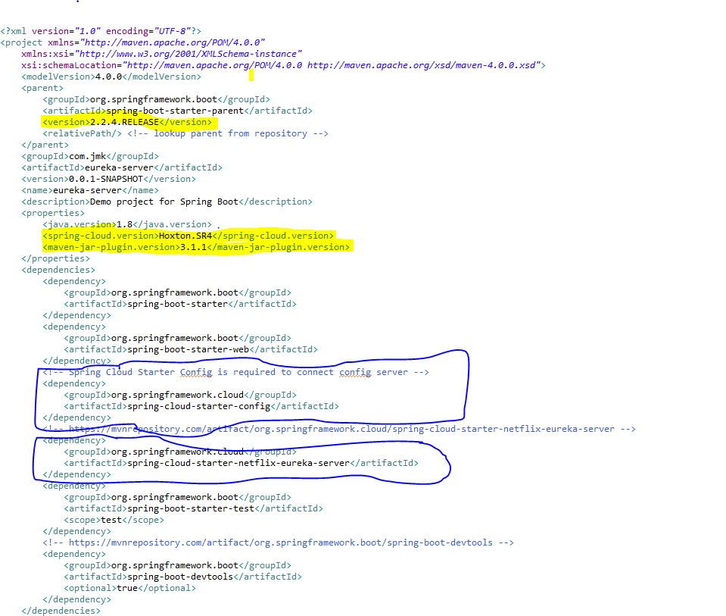

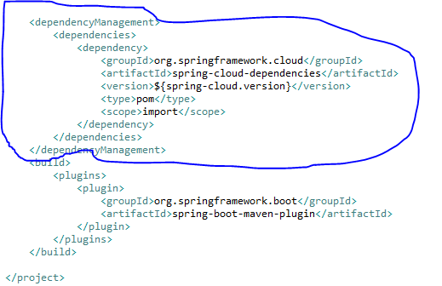

* Moved the following main application.properties along with different profiles to git repository: **bjjd-config-server-git-repo**



* In this application, still there will be an application.properties file but it will have the following minimum details:
  + Name of the application
  + Active Default Profile
  + Cloud Config server URI with port



* Made changes in the **EurekaServerApplication** Class



* Run the application as **Spring Boot App**: EurekaServerApplication



* Open the browser and enter the url: <http://localhost:8761/>



## **Gateway-service (Zuul)**

A gateway is a single-entry point into the system, used to handle requests by routing them to the corresponding microservice.

It’s a proxy, gateway, an intermediate layer between the users and your services.

Eureka server solved the problem of giving names to services instead of hardcoding their IP addresses.

But, still, we may have more than one service (instances) running on different ports. So, Zuul …

1. Maps between a prefix path, say/gallery/\*\* and a service gallery-service. It uses Eureka server to route the requested service.
2. It loads balances (using Ribbon) between instances of a service running on different ports.
3. What else? We can filter requests, add authentication, etc.
4. *It’s worth mentioning that Zuul acts as a Eureka client. So, we give it a name, port, and link to Eureka server (same as we did with image service).*
5. Steps:

* Create Spring Boot Project



* Click on next and fill the required details shown in the below screen:



* Add the following dependencies in the pom.xml with the following considerations:
  + Spring Cloud Starter Config: This dependency is required to connect to the Config Server
  + Spring Boot Starter Parent: update the version: 2.2.4.RELEASE highlighted in yellow colour.
  + Spring Cloud version: upgraded to Hoston.SR4. It is highlighted in yellow colour.
  + Maven Jar Plugin Version: After the above updates, pom is giving compiler error in pom.xml so downgraded version of maven jar plugin to 3.1.1. It is highlighted in yellow colour.
  + Web
  + Eureka Client
  + Zuul

It’s worth mentioning that Zuul acts as a Eureka client. So, we give it a name, port, and link to Eureka server (same as we did with image service).

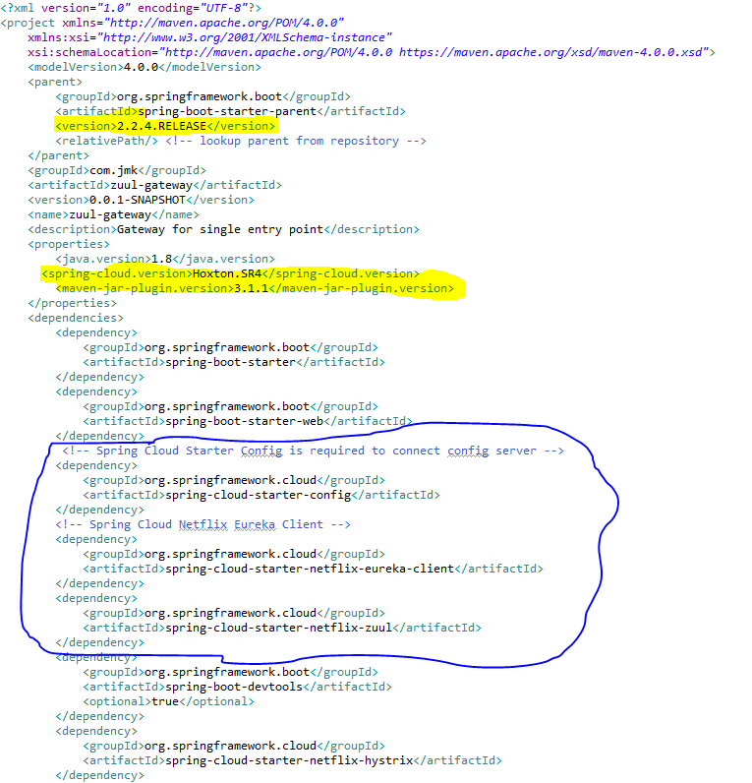

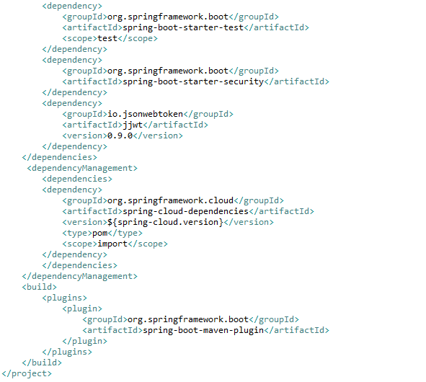

* Moved the following main application.properties along with different profiles to git repository: **bjjd-config-server-git-repo**

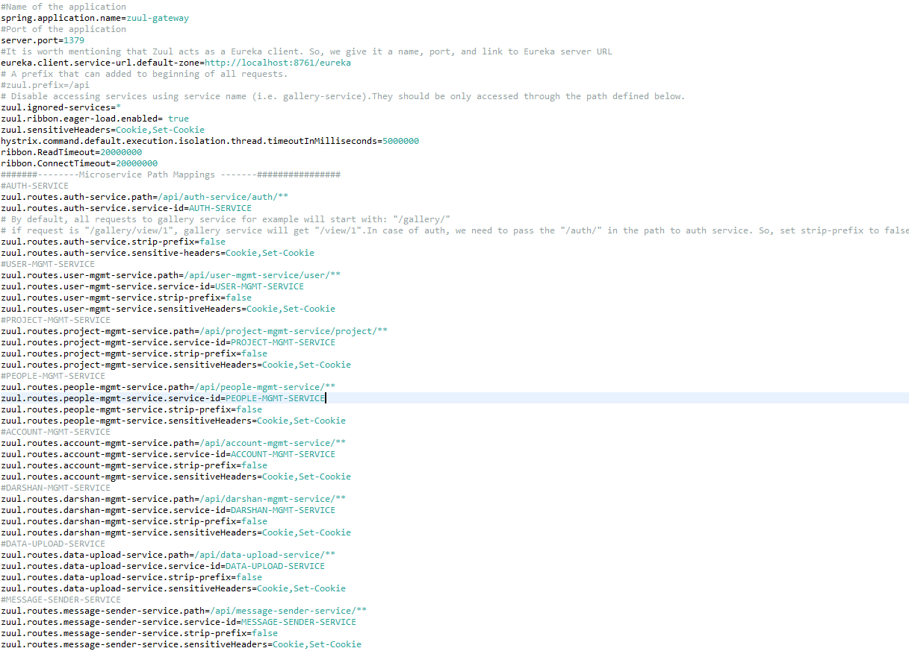

* In this application, still there will be an application.properties file but it will have the following minimum details:
  + Name of the application
  + Active Default Profile
  + Cloud Config server URI with port

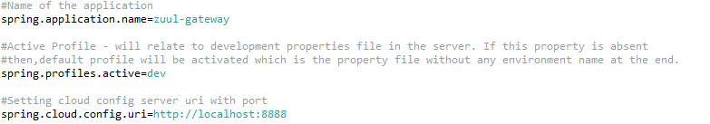

* Finally, make the changes in the ZuulGatewayApplication to enable Zuul and Eureka Client.

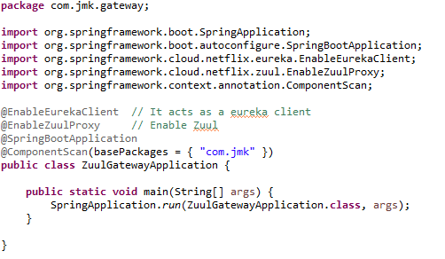

* Need to make changes in this gateway-service application to enable authenticate the user before routing to other microservices.

Can refer the Authentication Service to see other changes in this gateway-service.

* Run the application as **Spring Boot App** in the following order
  + EurekaServerApplication
  + ZuulGatewayApplication



* Open the browser of Eureka Server at localhost:8761, you should see the running zuul-gateway microservices and enter the url: <http://localhost:8761/>



## **User-Mgmt Service (Hazelcast cache)**

Create the user-mgmt-service application as microservice with the following functionalities:

1. Create the user:

While creating user, people-mgmt-service will call dependent microservice: **user-mgmt-service** to create the user credentials/information for every member so that member would be able to login into the BJJD application with his details)

1. Update the user
2. Get the list of all the user
3. Delete the user
4. Get the user details
5. Follow the document to implement user-mgmt-service: **DemoProjectWork-member-mgmt-service.doc** along with the following changes:

|  |  |
| --- | --- |
| Database/Schema Name | users\_db |
| User name | bjjd |
| Password | bjjd\_379 |

**Commands:**

Connect with the root with the following credentials in MySQL database command line or UI

User Id: root

Password: bjjd

* create database users\_db;
* create user 'bjjd'@'%' identified by 'bjjd\_379';
* grant all on users\_db.\* to 'bjjd'@'%';
* grant SELECT,INSERT,UPDATE,DELETE,CREATE,index,drop,ALTER,create temporary tables,references ON users\_db.\* to 'bjjd'@'%';

1. Use the following document related to the swagger, database scripts, ER diagram of Users:



* mvn --encrypt-master-password rajiv379
* 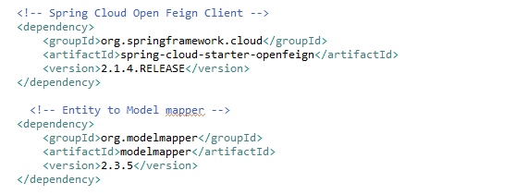Move the following maven dependency from project-mgmt-service to common-service to make it centralize and create the bean in common service for these features so that these can be used in various microservices.

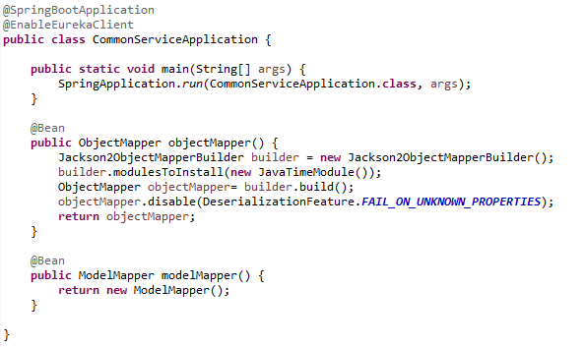

* Add the following dependencies in the pom.xml with the following considerations:
  + Spring Cloud Starter Config: This dependency is required to connect to the Config Server
  + Spring Boot Starter Parent: update the version: 2.2.4.RELEASE highlighted in yellow colour.
  + Spring Cloud version: upgraded to Hoston.SR4. It is highlighted in yellow colour.
  + Hazelcast: to be used for distributed embedded cache
  + jib-maven-plugin: A Maven plugin for building docker container images for your Java applications and pushed to the docker hub.
  + Maven Jar Plugin Version: After the above updates, pom is giving compiler error in pom.xml so downgraded version of maven jar plugin to 3.1.1. It is highlighted in yellow colour.
  + Profiles: There are two profiles configured in maven
    1. Dev:
       1. It will pull the application configuration properties from config server.
       2. It will use Eureka Server
       3. It will use the mysql database locally.
       4. It will not use Kubernetes discovery strategy for Hazelcast cache
    2. Prod:
       1. Eureka client will be disable and it will not use Eureka Server to discover any other microservices. It will use Kubernetes discovery client to disc
       2. configure the Kubernetes Discovery Strategy. this configuration will form a Hazelcast with all Hazelcast instances assigned to services in the current namespace.
       3. It will use the mysql AWS database remotely.

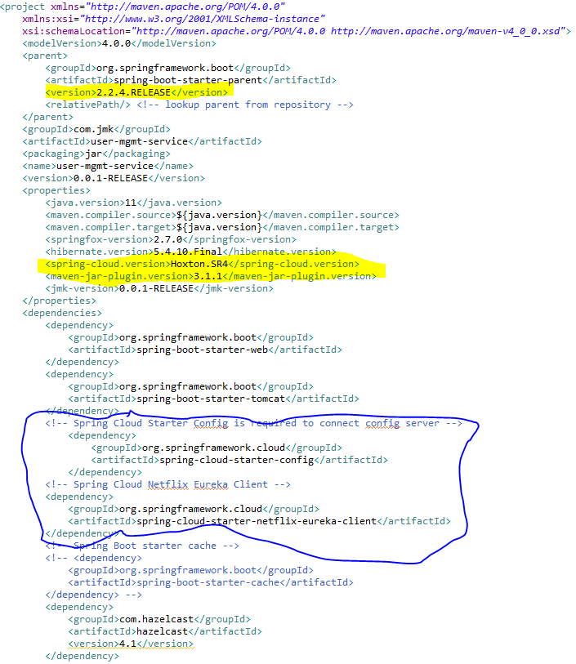

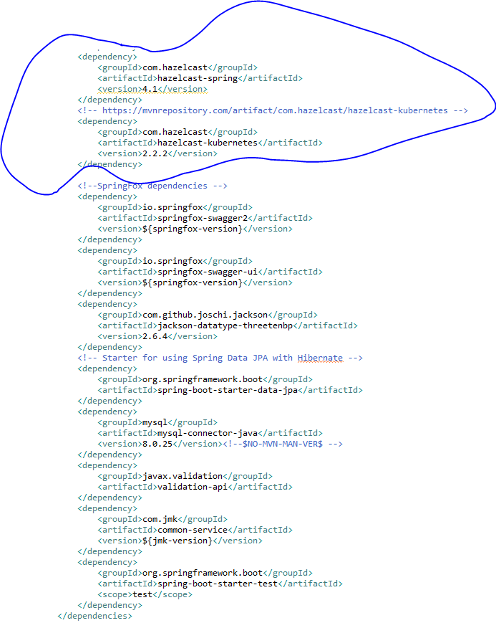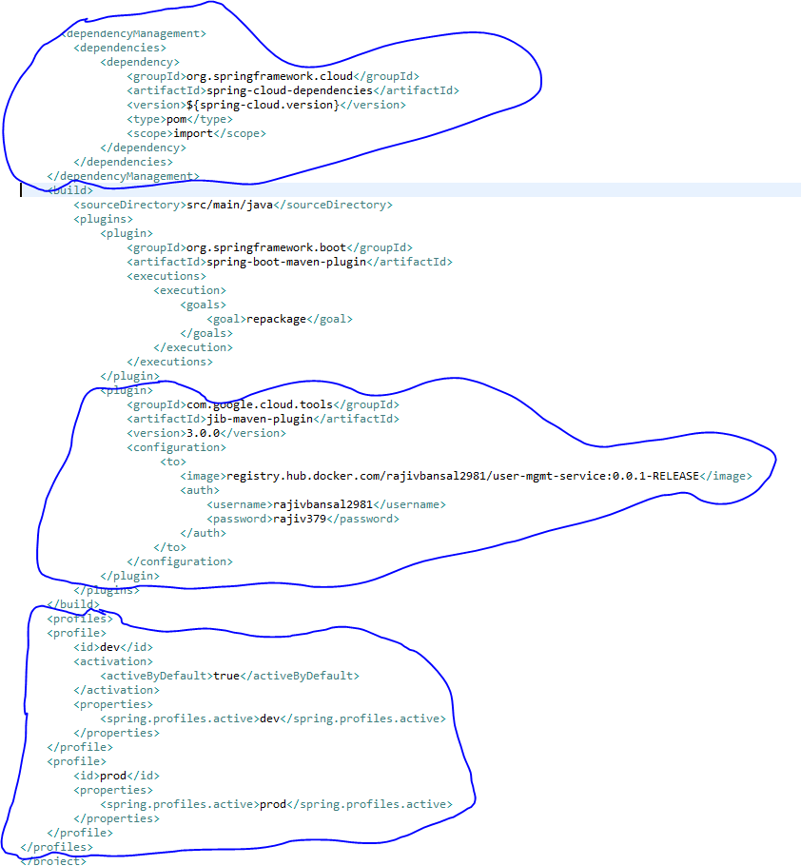

1. Rename the package of io.swagger to com.jmk.user
2. Rename and refactor the Swagger2SpringBoot.java to UserMgmtWebApplication.java with the following details:
   1. Enable Eureka Client so that it can register with Eureka Server
   2. Enable JpaRepositories

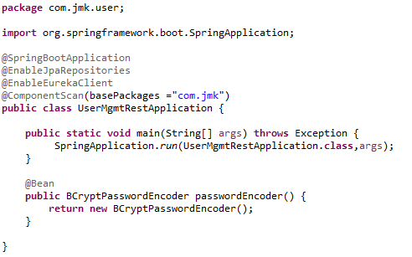

* Moved the following main application.properties along with different profiles to git repository: **bjjd-config-server-git-repo**

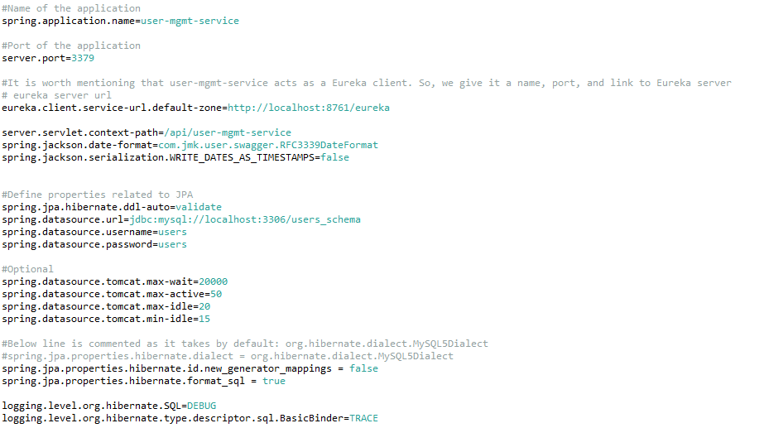

* In this application, still there will be an application.properties file but it will have the following minimum details:
  + Name of the application
  + Active Default Profile
  + Cloud Config server URI with port

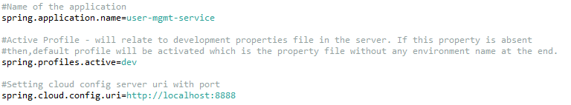

1. Service should be exposed as following:

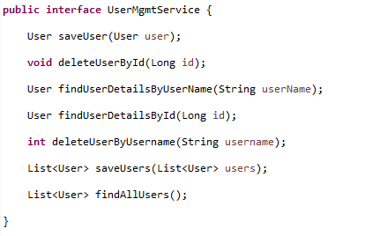

1. Custom Exception Handling where EntityNotFoundException class (created in common-service) thrown if entity not present in database which is handled in RestExcceptionHandler(created in common-service), in this handler we are creating the appropriate error message in json and send back to client.

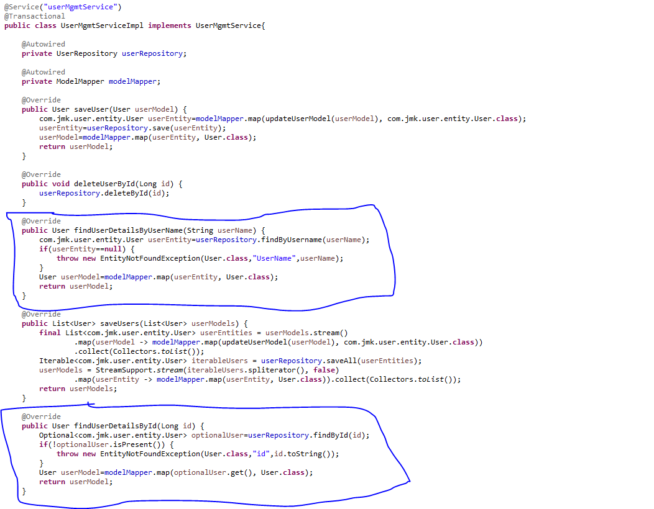

1. Made changes for swagger documentation
   1. in the SwaggerDocumentationConfig, @EnableSwagger2 - Annotation to Enable Swagger Documentation on the API

@EnableSwagger2

@Configuration

**public** **class** SwaggerDocumentationConfig {

ApiInfo apiInfo() {

**return** **new** ApiInfoBuilder()

.title("User Managerment Service API")

.description("User Managerment Service API for BJJD")

.license("")

.licenseUrl("http://unlicense.org")

.termsOfServiceUrl("")

.version("18.10.0")

.contact(**new** Contact("","", ""))

.build();

}

@Bean

**public** Docket customImplementation(){

**return** **new** Docket(DocumentationType.***SWAGGER\_2***)

.select()

.apis(RequestHandlerSelectors.*basePackage*("com.jmk.user.api")).paths(PathSelectors.*regex*("/user.\*"))

.build()

.directModelSubstitute(org.threeten.bp.LocalDate.**class**, java.sql.Date.**class**)

.directModelSubstitute(org.threeten.bp.OffsetDateTime.**class**, java.util.Date.**class**)

.apiInfo(apiInfo());

}

}

* 1. Made changes in the Swagger’s HomeController



1. Run the application as **Spring Boot App** in the following order
   1. EurekaServerApplication
   2. UserMgmtRestApplication

Check Eureka Server is running and UserMgmtServiceApplication is registered with Eureka Server: <http://localhost:8761/>



1. After running the application, should be visible following functions for the following url: <http://localhost:3379/api/user-mgmt-service/swagger-ui.html>

Or

<http://localhost:3379/api/user-mgmt-service/api-docs>



1. Test the User Api using JUnit



1. Testing

* Getting user details based on the username using Postman



* Getting user details based on the username but not found, then custom ApiError message will be shown using Postman



## **entication**

Authentication Service is used for validating user credentials, and issuing tokens.

The authentication flow is simple as:

* 1. The user sends a request to get a token passing his credentials.
  2. The server validates the credentials and sends back a token.
  3. With every request, the user has to provide the token, and server will validate that token.
* Validating the token in Authentication service for every request: Gateway Service has to call the auth service to validate user credentials and the issued token before allowing the requests to go to any service.
* Authentication Service Tools
  1. Spring Cloud Security
  2. OAuth2
  3. JWT
* Authentication service can call any user-mgmt-service to validate the user credentials with the DB or any other source.

We’ll introduce another service called ‘auth service’ for validating user credentials, and issuing tokens.

What about validating the token? Well, it can be implemented in the auth service itself, and the gateway has to call the auth service to validate the token before allowing the requests to go to any service.

Instead, we can validate the tokens at the gateway level, and let the auth service validate user credentials, and issue tokens. And that’s what we’re going to do here.

In both ways, we are blocking the requests unless it’s authenticated (except the requests for generating tokens).

**JSON Based Token (JWT)**

* A token is an encoded string, generated by our application (after being authenticated) and sent by the user along each request to allow access to the resources exposed by our application.
* JSON Based Token (JWT) is a JSON-based open standard for creating access tokens. It consists of three parts; header, payload, and signature.
* The header contains the hashing algorithm

{type: “JWT”, hash: “HS256”}

* The payload contains attributes (username, email, etc) and their values.

{username: "Omar", email: "omar@example.com", admin: true }

* The signature is hashing of: Header + “.” + Payload + Secret key

**Steps:**

**To implement the Authentication Service there are two major steps :**

1. Need to change in the gateway-service(gateway-zuul) previously created project.
2. Create Authentication Service

**I. Need to change in the gateway-service(gateway-zuul) previously created project**

In the gateway, we need to do two things:

* 1. validate tokens with every request, and
  2. prevent all unauthenticated requests to our services. Fair enough?

**🡪Steps:**

* In the pom.xml add spring security and JWT dependencies.



* Made changes in the application.properties



* Three Java Classes need to be created
  + SecurityTokenConfig
  + **JwtTokenAuthenticationFilter**
  + **JwtConfig**
  + JwtAuthenticationEntryPoint – to handle an authorized attempts
* To define our security configurations, create a class, and annotated with @EnableWebSecurity, and extends WebSecurityConfigurerAdapter class to override and provide our own custom security configurations.

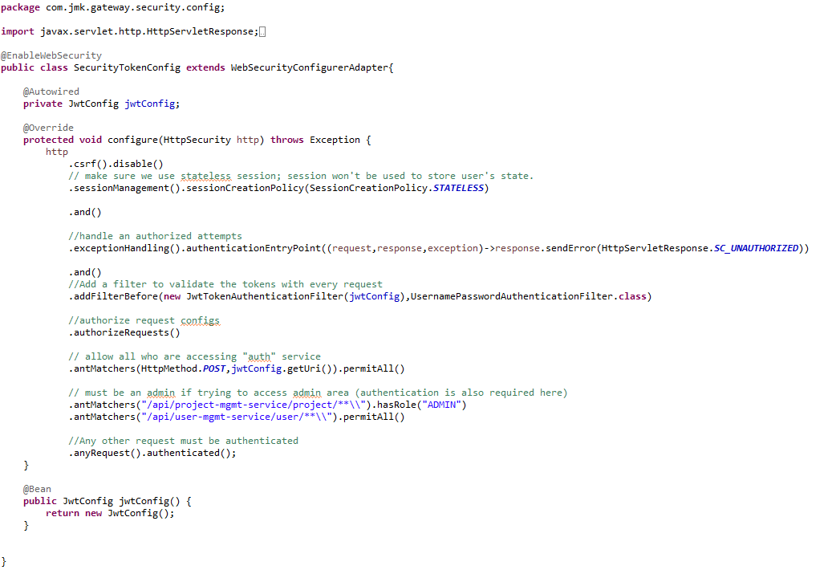

* Create the filter **JwtTokenAuthenticationFilter**

Spring has filters that will get executed within the life cycle of the request (filter chain). To enable and use these filters, we need to extend the class of any of these filters.

By default, spring will try to figure out when the filter should be executed. Otherwise, we can also define when should be executed (after or before another filter).

In this step, we implement our filter that validates the tokens. We’re using OncePerRequestFilter. It guarantee a single execution per request (since you can have a filter on the filter chain more than once).

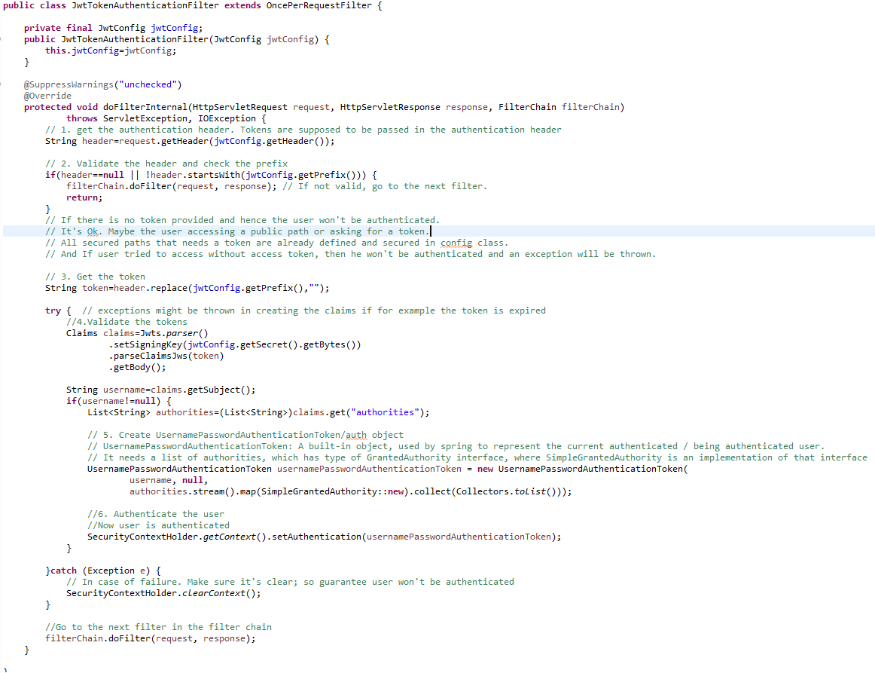

* Create **JwtConfig** Class first which contains configuration variables with getters and setters.



* Create **JwtAuthenticationEntryPoint** to handle the authorized attempt

This class is used to return a 401 unauthorized error to clients that try to access a protected resource without proper authentication. It implements Spring Security's AuthenticationEntryPoint interface.

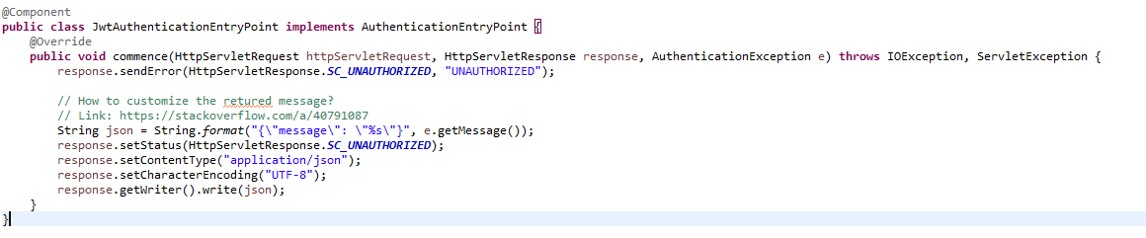

1. **Create Authentication Service**

In the auth service, we need to

* + 1. Validate the user credentials, and if valid: by calling UserMgmtService using Fiegn Client
    2. generate a token, otherwise, throw an exception.

**🡪Steps:**

* Create Spring Boot Project



* Click on next and fill the required details shown in the below screen:



* Add the following dependencies in the pom.xml with the following considerations:
  + Spring Cloud Starter Config: This dependency is required to connect to the Config Server
  + Spring Boot Starter Parent: update the version: 2.2.4.RELEASE highlighted in yellow colour.
  + Spring Cloud version: upgraded to Hoston.SR4. It is highlighted in yellow colour.
  + Maven Jar Plugin Version: After the above updates, pom is giving compiler error in pom.xml so downgraded version of maven jar plugin to 3.1.1. It is highlighted in yellow colour.
  + Web
  + Eureka Client
  + JWT
  + Spring Cloud Open Feign Client
  + Common-service : user created service of reusing the enums, model and utility classes

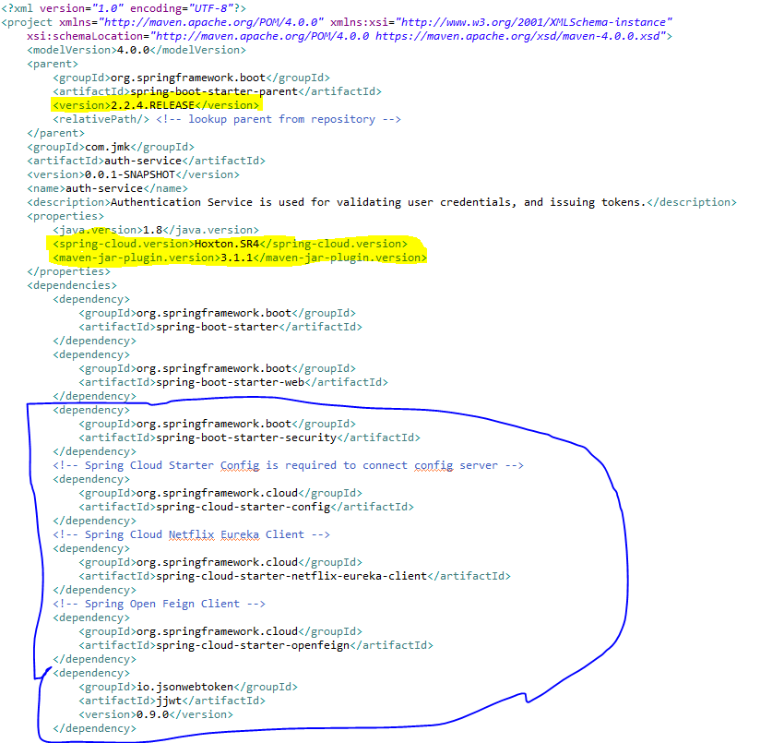

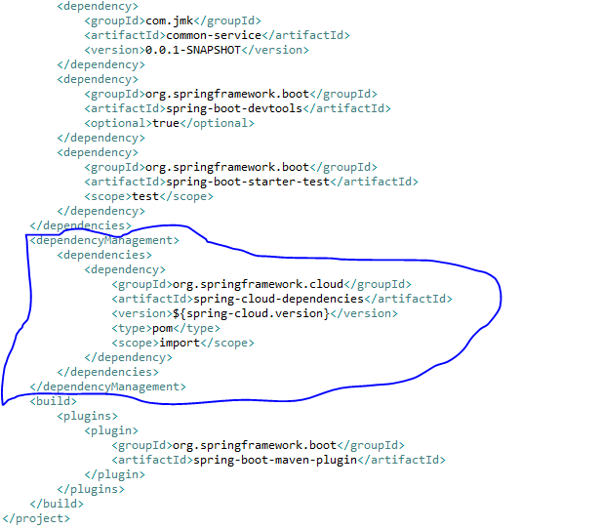

* Moved the following main application.properties along with different profiles to git repository: **bjjd-config-server-git-repo**

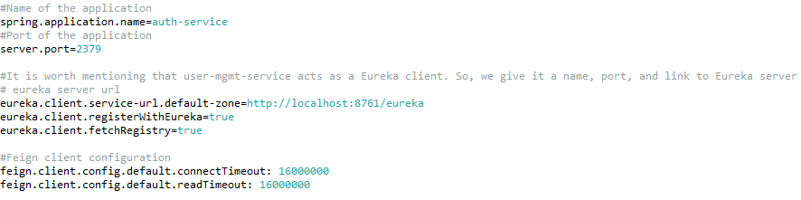

* In this application, still there will be an application.properties file but it will have the following minimum details:
  + Name of the application
  + Active Default Profile
  + Cloud Config server URI with port

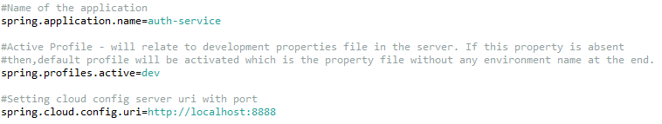

* Update the main **AuthServiceApplication** application with the following details:
  + Enable Eureka Client so that it can register with Eureka Server
  + Enable FeignClient to interact with user-mgmt-service
  + Enable JpaRepositories

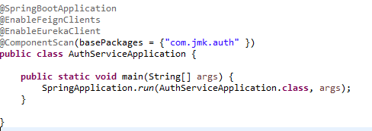

* Following Classes need to be created
  + UserMgmtServiceClient – Feign Client for user-mgmt-service
  + UserDetailsServiceImpl – It will call microservice : user-mgmt-service to validate the credentials using feign client created above.
  + SecurityCredentialsConfig
  + JwtUsernameAndPasswordAuthenticationFilter
  + JwtConfig (same as already created in the above section)
* UserMgmtServiceClient- Feign Client for user-mgmt-service.
* Feign dynamically generates the implementation of the interface we created, so Feign has to know which service to call beforehand. That's why we need to give a name for the interface, which is the {Service-Id} of UserMgmtService. Now, Feign contacts the Eureka server with this Service Id, resolves the actual IP/hostname of the UserMgmtService, and calls the URL provided in Request Mapping.
* To send HTTP Request to a destination **user-mgmt-service** Microservice we will need to create a Feign Client interface. Please note the use of @FeignClient annotation which accepts the name user-mgmt-service under which the destination Microservice is registered with Eureka Discovery Service.

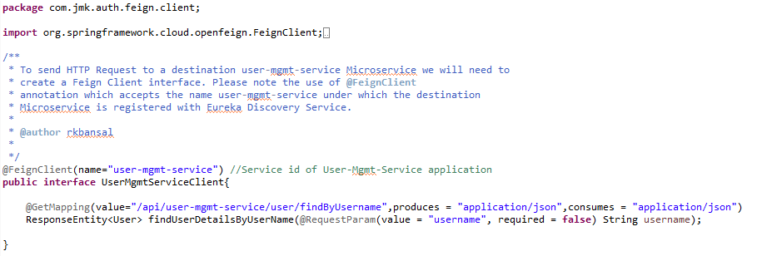

* UserDetailsServiceImpl –

It will implement UserDetailsService(Spring Security API) interface and will call microservice: user-mgmt-service to validate the credentials using feign client created above.

This class acts like a provider for the user; meaning it loads the user from the database (or any data source). It doesn’t do authentication. It just loads the user given his username.

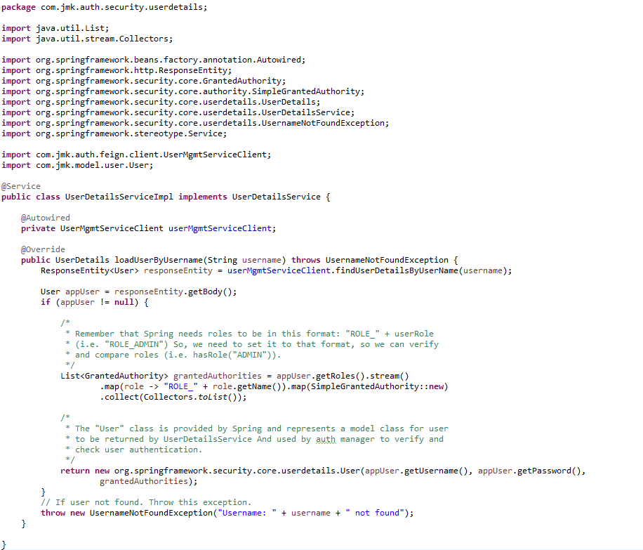

* SecurityCredentialsConfig :

As we did in the Gateway for security configurations, create a class: SecurityCredentialsConfig, annotated with @EnableWebSecurity, and extends WebSecurityConfigurerAdapter



* JwtUsernameAndPasswordAuthenticationFilter

We’re using JwtUsernameAndPasswordAuthenticationFilter. It’s used to validate user credentials, and generate tokens. The username and password must be sent in a POST request.

NOTE: we can complete the following class with getter and setter of UserCredentials not showing in the below pic.



* Create **JwtConfig** Class first which contains configuration variables with getters and setters.



* Run the application as **Spring Boot App** in the following order
  1. EurekaServerApplication
  2. UserMgmtRestApplication
  3. AuthServiceApplication
  4. ZuulGatewayApplication
* Open the browser of Eureka Server at localhost:8761, you should see the all the microservices running and enter the url: <http://localhost:8761/>



* To use any microservices, we have to go via zuul-gateway port: 1379.
  + To get the token, user will pass his credentials and call auth service via zuul-gateway service.
  + The Auth service validates the credentials and sends back a token.
  + With every request, the user has to provide the token, and server will validate that token.

**Request**



**Response –** see the response header containing the token in the Authorization attribute.



## **Common-Service**

When we have common configuration variables, classes, enum classes, or logic, used by multiple microservices, like the one we had JwtConfig, Status Enum, User Model related classes used in the Authentication Services and User Management Service.

* To do so, just create a new project (service), call it ‘common-service’, and follow the same steps as we did with the image service. So, In pom.xml file

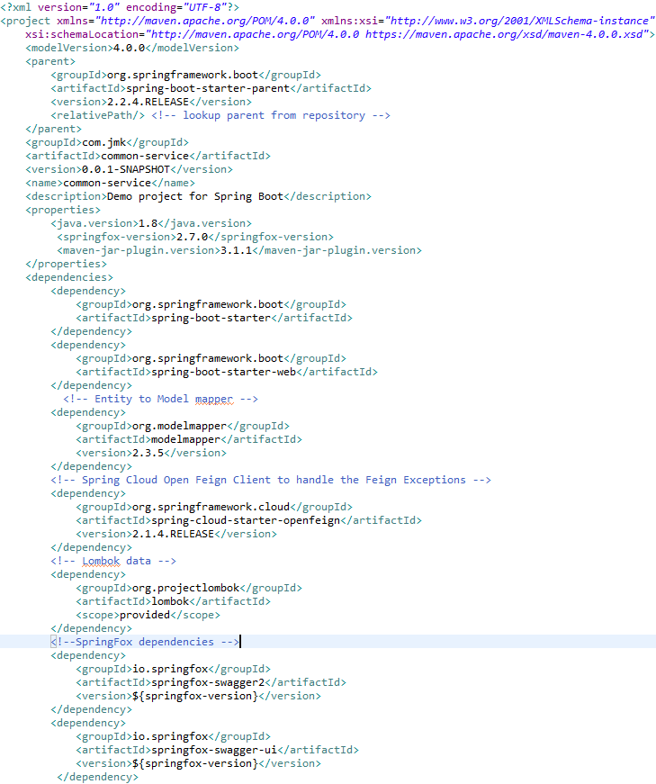

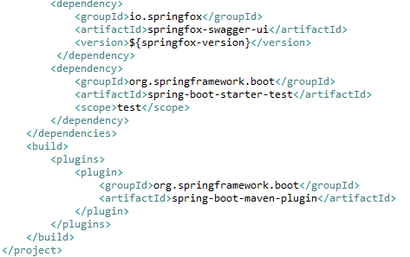

* In Application.properties, No need to define anything as it will be used a JAR file in other microservices
* Put all the
  + common configuration variables,
  + classes, enum classes, or logic, used by multiple microservices,
  + like the one we had JwtConfig, Status Enum, User Model related classes used in the Authentication Services and User Management Service
  + Model classes of all the microservices.
* Now, to be able to call JwtConfig class, User Model related classes from other services, like auth and gateway, we just need to add the common service in pom.xml as dependency.
* Add the dependency of common-service in auth-service pom.



* Now we can use the common configurations and classes.

### **Exception Handling**

Handling errors correctly in APIs while providing meaningful error messages is a very desirable feature, as it can help the API client properly respond to issues. The default behaviour tends to be returning stack traces that are hard to understand and ultimately useless for the API client. Partitioning the error information into fields also enables the API client to parse it and provide better error messages to the user.

#### **Making Error Responses Clearer**

Throughout this article, we’ll be using the [source code hosted on GitHub](https://github.com/brunocleite/spring-boot-exception-handling) of an application that implements a REST API for retrieving objects that represent birds. It has the features described in this article and a few more examples of error handling scenarios. Here’s a summary of endpoints implemented in that application:



The Spring framework MVC module comes with some great features to help with error handling. But it is left to the developer to use those features to treat the exceptions and return meaningful responses to the API client.

Let’s look at an example of the default Spring Boot answer when we issue an HTTP POST to the /birds endpoint with the following JSON object, that has the string “aaa” on the field “mass,” which should be expecting an integer:



The Spring Boot default answer, without proper error handling:



Well… the response message has some good fields, but it is focused too much on what the exception was. By the way, this is the class DefaultErrorAttributes from Spring Boot. The timestamp field is an integer number that doesn’t even carry information of what measurement unit the timestamp is in. The exception field is only interesting to Java developers and the message leaves the API consumer lost in all the implementation details that are irrelevant to them. And what if there were more details that we could extract from the exception that the error originated from? So let’s learn how to treat those exceptions properly and wrap them into a nicer JSON representation to make life easier for our API clients.

Well… the response message has some good fields, but it is focused too much on what the exception was. By the way, this is the class DefaultErrorAttributes from Spring Boot. The timestamp field is an integer number that doesn’t even carry information of what measurement unit the timestamp is in. The exception field is only interesting to Java developers and the message leaves the API consumer lost in all the implementation details that are irrelevant to them. And what if there were more details that we could extract from the exception that the error originated from? So let’s learn how to treat those exceptions properly and wrap them into a nicer JSON representation to make life easier for our API clients.

As we’ll be using Java 8 date and time classes, we first need to add a Maven dependency for the Jackson JSR310 converters. They take care of converting Java 8 date and time classes to JSON representation using the @JsonFormat annotation:



Ok, so let’s define a class for representing API errors. We’ll be creating a class called ApiError  and its associated classes that has enough fields to hold relevant information about errors that happen during REST calls.



**ApiError Class:**



* The status property holds the operation call status. It will be anything from 4xx to signalize client errors or 5xx to mean server errors. A common scenario is a http code 400 that means a BAD\_REQUEST, when the client, for example, sends an improperly formatted field, like an invalid email address.
* The timestamp property holds the date-time instance of when the error happened.
* The message property holds a user-friendly message about the error.
* The debugMessage property holds a system message describing the error in more detail.
* The subErrors property holds an array of sub-errors that happened. This is used for representing multiple errors in a single call. An example would be validation errors in which multiple fields have failed the validation. The ApiSubError class is used to encapsulate those.





So then the ApiValidationError is a class that extends ApiSubError and expresses validation problems encountered during the REST call.

Below, you’ll see some examples of JSON responses that are being generated after we have implemented the improvements described here, just to get an idea of what we’ll have by the end of this article.

Here is an example of JSON returned when an entity is not found while calling endpoint GET /birds/2:



#### **Spring Boot Error Handling**

Let’s explore some of the Spring annotations that will be used to handle exceptions.

[RestController](https://docs.spring.io/spring/docs/current/javadoc-api/org/springframework/web/bind/annotation/RestController.html) is the base annotation for classes that handle REST operations.

[ExceptionHandler](https://docs.spring.io/spring/docs/current/javadoc-api/org/springframework/web/bind/annotation/ExceptionHandler.html) is a Spring annotation that provides a mechanism to treat exceptions that are thrown during execution of handlers (Controller operations). This annotation, if used on methods of controller classes, will serve as the entry point for handling exceptions thrown within this controller only. Altogether, the most common way is to use @ExceptionHandler on methods of @ControllerAdvice classes so that the exception handling will be applied globally or to a subset of controllers.

[ControllerAdvice](https://docs.spring.io/spring/docs/current/javadoc-api/org/springframework/web/bind/annotation/ControllerAdvice.html) is an annotation introduced in Spring 3.2, and as the name suggests, is “Advice” for multiple controllers. It is used to enable a single ExceptionHandler to be applied to multiple controllers. This way we can in just one place define how to treat such an exception and this handler will be called when the exception is thrown from classes that are covered by this ControllerAdvice. The subset of controllers affected can defined by using the following selectors on @ControllerAdvice: annotations(), basePackageClasses(), and basePackages(). If no selectors are provided, then the ControllerAdvice is applied globally to all controllers.

So by using @ExceptionHandler and @ControllerAdvice, we’ll be able to define a central point for treating exceptions and wrapping them up in an ApiError object with better organization than the default Spring Boot error handling mechanism.

#### **Handling Exceptions**



The next step is to create the class that will handle the exceptions. For simplicity, we are calling it RestExceptionHandler and it must extend from Spring Boot’s ResponseEntityExceptionHandler. We’ll be extending ResponseEntityExceptionHandler as it already provides some basic handling of Spring MVC exceptions, so we’ll be adding handlers for new exceptions while improving the existing ones.

Overriding Exceptions Handled In ResponseEntityExceptionHandler

If you take a look into the source code of ResponseEntityExceptionHandler, you’ll see a lot of methods called handle\*\*\*\*\*\*() like handleHttpMessageNotReadable() or handleHttpMessageNotWritable(). Let’s first see how can we extend handleHttpMessageNotReadable() to handle HttpMessageNotReadableException exceptions. We just have to override the method handleHttpMessageNotReadable() in our RestExceptionHandler class:



We have declared that in case of a HttpMessageNotReadableException being thrown, the error message will be “Malformed JSON request” and the error will be encapsulated inside the ApiError object. Below we can see the answer of a REST call with this new method overridden:



##### **Handling Rest Custom Exceptions**

Now we’ll see how to create a method that handles an exception that is not yet declared inside Spring Boot’s ResponseEntityExceptionHandler.

A common scenario for a Spring application that handles database calls is to have a call to find a record by its ID using a repository class. But if we look into the CrudRepository.findOne() method, we’ll see that it returns null if an object is not found. That means that if our service just calls this method and returns directly to the controller, we’ll get an HTTP code 200 (OK) even if the resource isn’t found. In fact, the proper approach is to return a HTTP code 404 (NOT FOUND) as specified in the [HTTP/1.1 spec](https://www.w3.org/Protocols/rfc2616/rfc2616-sec10.html).

To handle this case, we’ll be creating a custom exception called EntityNotFoundException. This one is a custom created exception and different from javax.persistence.EntityNotFoundException, as it provides some constructors that ease the object creation, and one may choose to handle the javax.persistence exception differently.



That said, let’s create an ExceptionHandler for this newly created EntityNotFoundException in our RestExceptionHandler class. To do that, create a method called handleEntityNotFound() and annotate it with @ExceptionHandler, passing the class object EntityNotFoundException.class to it. This signalizes Spring that every time EntityNotFoundException is thrown, Spring should call this method to handle it. When annotating a method with @ExceptionHandler, it will accept a wide range of auto-injected parameters like WebRequest, Locale and others as described [here](https://docs.spring.io/spring/docs/current/javadoc-api/org/springframework/web/bind/annotation/ExceptionHandler.html). We’ll just provide the exception EntityNotFoundException itself as a parameter for this handleEntityNotFound method.

Source Code of the Custom exception classes discussed above.

###### **EntityNotFoundException**



###### **StatusNotActiveException**



* **RestExceptionHandler**



Great! In the handleEntityNotFound() method, we are setting the HTTP status code to NOT\_FOUND and using the new exception message. Here is what the response for the GET /birds/2 endpoint looks like now:



##### **Handling Feign Exceptions**

OpenFeign’s FeignException doesn’t bind to a specific HTTP status (i.e. doesn’t use Spring’s @ResponseStatus annotation), which makes Spring default to 500 whenever faced with a FeignException.

*Sample response when FeignException occurs*



That’s because the root cause for FeignException may not be even related to Http status code sent by remote web service.

In order to propagate the actual error message to the client, we can write our custom ExceptionHandler using a ControllerAdvice.







## **Project-Mgmt Service**

Create the project-mgmt-service application as microservice with the following functionalities:

* Create the project:
* Update the project based on the project id
* Get the list of all the project based on the status
* Get the project based on the project id
* Delete the project based on the project id



Follow the document to implement project-mgmt-service: **DemoProjectWork-member-mgmt-service.doc** along with the following changes:

|  |  |
| --- | --- |
| Database/Schema Name | project\_db |
| User name | bjjd |
| Password | bjjd\_379 |

**Commands:**

Connect with the root with the following credentials in MySQL database command line or UI

User Id: root

Password: bjjd

* create database project\_db;
* create user 'bjjd'@'%' identified by 'bjjd\_379';
* grant all on project\_db.\* to 'bjjd'@'%';
* Use the following document related to the swagger, database scripts, ER diagram of Users:



* Move the following maven dependency from project-mgmt-service to common-service to make it centralize and create the bean in common service for these features so that these can be used in various microservices.



* Add the following dependencies in the pom.xml with the following considerations:
  + Spring Cloud Starter Config: This dependency is required to connect to the Config Server
  + Spring Boot Starter Parent: update the version: 2.2.4.RELEASE highlighted in yellow colour.
  + Spring Cloud version: upgraded to Hoston.SR4. It is highlighted in yellow colour.
  + Maven Jar Plugin Version: After the above updates, pom is giving compiler error in pom.xml so downgraded version of maven jar plugin to 3.1.1. It is highlighted in yellow colour.

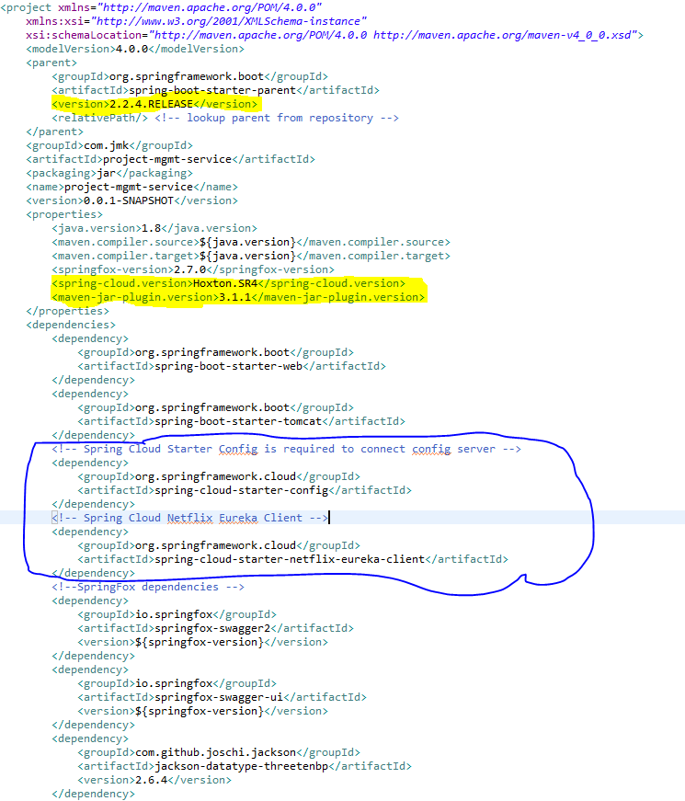

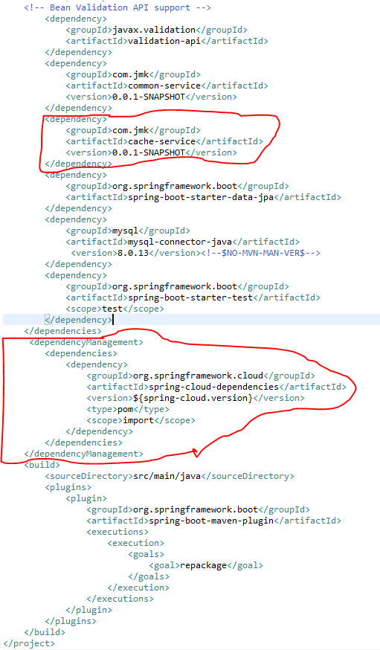

* Rename the package of io.swagger to com.jmk.project
* Rename and refactor the Swagger2SpringBoot.java to ProjectMgmtWebApplication.java with the following details:
  + Enable Eureka Client so that it can be register with Eureka Server
  + Enable JpaRepositories
  + Enable swagger2 so that we can view the document

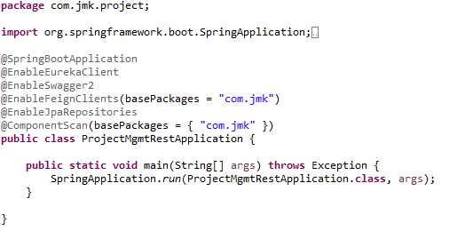

* Moved the following main application.properties along with different profiles to git repository: **bjjd-config-server-git-repo**

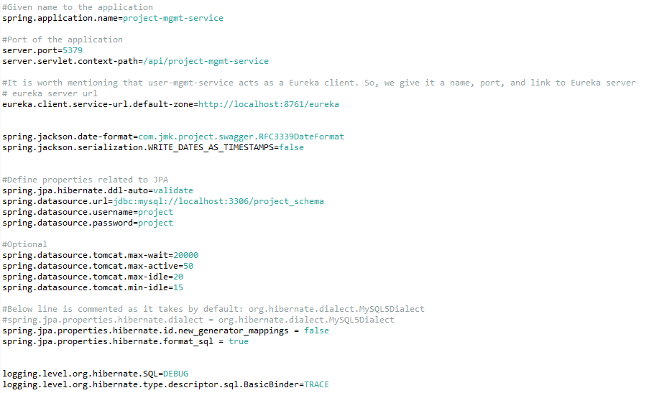

* In this application, still there will be an application.properties file but it will have the following minimum details:
  + Name of the application
  + Active Default Profile
  + Cloud Config server URI with port

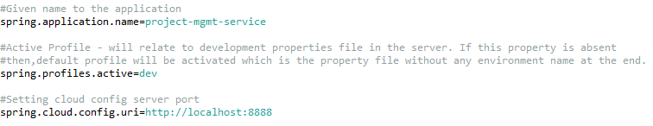

* ProjectApi and ProjectApiController: api exposed by ProjectMgmtService Application
  + ProjectApi

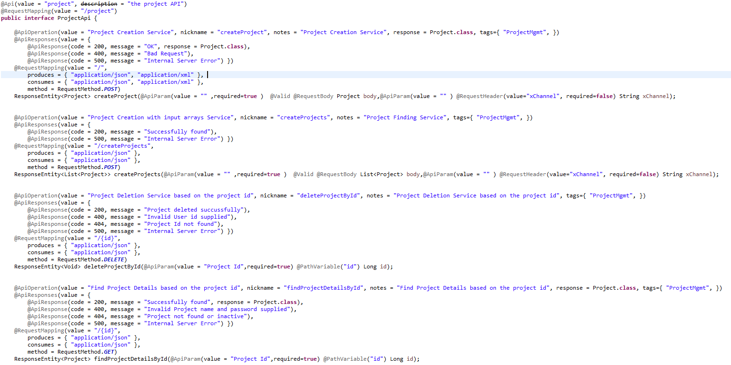

* + ProjectApiController

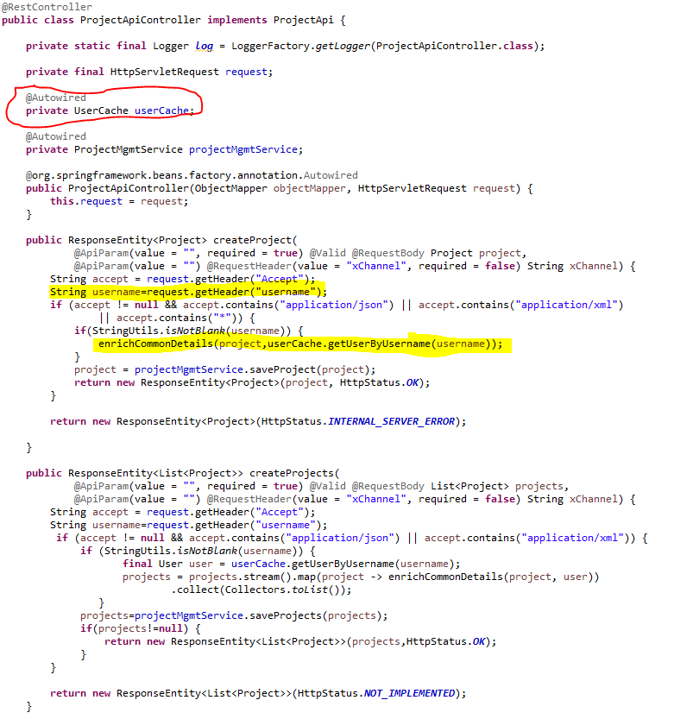

* Service should be exposed as following:

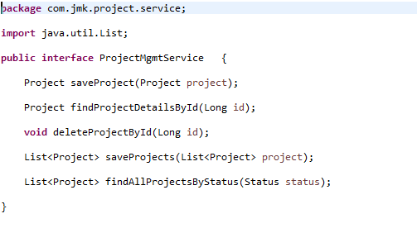

* Custom Exception Handling where EntityNotFoundException class (created in common-service) thrown if entity not present in database which is handled in RestExcceptionHandler(created in common-service), in this handler we are creating the appropriate error message in json and send back to client.

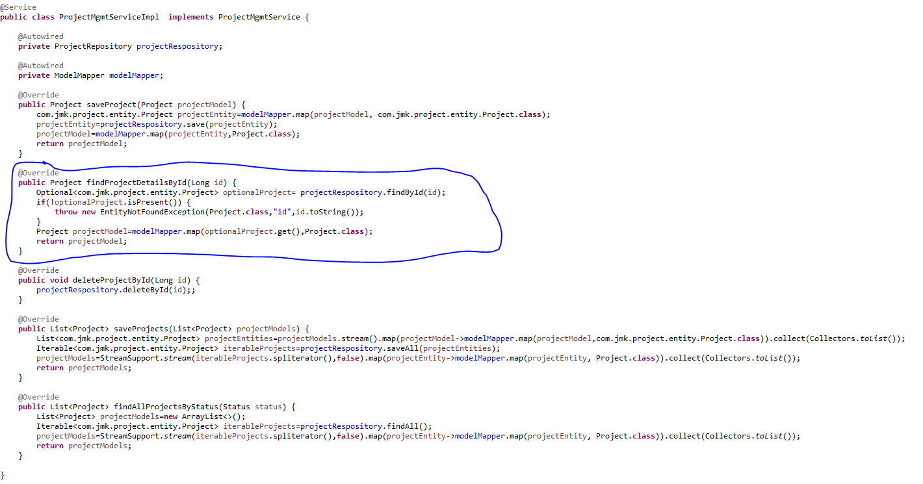

* Made changes in the SwaggerDocumentationConfig

@EnableSwagger2 - Annotation to Enable Swagger Documentation on the API

@EnableSwagger2

@Configuration

**public** **class** SwaggerDocumentationConfig {

ApiInfo apiInfo() {

**return** **new** ApiInfoBuilder()

.title("Project Management Service API")

.description("No description provided (generated by Swagger Codegen https://github.com/swagger-api/swagger-codegen)")

.license("")

.licenseUrl("http://unlicense.org")

.termsOfServiceUrl("")

.version("18.10.0")

.contact(**new** Contact("","", ""))

.build();

}

@Bean

**public** Docket customImplementation(){

**return** **new** Docket(DocumentationType.***SWAGGER\_2***)

.select()

.apis(RequestHandlerSelectors.*basePackage*("com.jmk.project.api")).paths(PathSelectors.*regex*("/project.\*"))

.build()

.directModelSubstitute(org.threeten.bp.LocalDate.**class**, java.sql.Date.**class**)

.directModelSubstitute(org.threeten.bp.OffsetDateTime.**class**, java.util.Date.**class**)

.apiInfo(apiInfo());

}

}

* Made changes in the Swagger’s HomeController



* After running the application, should be visible following functions for the following url: <http://localhost:5379/api/project-mgmt-service/swagger-ui.html>

Or

<http://localhost:5379/api/project-mgmt-service/api-docs>



* Test the Project Api using JUnit



* Run the application as **Spring Boot App** in the following order
  1. EurekaServerApplication
  2. UserMgmtRestApplication
  3. AuthServiceApplication
  4. ZuulGatewayApplication
  5. ProjectMgmtRestApplication
* Open the browser of Eureka Server at localhost:8761, you should see the all the microservices running and enter the url: <http://localhost:8761/>



* Testing
  + Without authentication means directly hitting the project-mgmt-project running on 5379 and getting the details of project based on the status



* + Without authentication means directly hitting the project-mgmt-project running on 5379 and getting the details of project based on the id but not found



* + With authentication means every request to project-mgmt-service microservice will be hit via gateway running 1379
    - with authentication means every request to project-mgmt-service microservice will be hit via gateway running on 1379
      * getting project details with status “A” but without token means no authorization code(Bearer token) in the header will give the error.



* getting project details with status “A” but with token means authorization code(Bearer token) in the header will be provided using authentication service

1. **To get authentication code in response header using authentication service**
2. **Now hit the project-mgmt-service to** get project details with status “A” by providing the token means authorization code(Bearer token) in the header received in above step

## **People-Mgmt-Service**

Create the member-mgmt-service application as microservice with the following functionalities:

1. Create the member:

While creating member, it will call dependent microservice: **user-mgmt-service** to create the user credentials/information for every member so that member would be able to login into the BJJD application with his details)

2. Update the member

3. Get the list of all the members

4.Delete the member

5.Get the member details

1. Check the member exists:

this method would be invoked from **expense-mgmt-service** and **donation-mgmt-service** to check the member exists or not.

In this microservice, we will create parent class Person having three subclasses Member, Sevadar and Devotee:



After that made the following changes:



Follow the document to implement project-mgmt-service: **DemoProjectWork-member-mgmt-service.doc** along with the following changes:

|  |  |
| --- | --- |
| Database/Schema Name | person\_db |
| User name | bjjd |
| Password | bjjd\_379 |

**Commands:**

Connect with the root with the following credentials in MySQL database command line or UI

User Id: root

Password: bjjd

* create database person\_db;
* create user 'bjjd'@'%' identified by 'bjjd\_379';
* grant all on person\_db.\* to 'bjjd'@'%';
* Use the following document related to the swagger, database scripts, ER diagram of Users:



* Move the following maven dependency from project-mgmt-service to common-service to make it centralize and create the bean in common service for these features so that these can be used in various microservices.



* Add the following dependencies in pom.xml with the following considerations:
  + Spring Cloud Starter Config: This dependency is required to connect to the Config Server
  + Spring Boot Starter Parent: update the version: 2.2.4.RELEASE highlighted in yellow colour.
  + Spring Cloud version: upgraded to Hoston.SR4. It is highlighted in yellow colour.
  + Maven Jar Plugin Version: After the above updates, pom is giving compiler error in pom.xml so downgraded version of maven jar plugin to 3.1.1. It is highlighted in yellow colour.

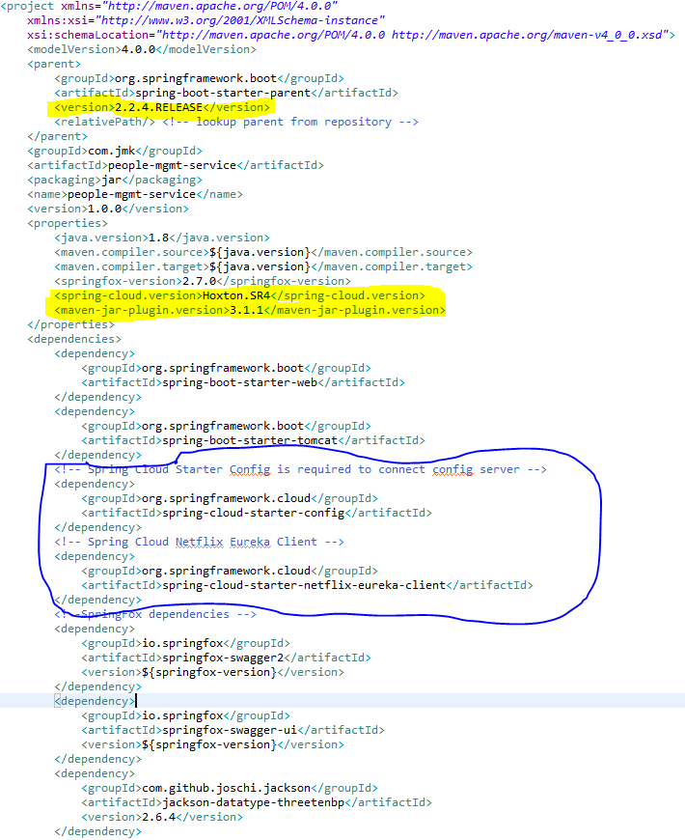

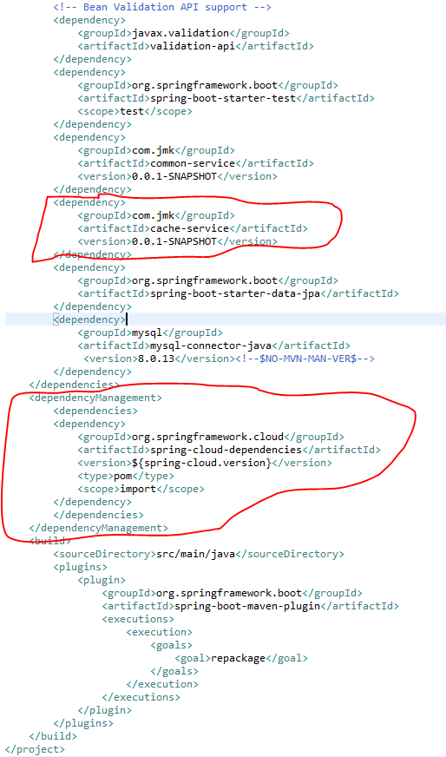

* Rename the package of io.swagger to com.jmk.people
* Rename and refactor the Swagger2SpringBoot.java to PeopleMgmtRestApplication.java with the following details:
  + Enable Eureka Client so that it can be register with Eureka Server
  + Enable JpaRepositories
  + Enable EnableSwagger2 so that we can view the document api

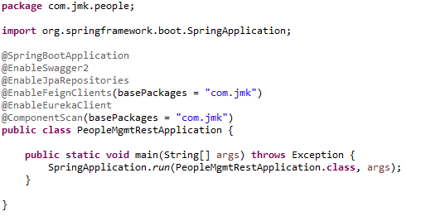

* Moved the following main application.properties along with different profiles to git repository: **bjjd-config-server-git-repo**



* In this application, still there will be an application.properties file but it will have the following minimum details:
  + Name of the application
  + Active Default Profile
  + Cloud Config server URI with port



* People Mgmt Service APIS
  + DevoteeApi and DevoteeApiController

DevoteeApi

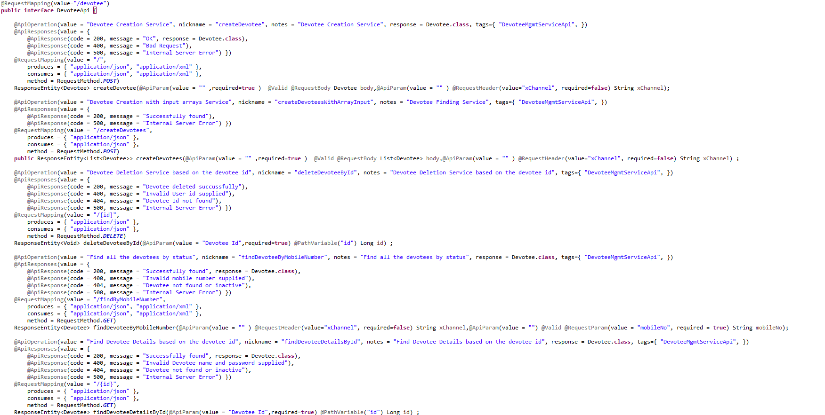

DevoteeApiController

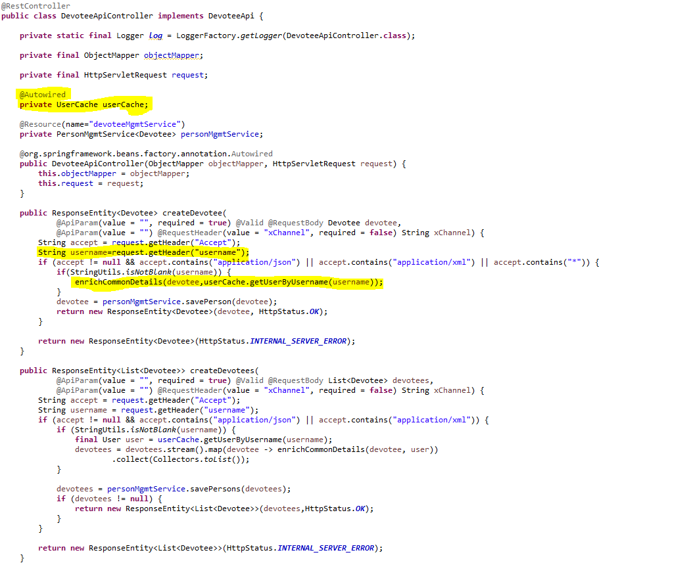

* + MemberApi and MemberApiController

MemberApi

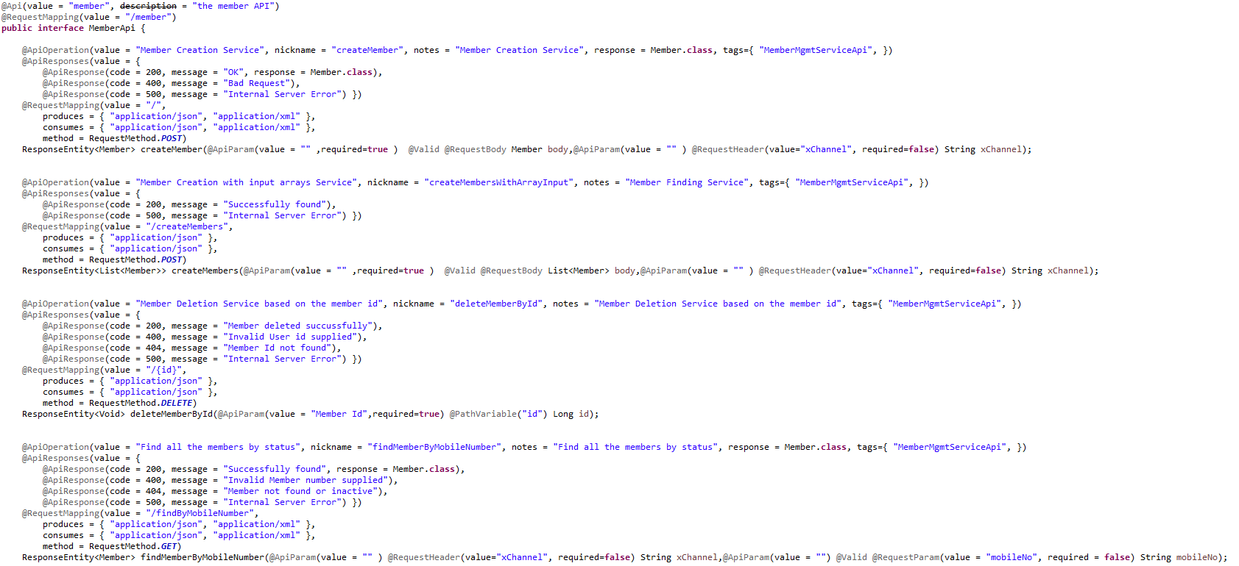

MemberApiController

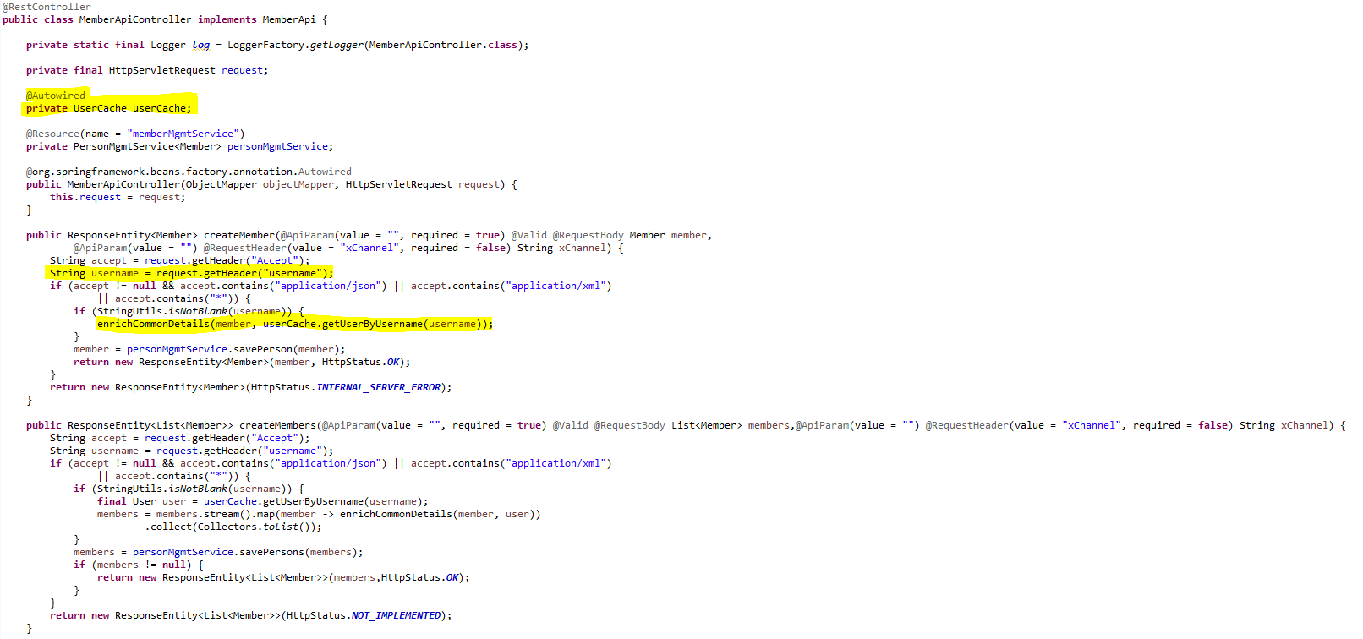

* + SevadarApi and SevadarApiController

SevadarApi

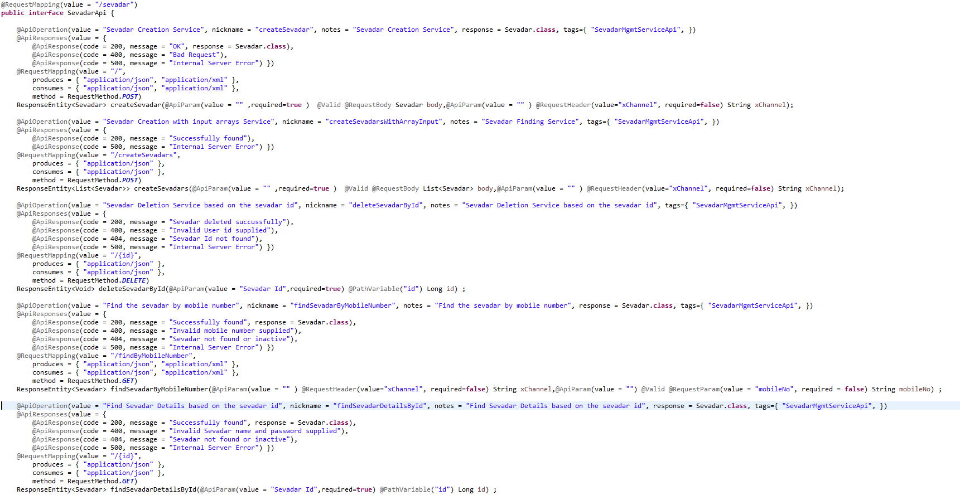

SevadarApiController

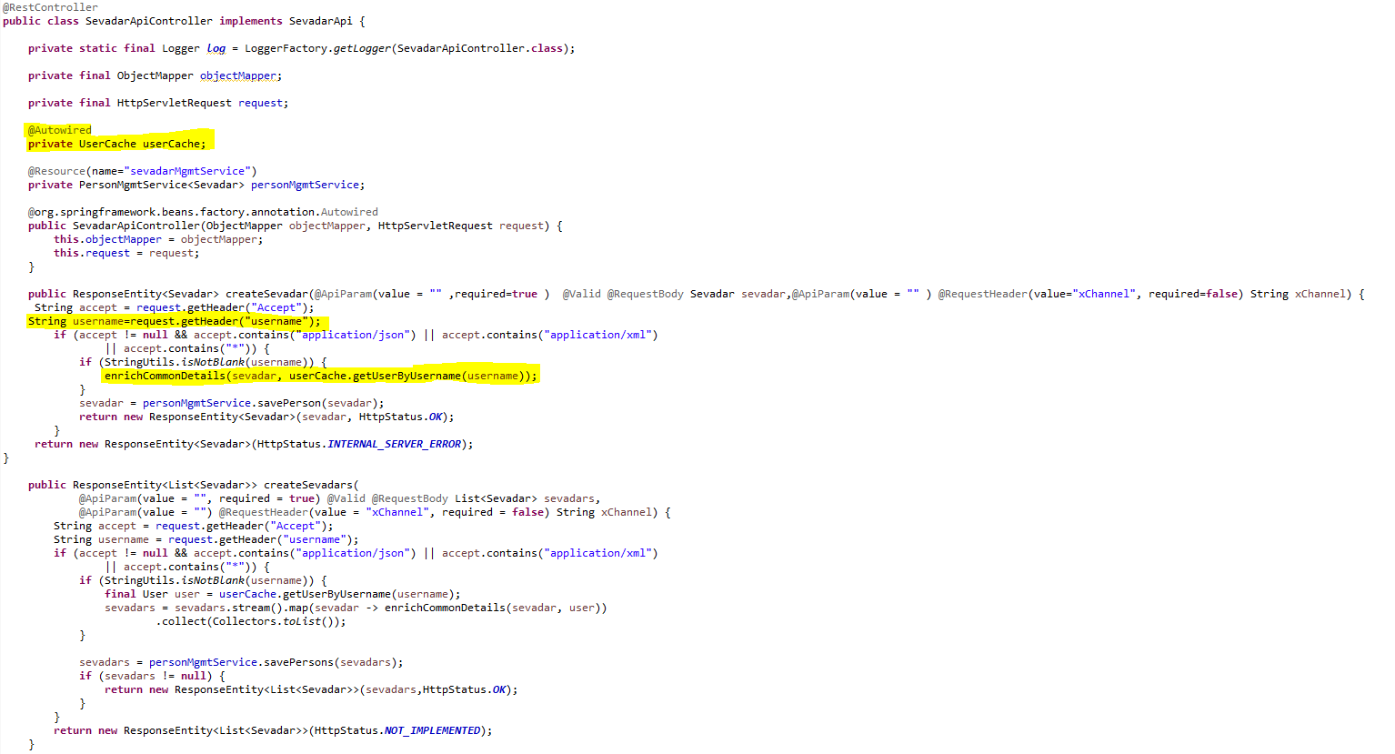

* Service should be exposed as following:

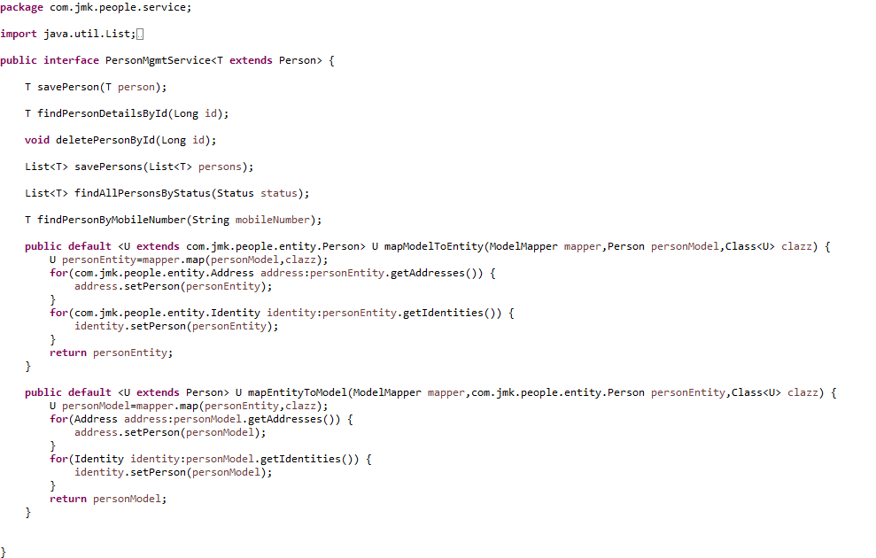

* Custom Exception Handling where EntityNotFoundException class (created in common-service) thrown if entity not present in database which is handled in RestExcceptionHandler(created in common-service), in this handler we are creating the appropriate error message in json and send back to client.

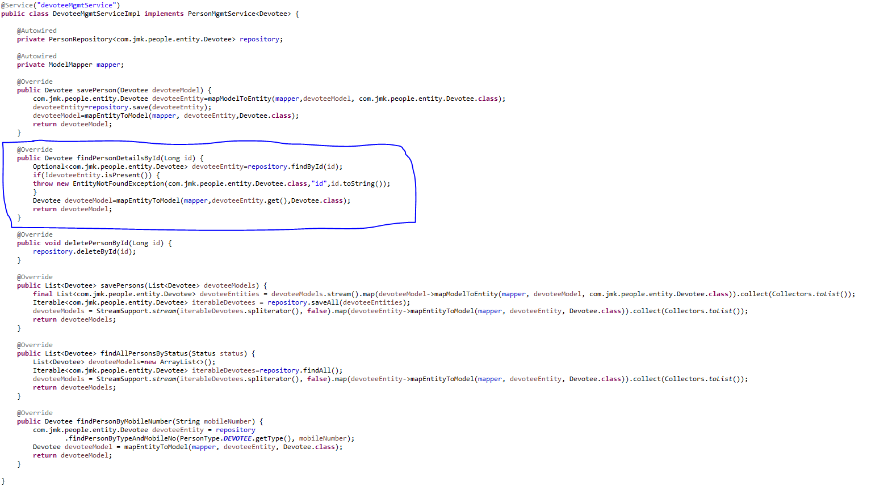

* Made changes in the SwaggerDocumentationConfig

@Configuration

**public** **class** SwaggerDocumentationConfig {

ApiInfo apiInfo() {

**return** **new** ApiInfoBuilder()

.title("People Management Service API")

.description("No description provided (generated by Swagger Codegen https://github.com/swagger-api/swagger-codegen)")

.license("")

.licenseUrl("http://unlicense.org")

.termsOfServiceUrl("")

.version("18.10.0")

.contact(**new** Contact("","", ""))

.build();

}

@Bean

**public** Docket customImplementation(){

**return** **new** Docket(DocumentationType.***SWAGGER\_2***)

.select()

.apis(RequestHandlerSelectors.*basePackage*("com.jmk.people.api")).paths(PathSelectors.*regex*("/\*.\*"))

.build()

.directModelSubstitute(org.threeten.bp.LocalDate.**class**, java.sql.Date.**class**)

.directModelSubstitute(org.threeten.bp.OffsetDateTime.**class**, java.util.Date.**class**)

.apiInfo(apiInfo());

}

}

* Made changes in the Swagger’s HomeController

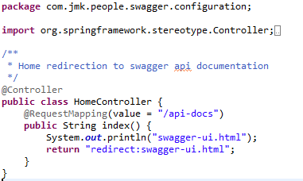

* After running the application, should be visible following functions for the following url: <http://localhost:6379/api/people-mgmt-service/swagger-ui.html>

Or

<http://localhost:6379/api/people-mgmt-service/api-docs>



* Test the People Api using JUnit



* Run the application as **Spring Boot App** in the following order
  + EurekaServerApplication
  + UserMgmtRestApplication
  + AuthServiceApplication
  + ZuulGatewayApplication
  + PeopleMgmtRestApplication
* Open the browser of Eureka Server at localhost:8761, you should see the all the microservices running and enter the url: <http://localhost:8761/>



* Testing
  + Without authentication means directly hitting the people-mgmt-project running on 6379 and fetch the member details based on the id



* + Without authentication means directly hitting the people-mgmt-project running on 6379 but not able to get the member id because it does not exist



* + With authentication means every request to people-mgmt-service microservice will be hit via gateway running 1379
    - with authentication means every request to people-mgmt-service microservice will be hit via gateway running on 1379
      * getting member details based on the id but without token means no authorization code (Bearer token) in the header will give the error.



* getting member details based on the id with token means authorization code(Bearer token) in the header will be provided using authentication service
  + 1. **To get authentication code in response header using authentication service**



* + 1. **Now hit the people-mgmt-service to** get member details based on the id by providing the token means authorization code (Bearer token) in the header received in above step



## **Account-Mgmt-Service**

Create the account-mgmt-service application as microservice with the following functionalities:

* Manage the donations
  + Saving the donation

1. Validate the donor if donor id and donor type is provided in the request. Or If donor is Devotee and its id does not exist in the request.
2. Validate the project exists.
3. Donation request is valid otherwise error message should be triggered for the user.
4. Creating the donor if required: If donor is devotee and its id does not exist it means we need to create the devotee record first then will save the donation.
5. Saving the donation.
   * Updating the donation
   * Find the donation based on the id
   * Delete the donation
   * Saving the donation in bulk

* Manage the expenses:
  + Saving the expense
    1. Validate the project exists.
  + Saving the expense in bulk
  + Updating the expense
  + Delete the expense
  + Find the expense by id

After that made the following changes:



Follow the document to implement project-mgmt-service: **DemoProjectWork-member-mgmt-service.doc** along with the following changes:

|  |  |
| --- | --- |
| Database/Schema Name | account\_db |
| User name | bjjd |
| Password | bjjd\_379 |

**Commands:**

Connect with the root with the following credentials in MySQL database command line or UI

User Id: root

Password: bjjd

* create database account\_db;
* create user 'bjjd'@'%' identified by 'bjjd\_379';
* grant all on account\_db.\* to 'bjjd'@'%';
* Use the following document related to the swagger, database scripts, ER diagram of Users:

  

* Move the following maven dependency from project-mgmt-service to common-service to make it centralize and create the bean in common service for these features so that these can be used in various microservices.



* Add the following dependencies in pom.xml with the following considerations:
  + Spring Cloud Starter Config: This dependency is required to connect to the Config Server
  + Spring Boot Starter Parent: update the version: 2.2.4.RELEASE highlighted in yellow colour.
  + Spring Cloud version: upgraded to Hoston.SR4. It is highlighted in yellow colour.
  + Maven Jar Plugin Version: After the above updates, pom is giving compiler error in pom.xml so downgraded version of maven jar plugin to 3.1.1. It is highlighted in yellow colour.

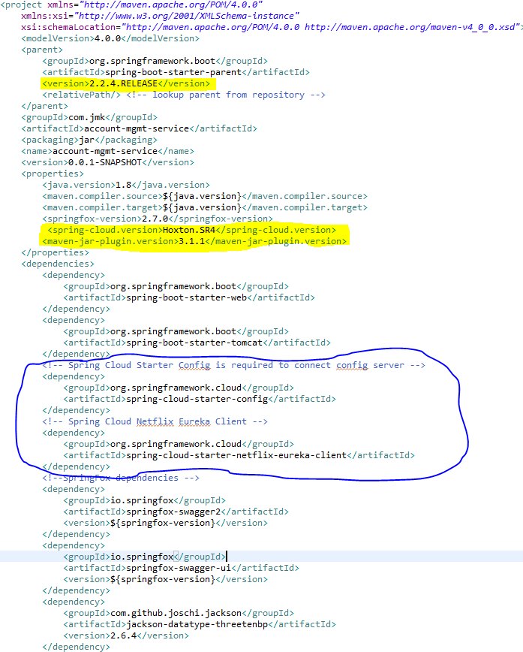

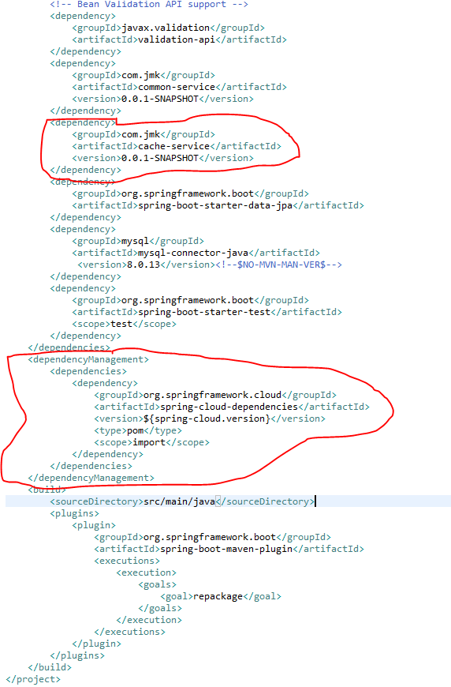

* Rename the package of io.swagger to com.jmk.account
* Rename and refactor the Swagger2SpringBoot.java to AccountMgmtRestApplication.java with the following details:
  + Enable Eureka Client so that it can be register with Eureka Server
  + Enable JpaRepositories
  + Enable FeignClient to interact with user-mgmt-service, people-mgmt-service, project-mgmt-service etc.
  + Enable EnableSwagger2 so that we can view the document api

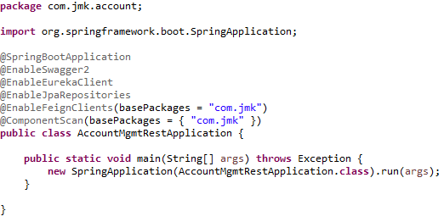

* Moved the following main application.properties along with different profiles to git repository: **bjjd-config-server-git-repo**

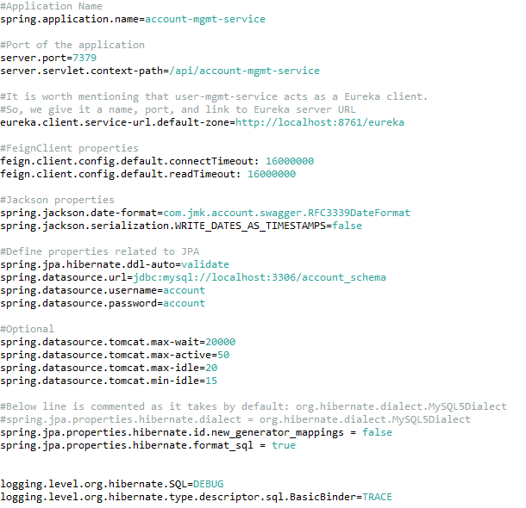

* In this application, still there will be an application.properties file but it will have the following minimum details:
  + Name of the application
  + Active Default Profile
  + Cloud Config server URI with port

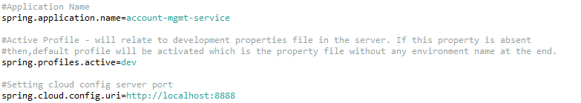

* Create the DonationApi and DonationApiController Class
* DonationApi interface

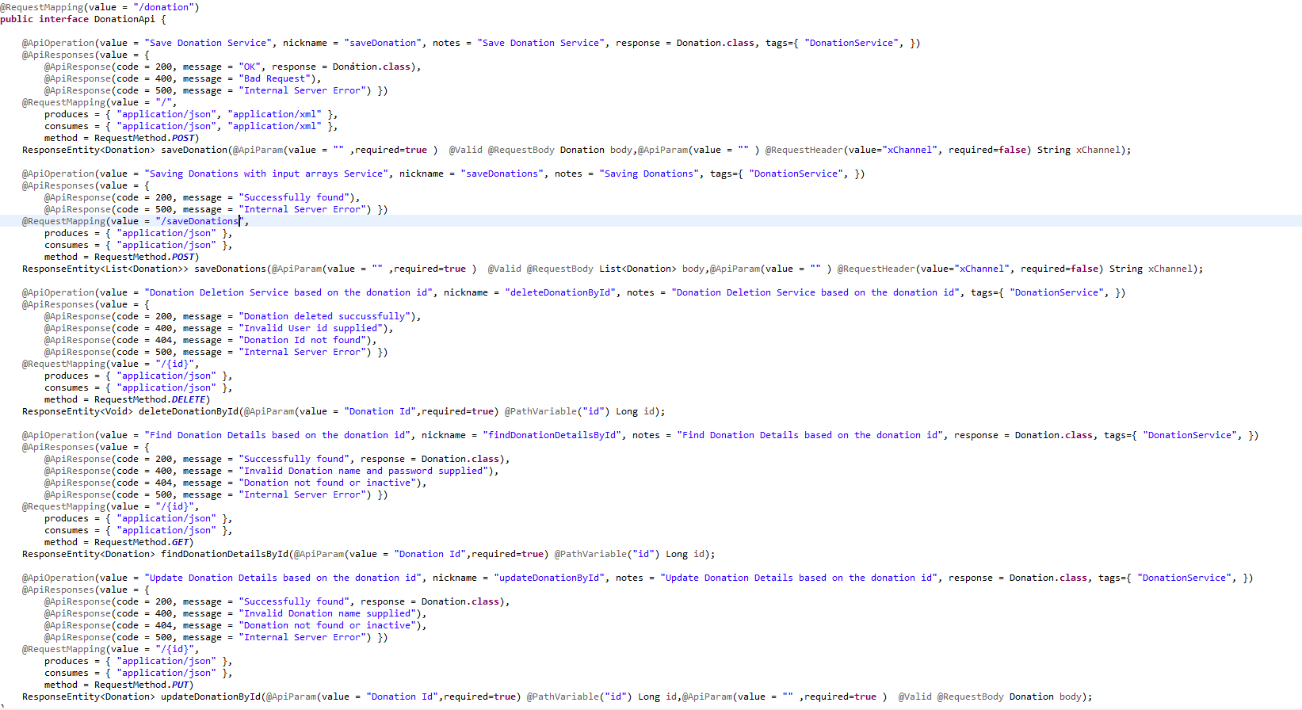

* DonationApiController Class: In this class, when saving donation, we will perform the following activities:
* Validate the donor if donor id and donor type is provided in the request. Or If donor is Devotee and its id does not exist in the request.
* Validate the project exists.
* Donation request is valid otherwise error message should be triggered for the user.
* Creating the donor if required: If donor is devotee and its id does not exist it means we need to create the devotee record first then will save the donation.
* Saving the donation.

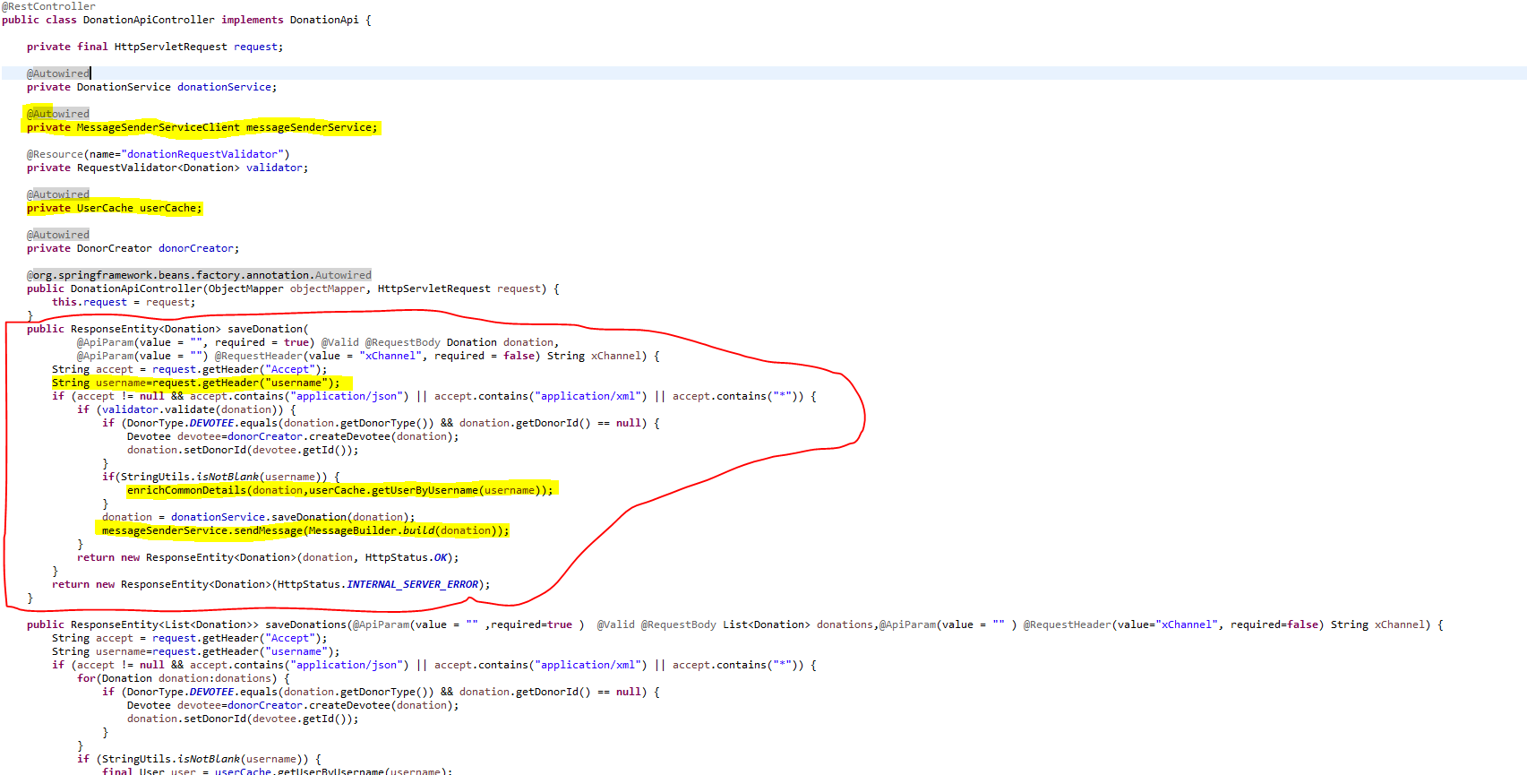

* Create the ExpenseApi and ExpenseApiController Class
* ExpenseApi

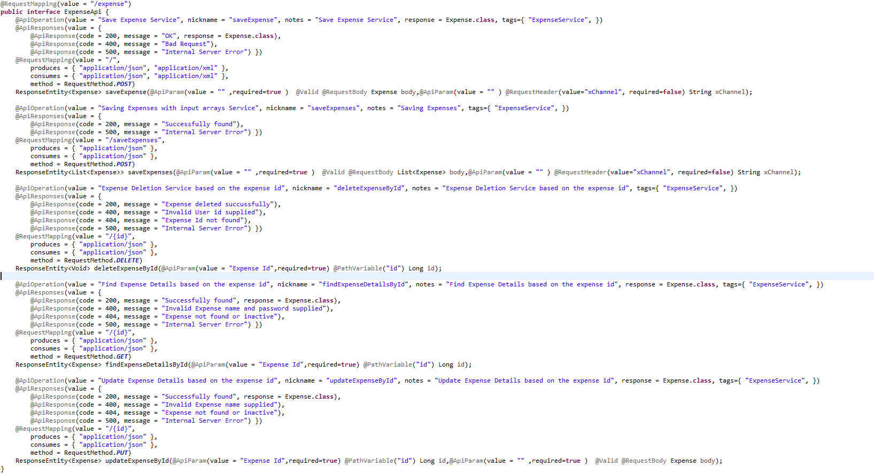

* ExpenseApiController Class: during the saving expense, validating the project.

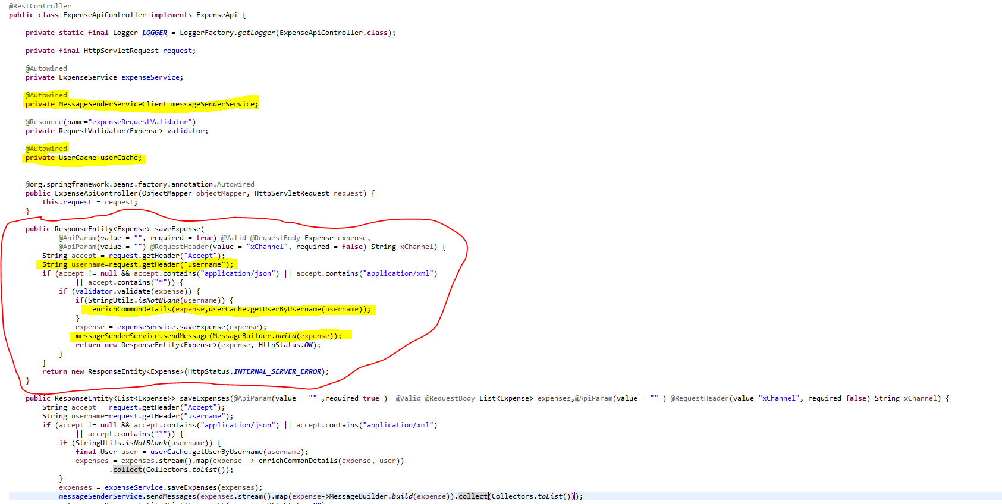

* Create the feign client to interact with people-mgmt-service and project-mgmt-service.
* PeopleMgmtServiceClient

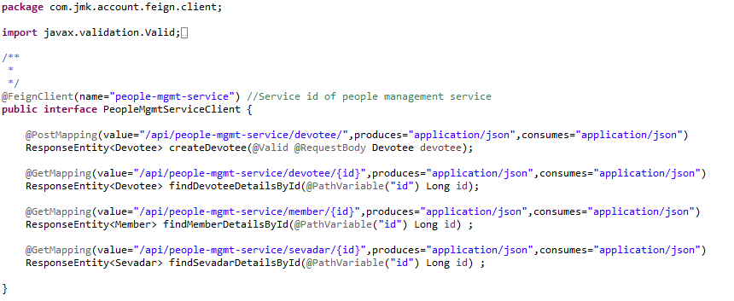

* ProjectMgmtServiceClient

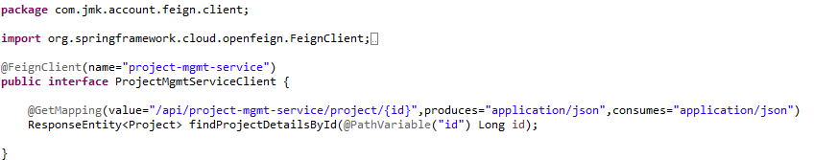

* **MessageSenderServiceClient**: to interact with message-sender-service to send the message to visitor.

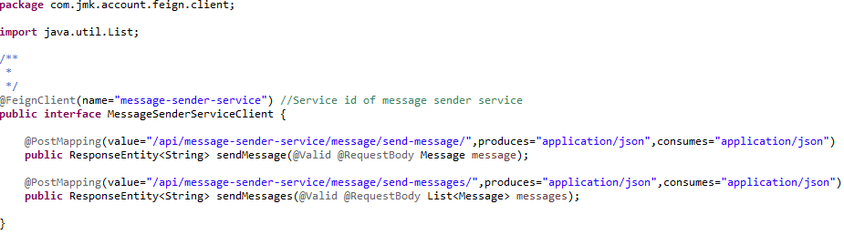

* Custom Exception Handling where
  + **EntityNotFoundException :** While interacting with people-mgmt-service and project-mgmt-service to validate the entity using feign client, EntityNotFoundException class (created in common-service) can be thrown if entity not present in database which is handled in RestExceptionHandler(created in common-service), But we are not able to catch this EntityNotFoundException exception from caller microservice as it throws FeignException so to catch the appropriate exception, need to handle this in FeignExceptionHandler class (created in common-service) we are creating the appropriate error message in json and send back to client.
  + **StatusNotFoundException:** This exception can be thrown when entity is present but its status is not active and it is handled in

RestExceptionHandler(created in common-service).

* Create the **RequestValidator** to validate the donation and expense request where we will validate the donor and project by invoking the people-mgmt-service and project-mgmt-service using feign client.

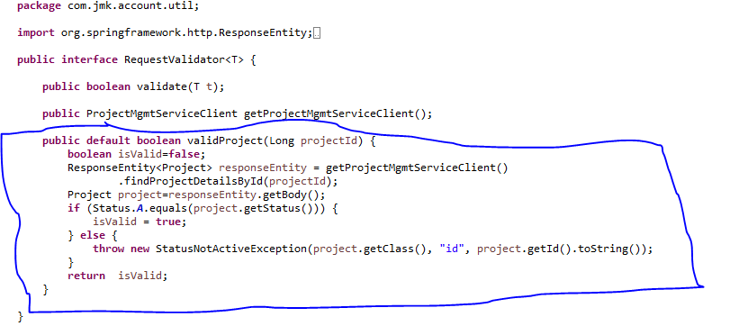

DonationRequestValidator implements RequestValidator where we are validating the donation request:

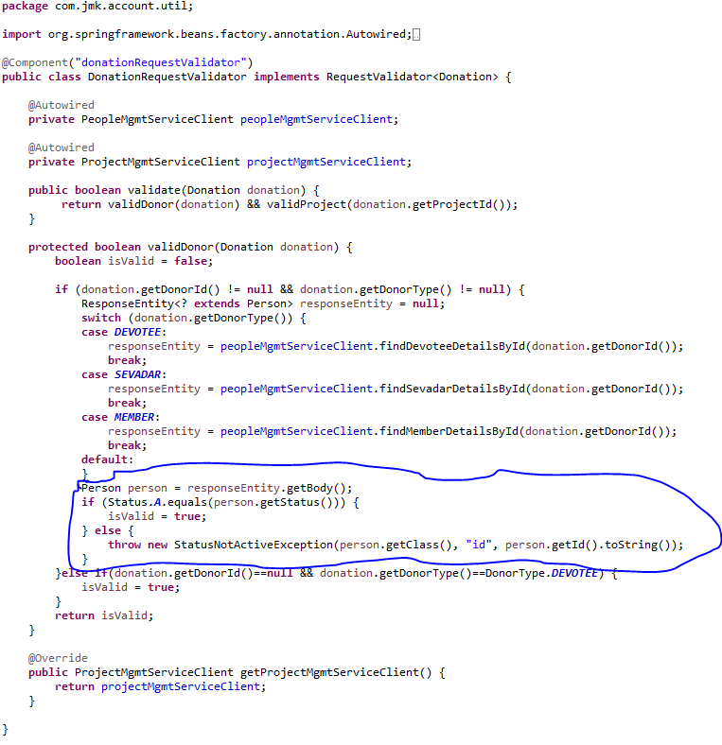

ExpenseRequestValidator implements RequestValidator where we are validating the donation request:



* Create DonorCreator class to create the donor by invoking the people-mgmt-service using feign client.

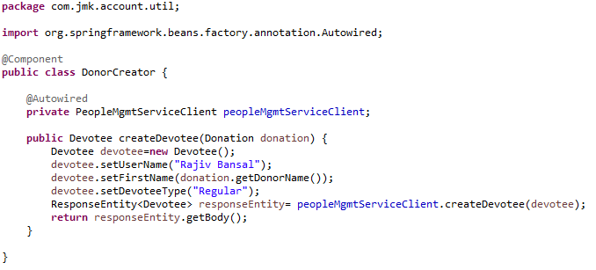

* DonationService and DonationServiceImpl Class should be exposed as following:
* DonationService interface



* DonationServiceImpl interface



* ExpenseService and ExpenseServiceImpl Class should be exposed as following:
* ExpenseService



* ExpenseServiceImpl



* Made changes in the SwaggerDocumentationConfig



* Made changes in the Swagger’s HomeController



* After running the application, should be visible following functions for the following url: <http://localhost:7379/api/account-mgmt-service/swagger-ui.html>

Or

<http://localhost:7379/api/account-mgmt-service/api-docs>



* Test the DonationApiTest using Junit



* Run the application as **Spring Boot App** in the following order
  + EurekaServerApplication
  + UserMgmtRestApplication
  + AuthServiceApplication
  + ZuulGatewayApplication
  + PeopleMgmtRestApplication
  + ProjectMgmtRestApplication
  + AccountMgmtRestApplication
* Open the browser of Eureka Server at localhost:8761, you should see the all the microservices running and enter the url: <http://localhost:8761/>



* Testing
  + Without authentication means directly hitting the account-mgmt-project running on 7379 and save the donation details



* + Without authentication means directly hitting the account-mgmt-project running on 7379 but member does not exist for whom we are saving the donation is not active.



* + With authentication means every request to people-mgmt-service microservice will be hit via gateway running 1379
    - with authentication means every request to people-mgmt-service microservice will be hit via gateway running on 1379
      * getting member details based on the id but without token means no authorization code (Bearer token) in the header will give the error.



* Saving donation with token means authorization code (Bearer token) in the header will be provided using authentication service
  + 1. **To get authentication code in response header using authentication service**



* + 1. **Now hit the account-mgmt-service to** save the donation by providing the token means authorization code (Bearer token) in the header received in above step
  + See the **Authorization** tab in the donation request



* + See the **Body** tab in the donation request and response can be seen.



## **Darshan Mgmt Service**

Create the darshan-mgmt-service application as microservice with the following functionalities:

* Saving the details of darshan which includes the Darshan Date, Visitor Details, number of members with Visitor, number of times he visited
  + Validate the visitor if visitor id and donor type is provided in the request. Or If donor is Devotee and its id does not exist in the request.
  + Darshan request is valid otherwise error message should be triggered for the user.
  + Creating the visitor if required: If visitor is devotee and its id does not exist it means we need to create the devotee record first then will save the donation.
  + Saving the donation.
  + Saving the details of darshan in bulk
  + Updating the darshan details
  + Delete the darshan
  + Find the darshan by id

After that made the following changes:



Follow the document to implement project-mgmt-service: **DemoProjectWork-member-mgmt-service.doc** along with the following changes:

|  |  |
| --- | --- |
| Database/Schema Name | darshan\_db |
| User name | bjjd |
| Password | bjjd\_379 |

**Commands:**

Connect with the root with the following credentials in MySQL database command line or UI

User Id: root

Password: bjjd

* create database darshan\_db;
* create user 'bjjd'@'%' identified by 'bjjd\_379';
* grant all on darshan\_db.\* to 'bjjd'@'%';
* Use the following document related to the swagger, database scripts, ER diagram of Users:



* Move the following maven dependency from darshan-mgmt-service to common-service to make it centralize and create the bean in common service for these features so that these can be used in various microservices.



* Add the following dependencies in pom.xml with the following considerations:
  + Spring Cloud Starter Config: This dependency is required to connect to the Config Server
  + Spring Boot Starter Parent: update the version: 2.2.4.RELEASE highlighted in yellow colour.
  + Spring Cloud version: upgraded to Hoston.SR4. It is highlighted in yellow colour.
  + Maven Jar Plugin Version: After the above updates, pom is giving compiler error in pom.xml so downgraded version of maven jar plugin to 3.1.1. It is highlighted in yellow colour.

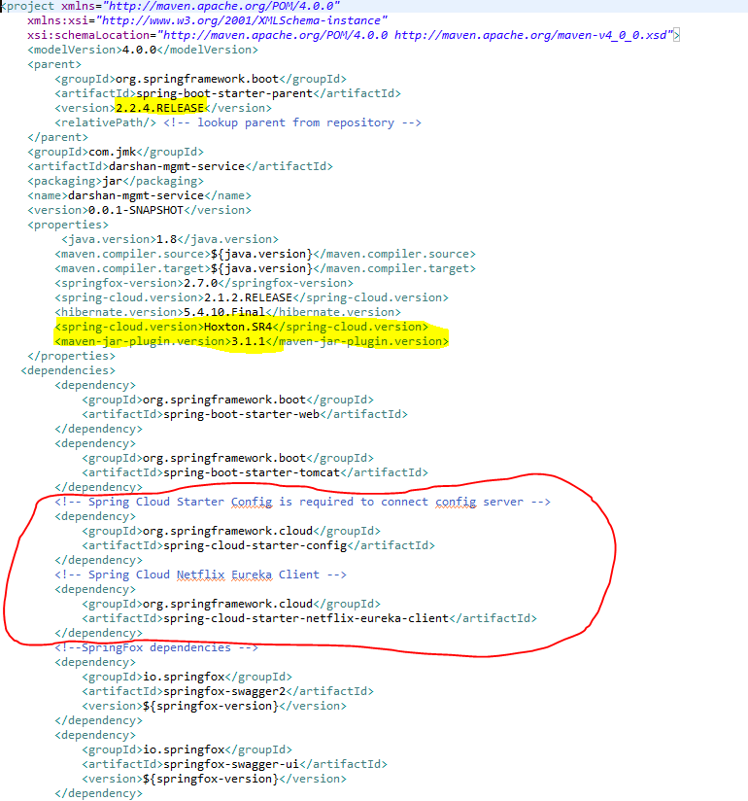

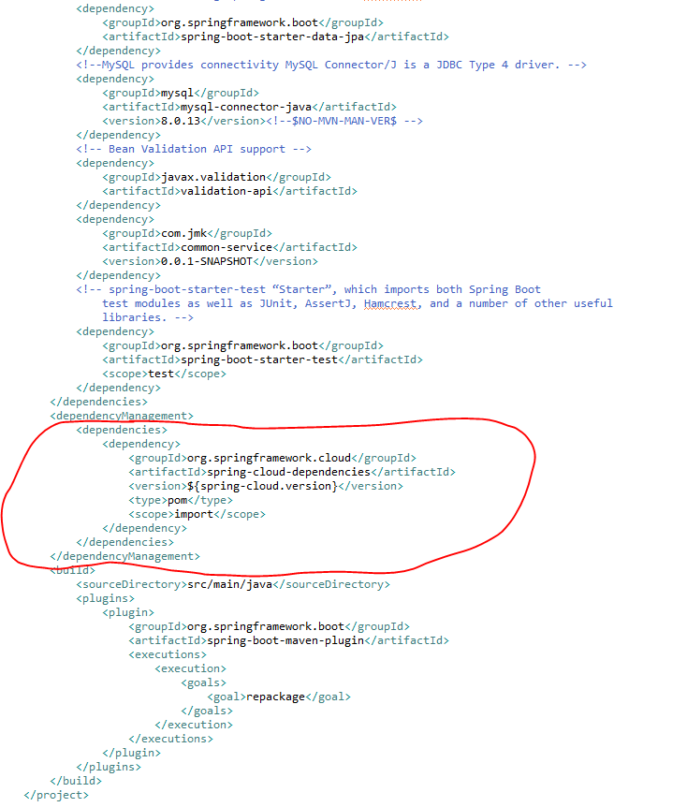

* Rename the package of io.swagger to com.jmk. darshan
* Rename and refactor the Swagger2SpringBoot.java to DarshanMgmtRestApplication.java with the following details:
  + Enable Eureka Client so that it can be register with Eureka Server
  + Enable JpaRepositories
  + Enable FeignClient to interact with user-mgmt-service, people-mgmt-service.
  + Enable EnableSwagger2 so that we can view the document api

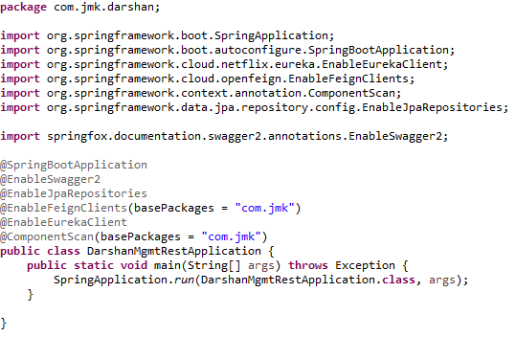

* Moved the following main application.properties along with different profiles to git repository: **bjjd-config-server-git-repo**

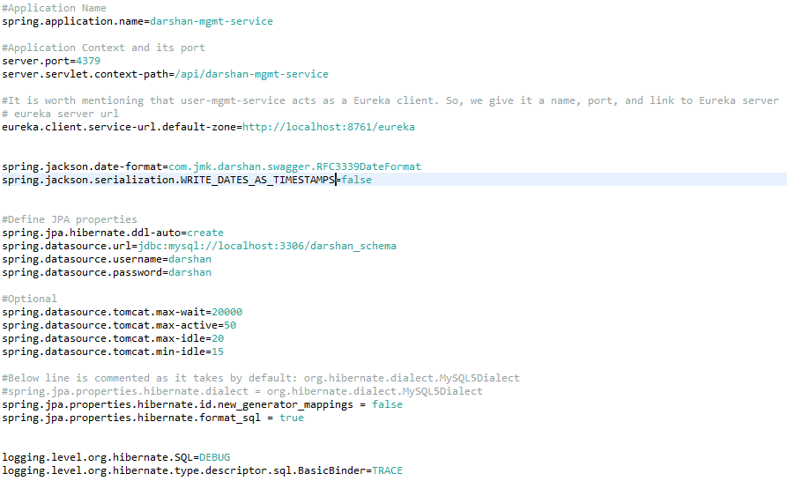

* In this application, still there will be an application.properties file but it will have the following minimum details:
  + Name of the application
  + Active Default Profile
  + Cloud Config server URI with port

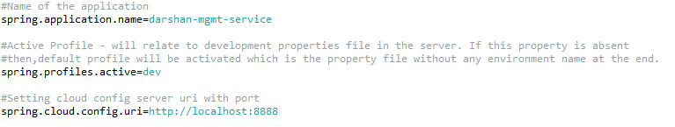

* Create the DarshanApi and DarshanApiController Class
* DarshanApi interface

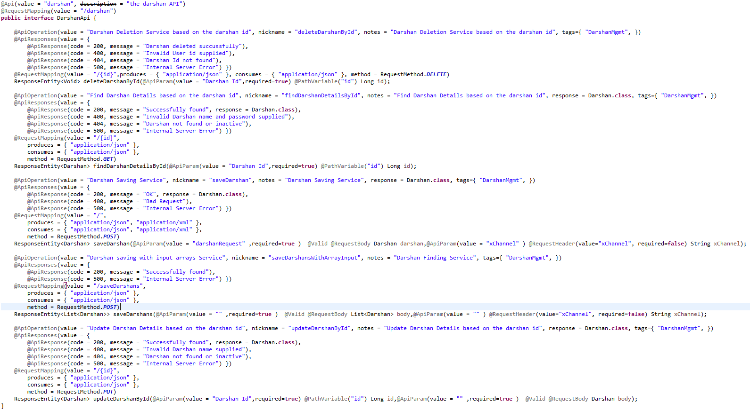

* DarshanApiController Class

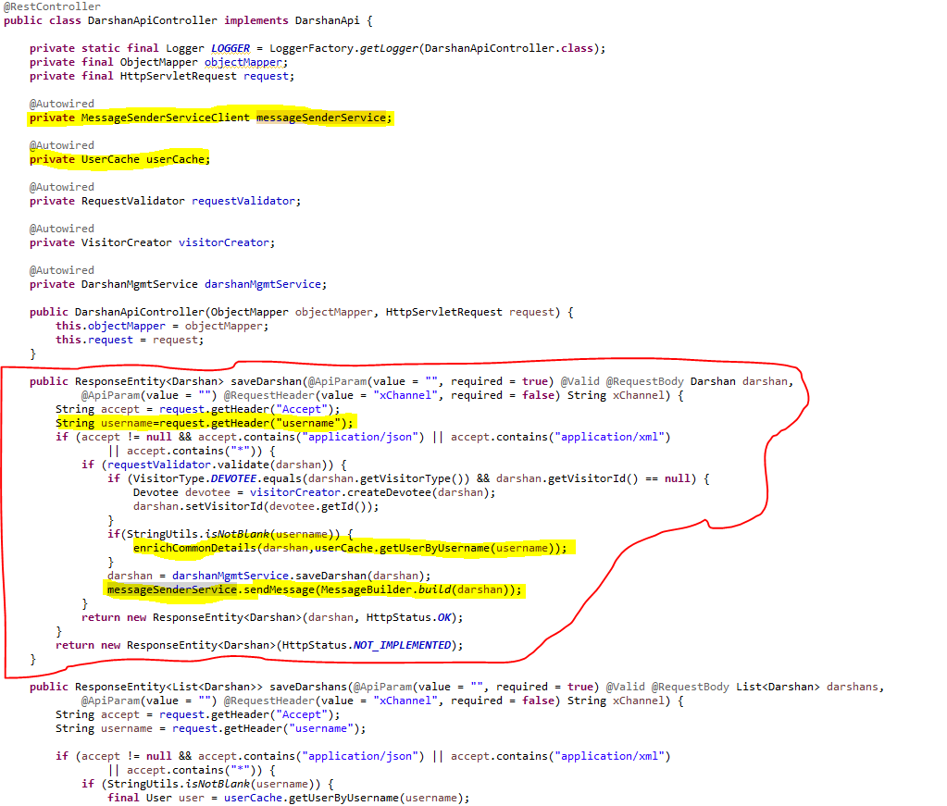

* Create the feign client to interact with people-mgmt-service to get the details of devotee, member and sevadar.
  + **PeopleMgmtServiceClient**: to interact with people-mgmt-service to get the details of devotee, member and sevadar.



* **MessageSenderServiceClient**: to interact with message-sender-service to send the message to visitor.

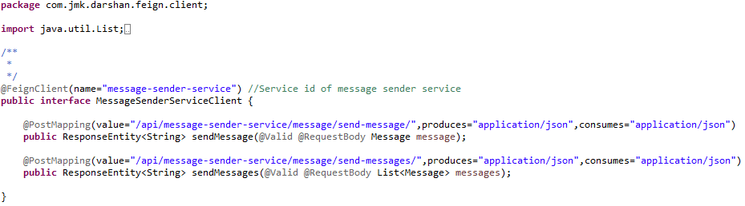

* Custom Exception Handling where
  + **EntityNotFoundException :** While interacting with people-mgmt-service to validate the entity using feign client, EntityNotFoundException class (created in common-service) can be thrown if entity not present in database which is handled in RestExceptionHandler(created in common-service), But we are not able to catch this EntityNotFoundException exception from caller microservice as it throws FeignException so to catch the appropriate exception, need to handle this in FeignExceptionHandler class (created in common-service) we are creating the appropriate error message in json and send back to client.
  + **StatusNotFoundException:** This exception can be thrown when entity is present but its status is not active and it is handled in

RestExceptionHandler(created in common-service).

* Create the **RequestValidator** to validate the darshan request where we will validate the visitor by invoking the people-mgmt-service using feign client.

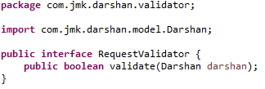

DarshanRequestValidator implements RequestValidator where we are validating the darshan request:

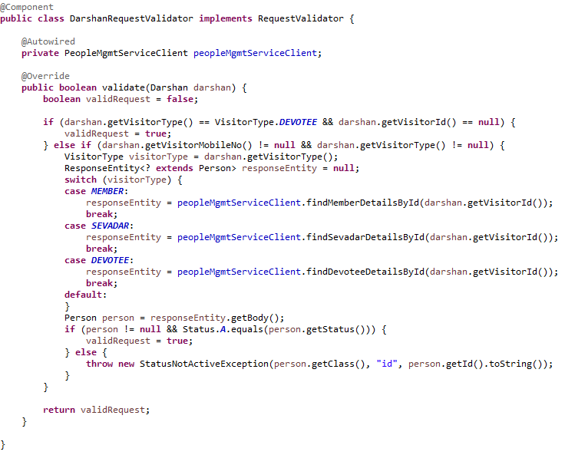

* Create VisitorCreator class to create the donor by invoking the people-mgmt-service using feign client.

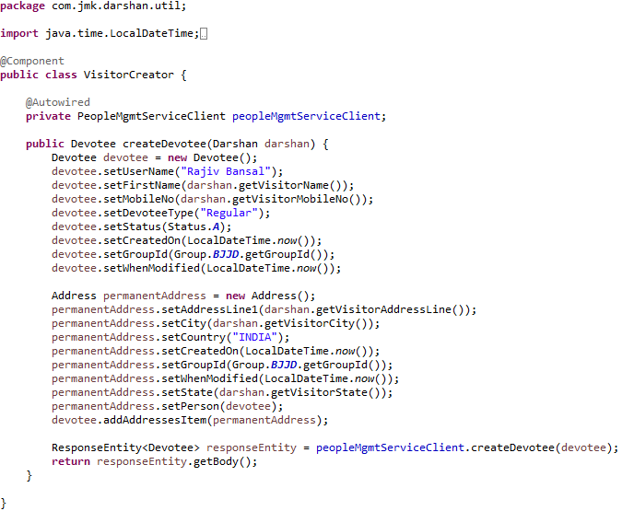

* DarshanMgmtService and DarshanMgmtServiceImpl Class should be exposed as following:
* DarshanMgmtService interface

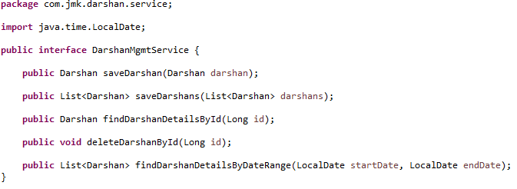

* DarshanMgmtServiceImpl interface

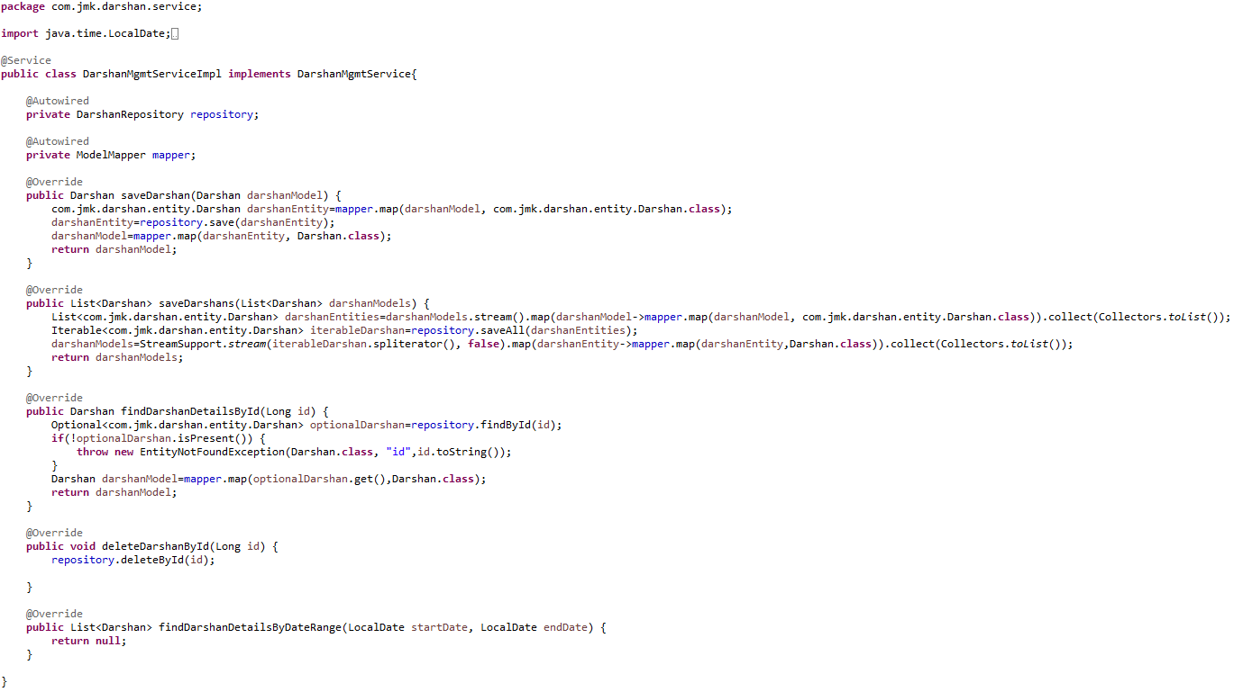

* Made changes in the hightlighted yellow in SwaggerDocumentationConfig

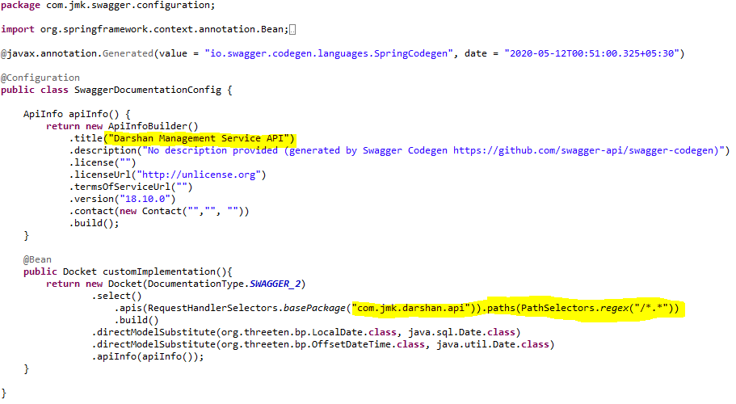

* Made changes in the Swagger’s HomeController

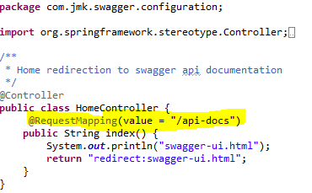

* After running the application, should be visible following functions for the following url: <http://localhost:4379/api/darshan-mgmt-service/swagger-ui.html>

Or

<http://localhost:4379/api/darshan-mgmt-service/api-docs>

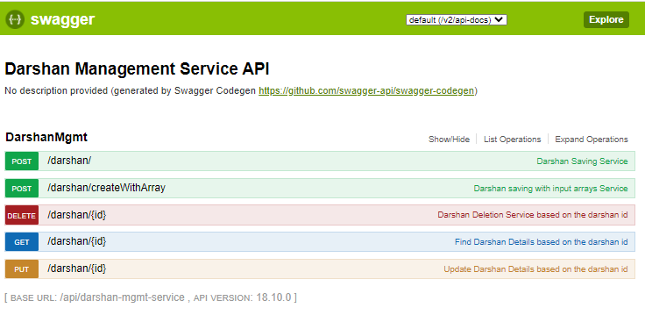

* Test the DarshanApiTest using Junit

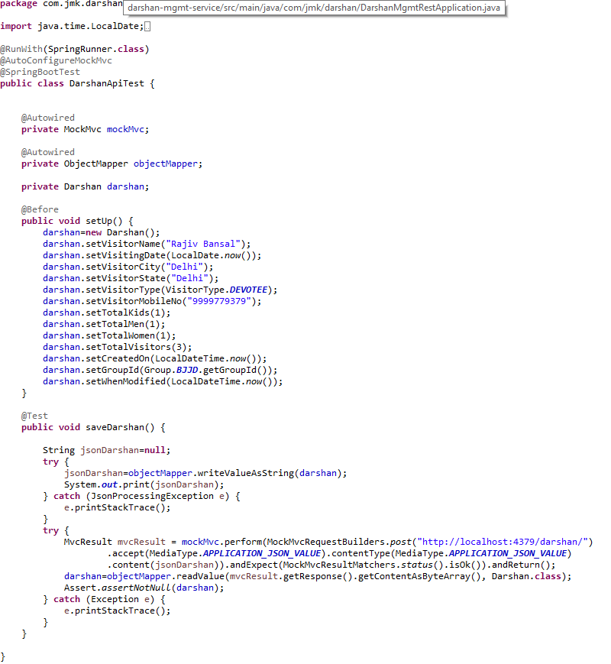

* Run the application as **Spring Boot App** in the following order
  + ConfigServerApplication
  + EurekaServerApplication
  + UserMgmtRestApplication
  + AuthServiceApplication
  + ZuulGatewayApplication
  + PeopleMgmtRestApplication
  + DarshanMgmtRestApplication
* Open the browser of Eureka Server at localhost:8761, you should see the all the microservices running and enter the url: <http://localhost:8761/>

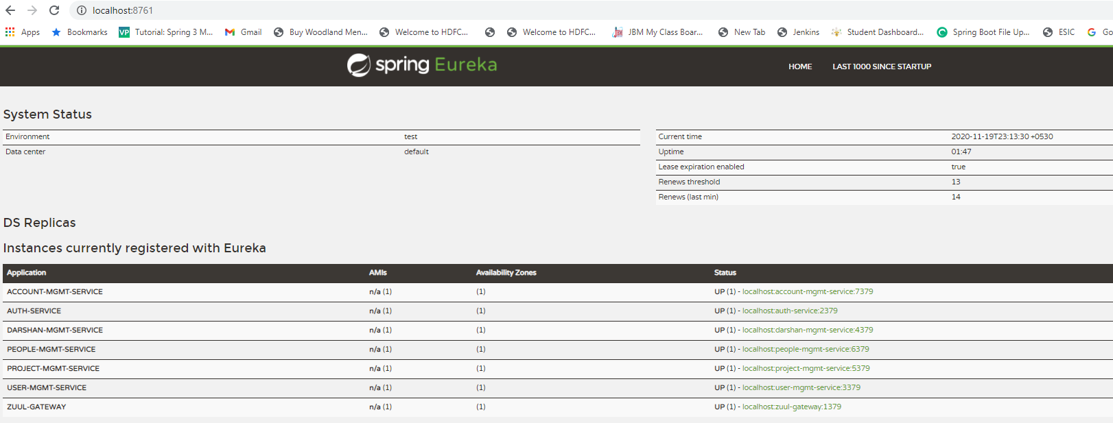

* Testing
  + Without authentication means directly hitting the darshan-mgmt-service running on 4379 and save the darshan details

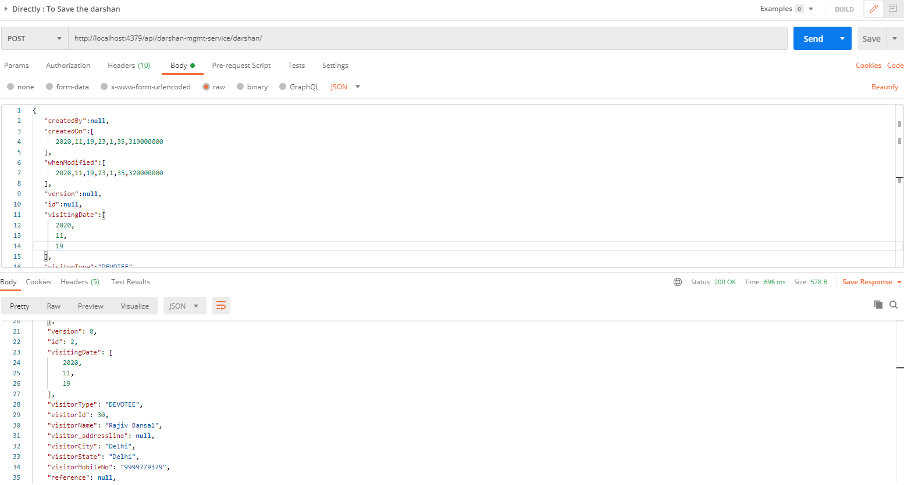

* + With authentication means every request to darshan-mgmt-service microservice will be hit via gateway running 1379
    - with authentication means every request to darshan-mgmt-service microservice will be hit via gateway running on 1379
      * saving darshan details based on the id but without token means no authorization code (Bearer token) in the header will give the error.

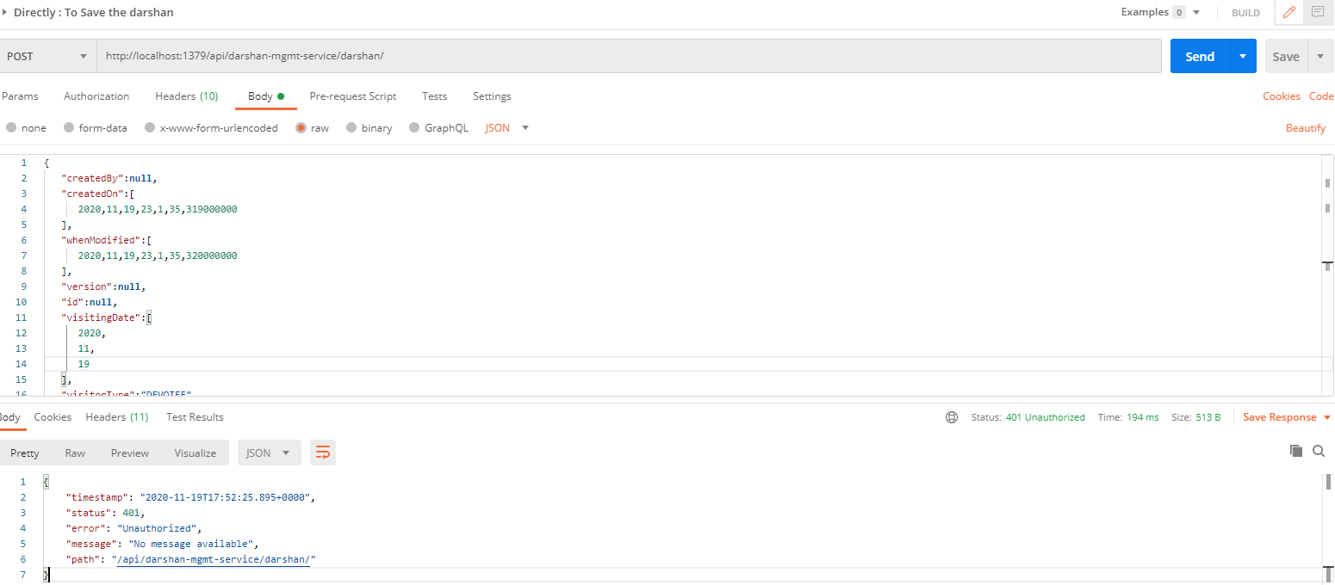

* Saving darshan with token means authorization code (Bearer token) in the header will be provided using authentication service
  + 1. **To get authentication code in response header using authentication service**

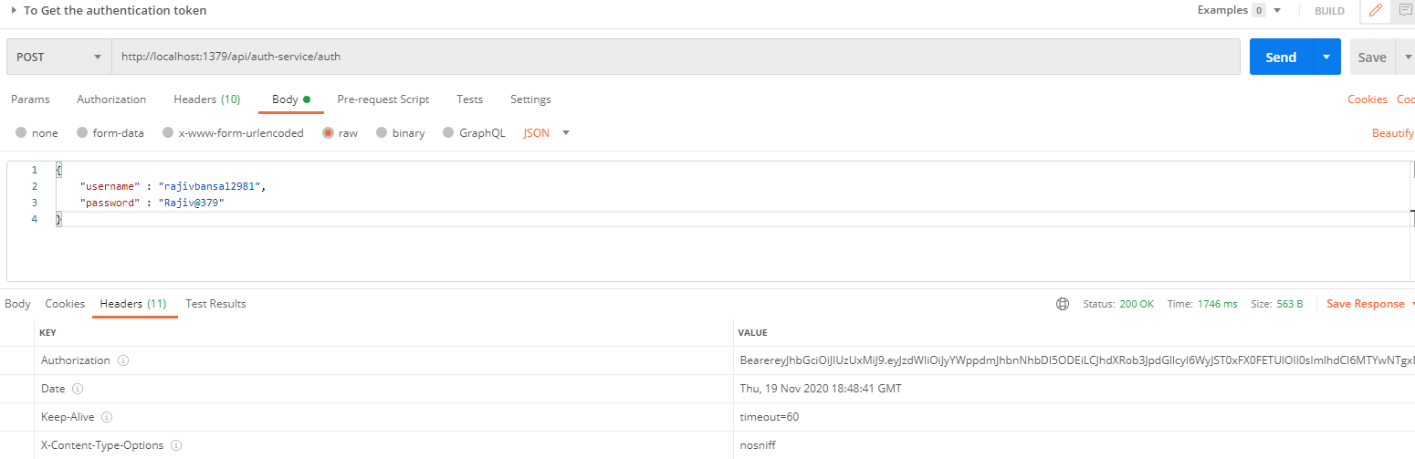

* + 1. **Now hit the darshan-mgmt-service to** save the donation by providing the token means authorization code (Bearer token) in the header received in above step
  + See the **Authorization** tab in the darshan request

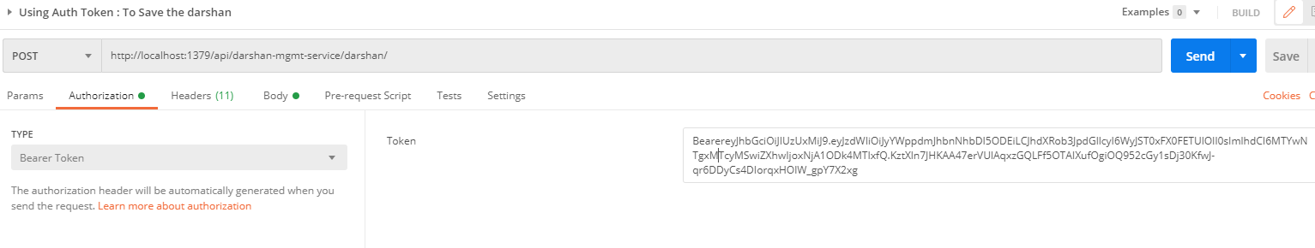

* + See the **Body** tab in the darshan request and response can be seen.

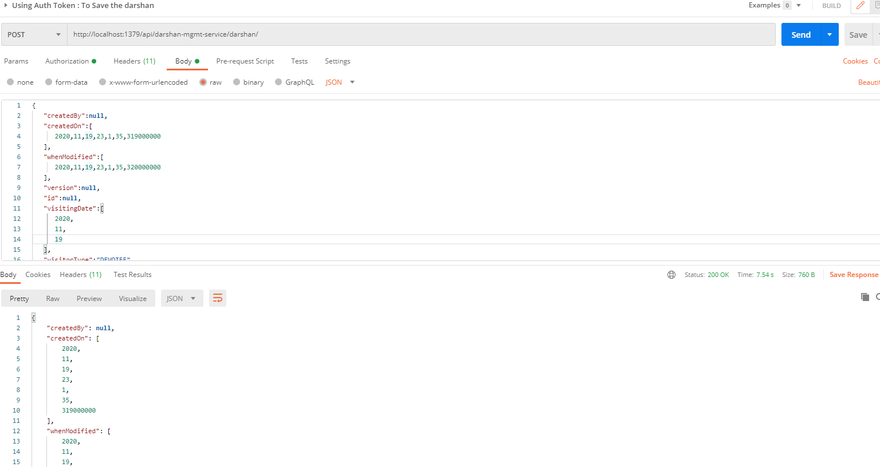

## **Data-Upload-Service**

This service will upload the data in bulk for Donations, Expenses, Darshan, Member, Devotee etc. in different format and call the appropriate microservice to save the data.

* Create the Project using spring Starter Project.



* Click on Next and select the Spring Web Module.

## 

* Click on Finish and import the project.



* Add the following dependencies in pom.xml with the following considerations:
  + Spring Cloud Starter Config: This dependency is required to connect to the Config Server
  + Spring Boot Starter Parent: update the version: 2.2.4.RELEASE highlighted in yellow colour.
  + Spring Cloud version: upgraded to Hoston.SR4. It is highlighted in yellow colour.
  + Excel File Processing API: used org.apache.poi API.
  + Cache-service and common-service: used internally created API: cache-service(to be discuss in next section) to cache the reference entities and common-service to use the model and utility classes.
  + Maven Jar Plugin Version: After the above updates, pom is giving compiler error in pom.xml so downgraded version of maven jar plugin to 3.1.1. It is highlighted in yellow colour.

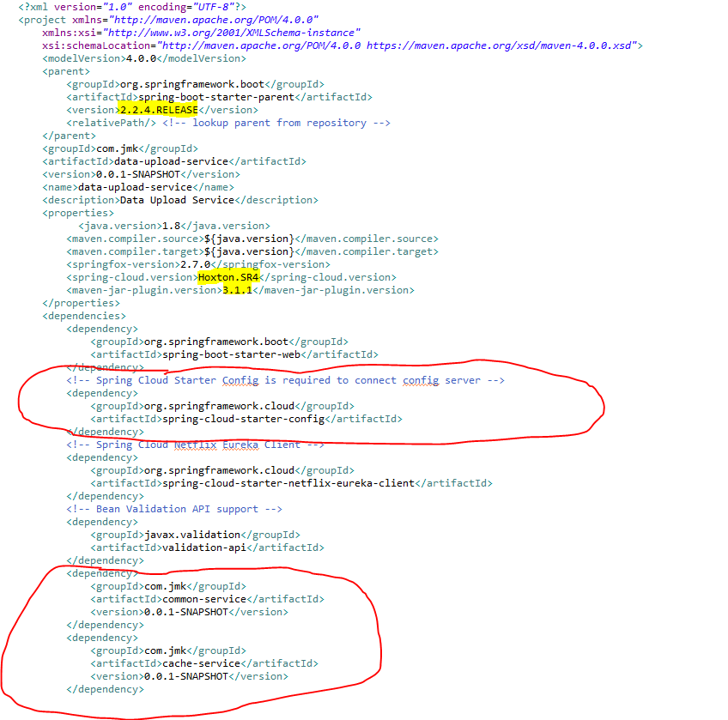

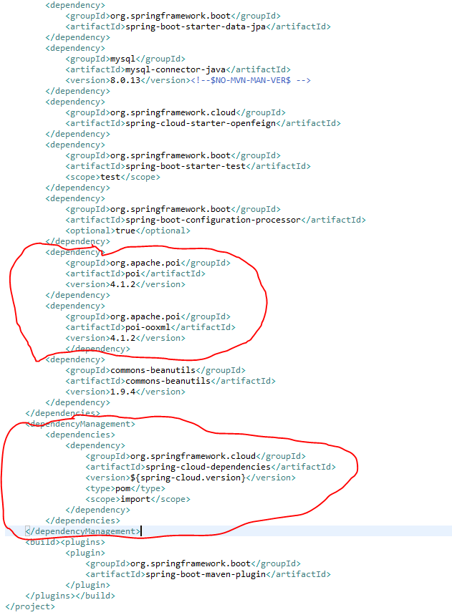

* **Update the main DataUploadServiceApplication application with the following details:**

1. Enable Eureka Client so that it can register with Eureka Server
2. Enable FeignClient to interact with people-mgmt-service, account-mgmt-service and project-mgmt-service
3. Enable JpaRepositories to store the data upload history.
4. To enable the ConfigurationProperties feature, you need to add [@EnableConfigurationProperties](https://docs.spring.io/spring-boot/docs/current/api/org/springframework/boot/context/properties/EnableConfigurationProperties.html) annotation to any configuration class.

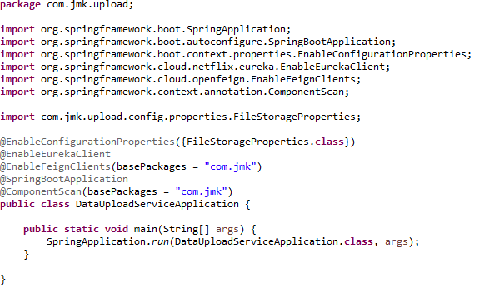

* Configuring Server and File Storage Properties

**First thing First!**

* + Let’s configure our Spring Boot application to enable Multipart file uploads, and define the maximum file size that can be uploaded. We’ll also configure the directory into which all the uploaded files will be stored.
  + Add the eureka client properties so that it can register with Eureka Server
  + Enable the feign client properties so that we can communicate with different microservices.

Open src/main/resources/application.properties file, and add the following properties to it.

* Moved the following main application.properties along with different profiles to git repository: **bjjd-config-server-git-repo**

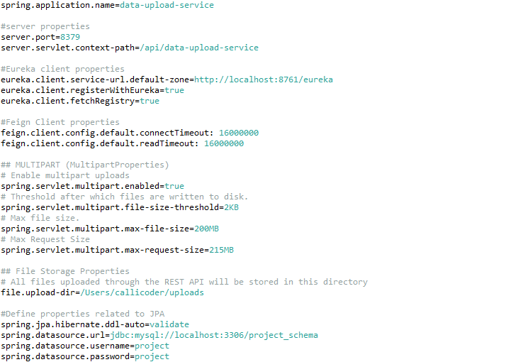

* In this application, still there will be an application.properties file but it will have the following minimum details:
  + Name of the application
  + Active Default Profile
  + Cloud Config server URI with port

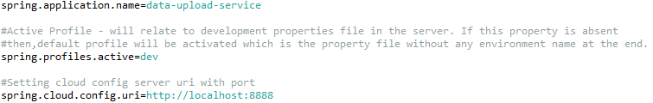

* **Automatically binding properties to a POJO class**

Spring Boot has an awesome feature called [@ConfigurationProperties](https://docs.spring.io/spring-boot/docs/current/reference/html/boot-features-external-config.html" \l "boot-features-external-config-typesafe-configuration-properties) using which you can automatically bind the properties defined in the application.properties file to a POJO class.

Let’s define a POJO class called FileStorageProperties to bind all the file storage properties.



The @ConfigurationProperties(prefix = "file") annotation does its job on application startup and binds all the properties with prefix file to the corresponding fields of the POJO class.

If you define additional file properties in future, you may simply add a corresponding field in the above class, and spring boot will automatically bind the field with the property value.

* Excel File Template(json format) to upload the excel file data in proper format so that it can be validated and processed. Basic format should be like this: excelSheetTemplate.json



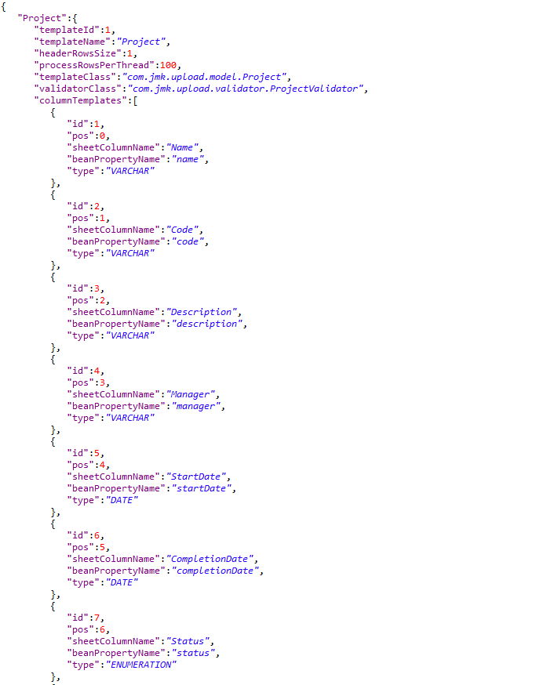

* To handle the data coming in excelFileTemplate we will have two classes:
  + ExcelSheetTemplate.java
  + ColumnTemplate.java
* ExcelSheetTemplate.java

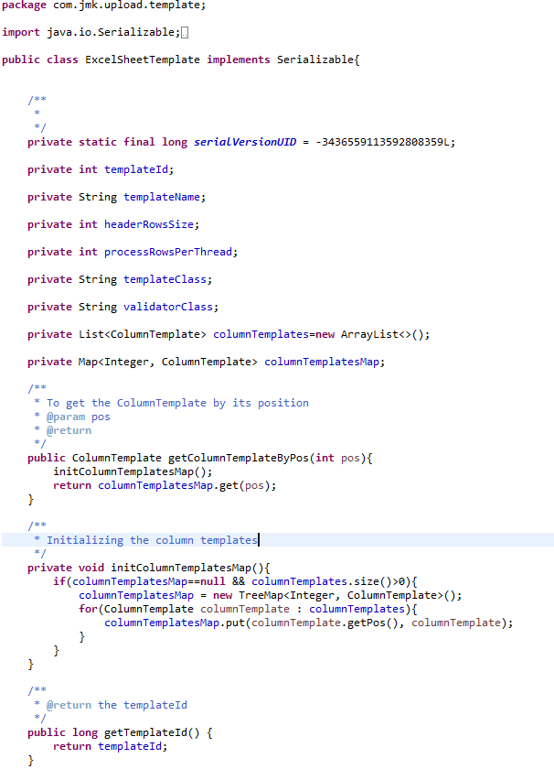

* ColumnTemplate.java

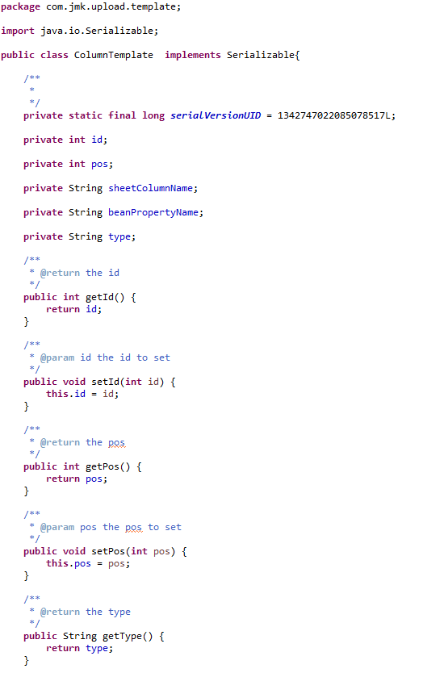

* Read Excel Sheet Template using class: ExcelSheetTemplateReader.java

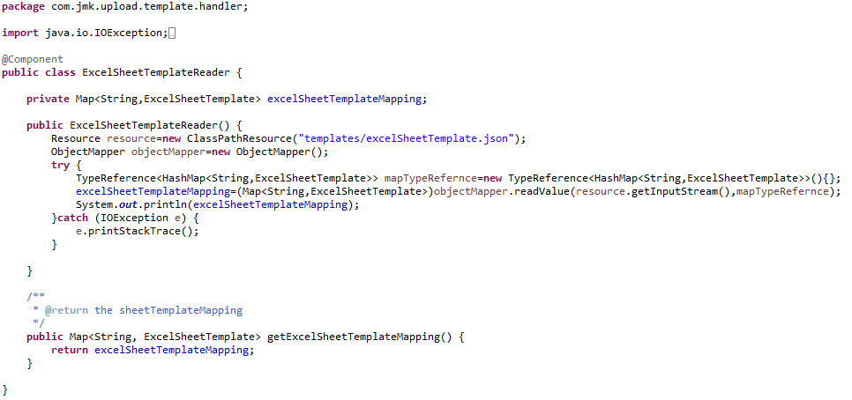

* Write REST FileUploadController to upload the single or multiple excel files from UI (Browser or Application).

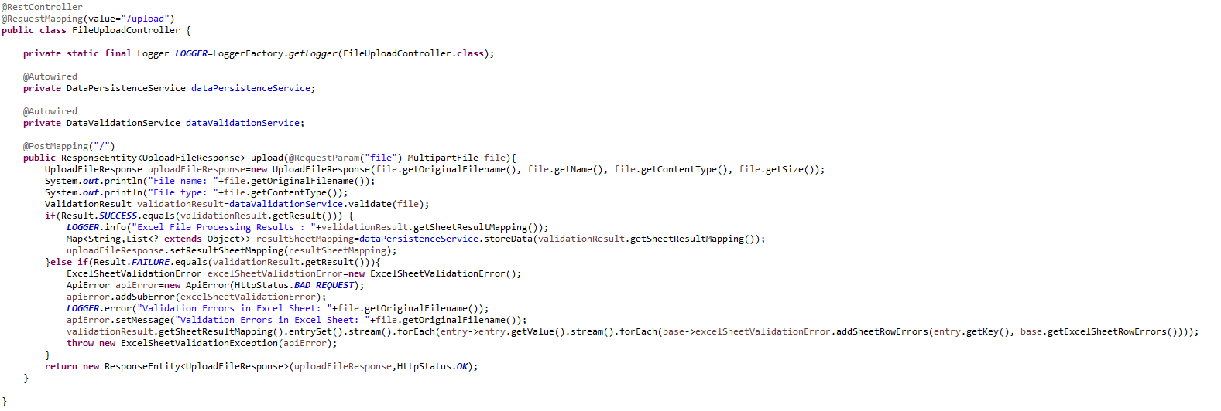

* DataValidationService Interface and its implementation class DataValidationServiceImpl to validate the uploaded excel file.
  + DataValidationService.java

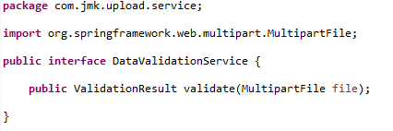

* DataValidationServiceImpl.java

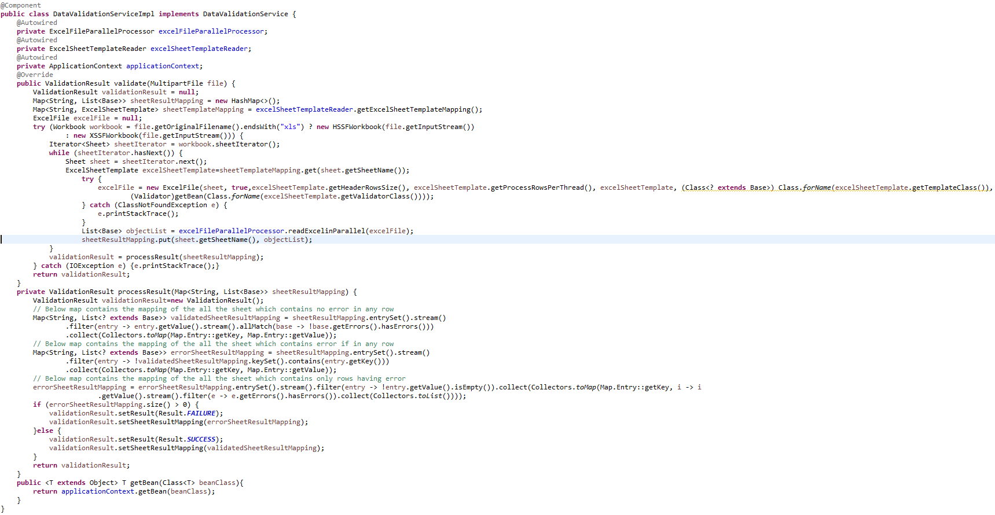

* ExcelFileParallelProcessor to process the excel file by reading the excelfile using ExcelFileReader in parallel using multithreading: ExecutorService

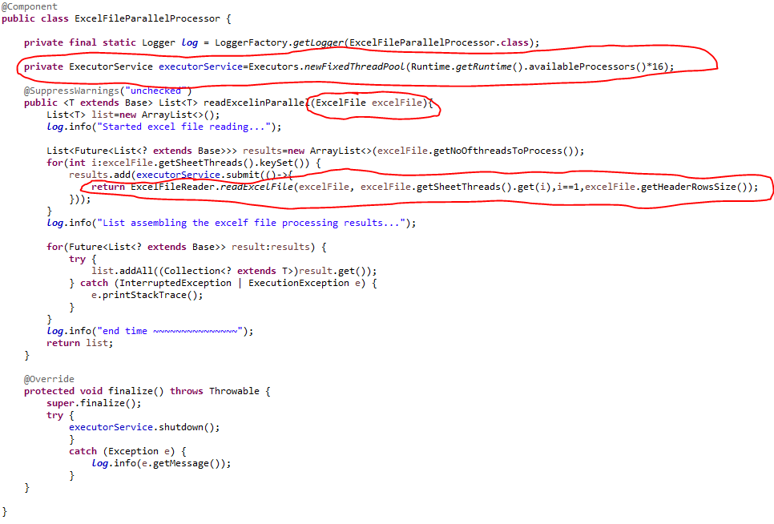

* ExcelFileReader to read the excel file

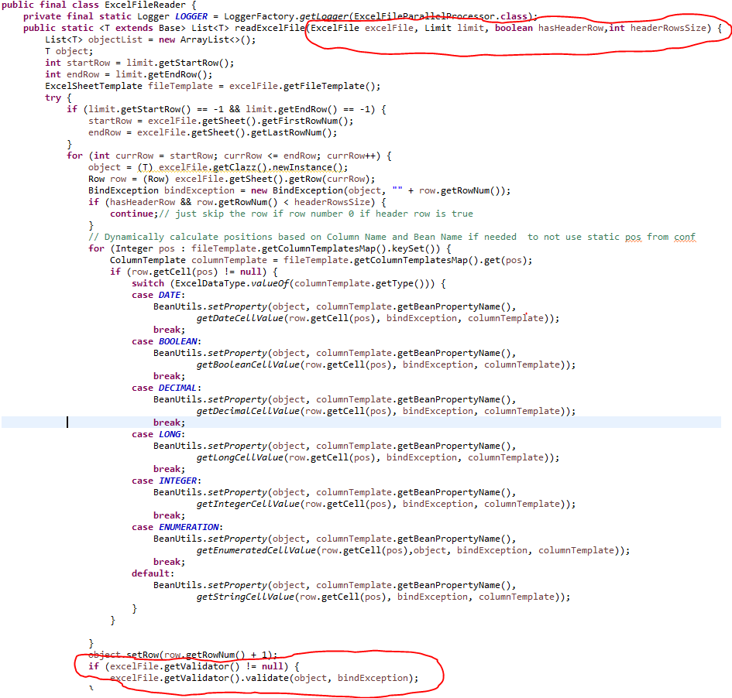

* ExcelFileReader will use ExcelFile object to read the object: ExcelFile.java

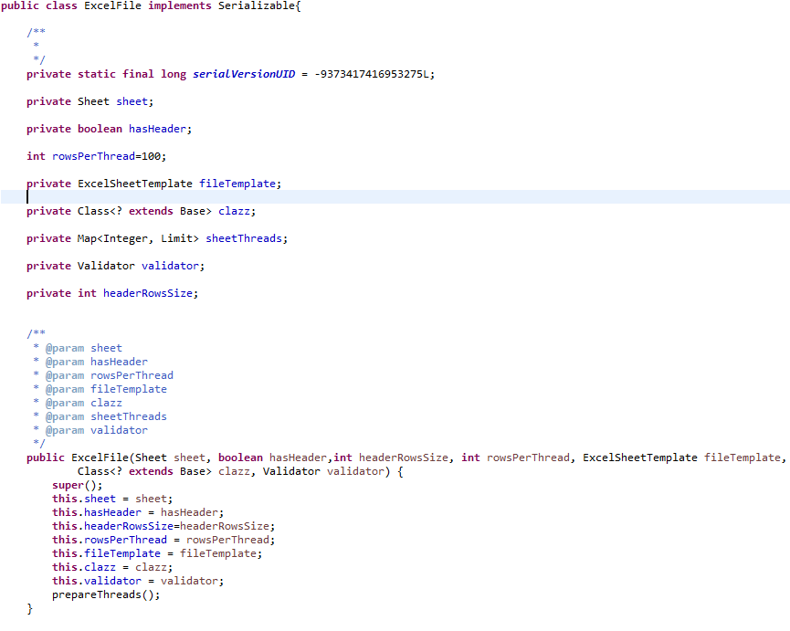

* ExcelFileReader will use the following validators and many more in future to validate the data after reading the excel file.
  + DonationValidator
  + ExpenseValidator
  + ProjectValidator
    - DonationValidator

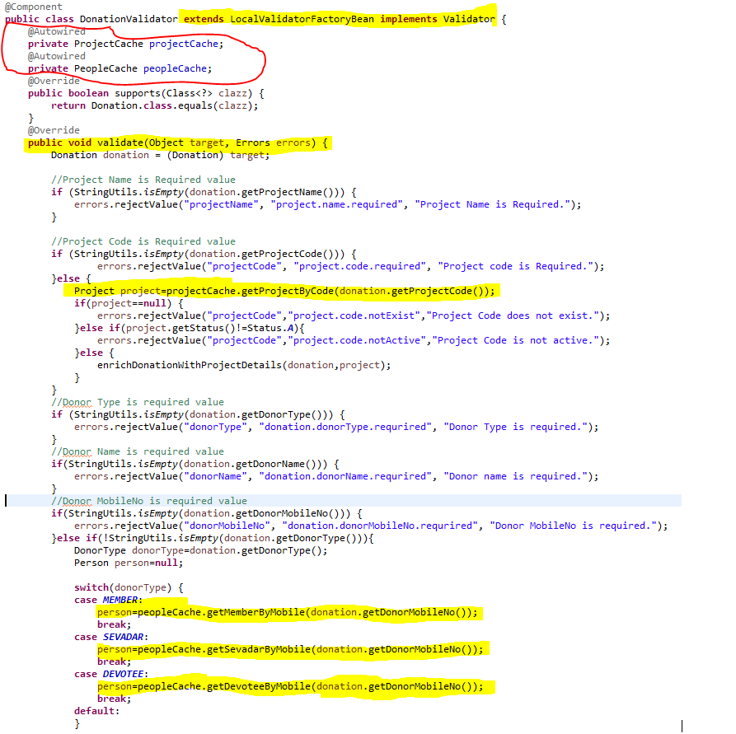

* + - ExpenseValidator

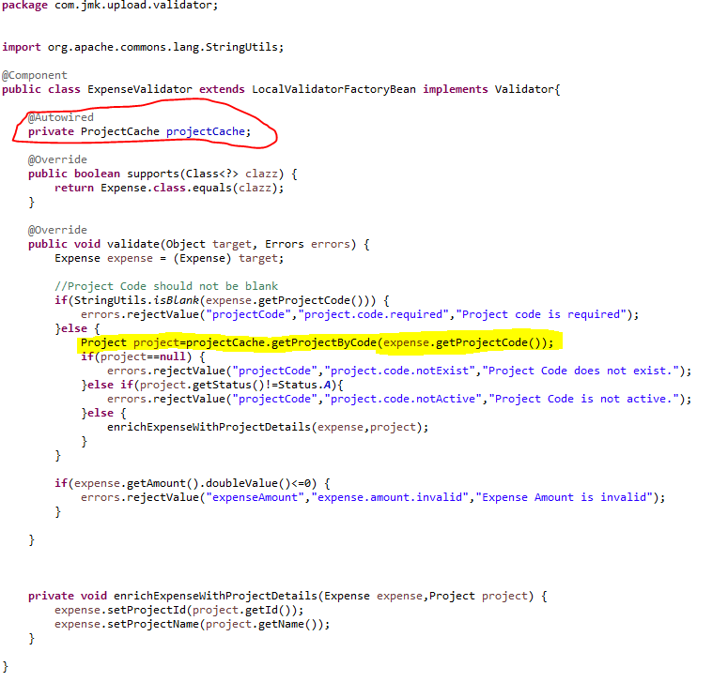

* + - ProjectValidator

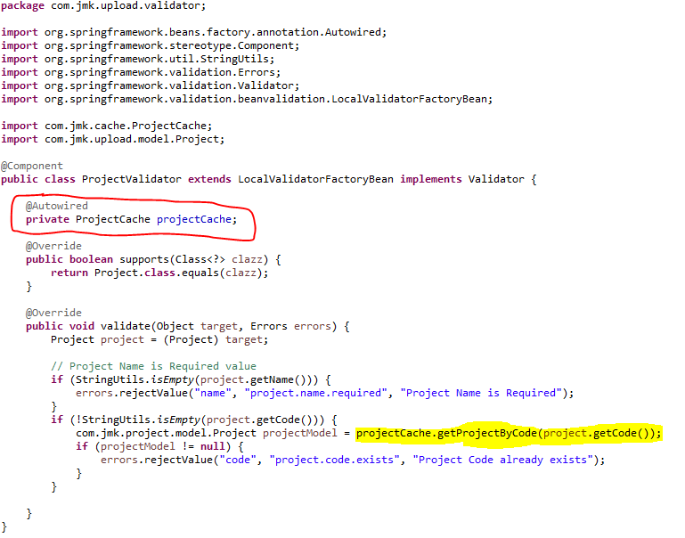

* To store the Validation result, used the ValidationResult class

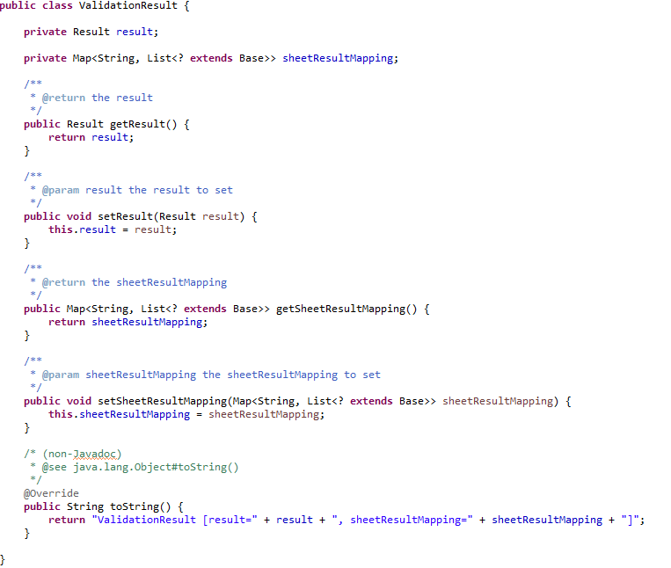

* **DataPersistenceService: Save the excel file data after successfully validating the excel file**
* DataPersistenceService

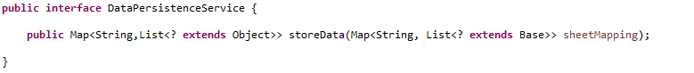

* DataPersistenceServiceImpl

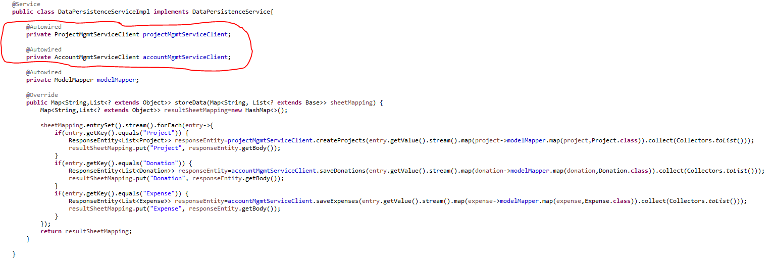

* **FeignClient to interact with other microservices to save the data.**
* ProjectMgmtServiceClient
* AccountMgmtServiceClient
  + ProjectMgmtServiceClient

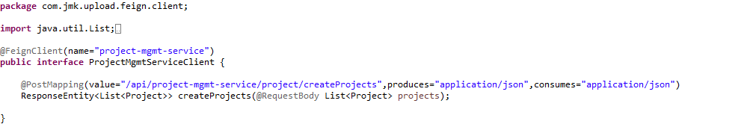

* + AccountMgmtServiceClient

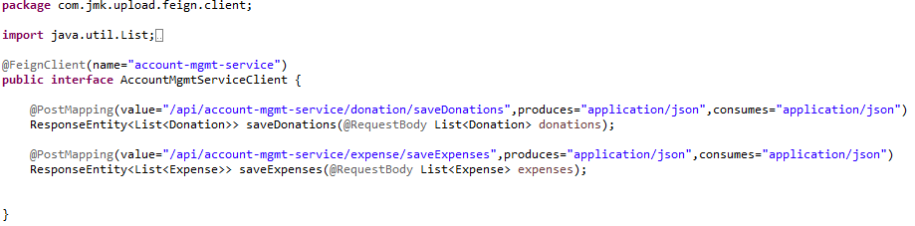

* + **To send the result to the client, use UploadFileResponse class**

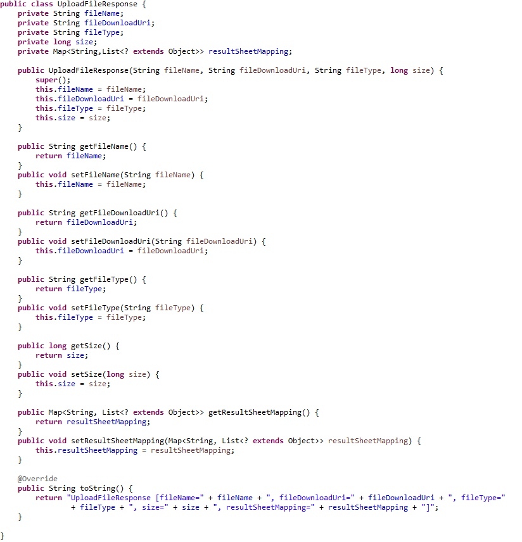

* Run the application as **Spring Boot App** in the following order
  + ConfigServerApplication
  + EurekaServerApplication
  + UserMgmtRestApplication
  + AuthServiceApplication
  + ZuulGatewayApplication
  + PeopleMgmtRestApplication
  + ProjectMgmtRestApplication
  + AccountMgmtRestApplication
  + DataUploadServiceApplication
* Open the browser of Eureka Server at localhost:8761, you should see the all the microservices running and enter the url: <http://localhost:8761/>

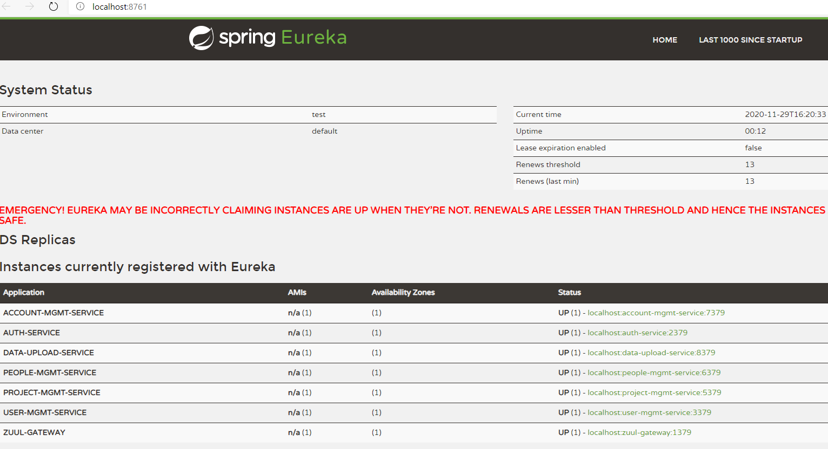

* Testing
  + Without authentication means directly hitting the data-upload-service running on 4379 and save the darshan details

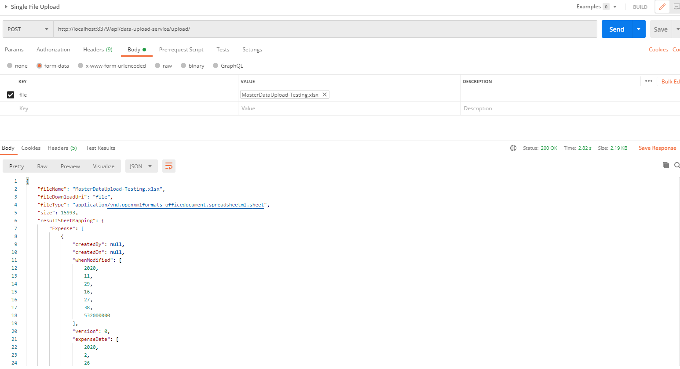

* + With authentication means every request to data-upload-service microservice will be hit via gateway running 1379
    - with authentication means every request to data-upload-service microservice will be hit via gateway running on 1379
      * uploading the data but without token means no authorization code (Bearer token) in the header will give the error.

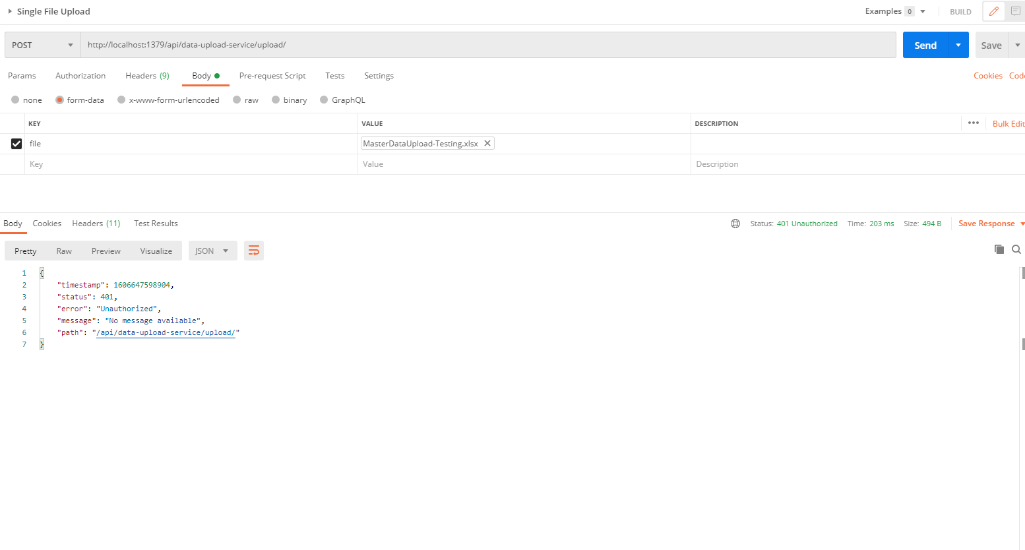

* Uploading file with token means authorization code (Bearer token) in the header will be provided using authentication service
  + 1. **To get authentication code in response header using authentication service**

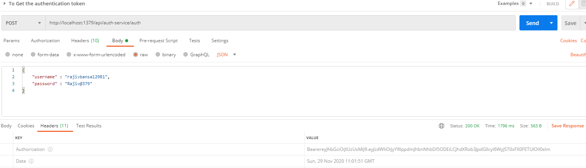

* + 1. **Now hit the** data-upload-service **to** upload the file by providing the token means authorization code (Bearer token) in the header received in above step
  + See the **Authorization** tab in the darshan request

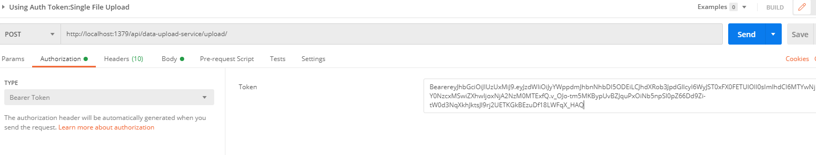

* + See the **Body** tab in the darshan request and response can be seen.

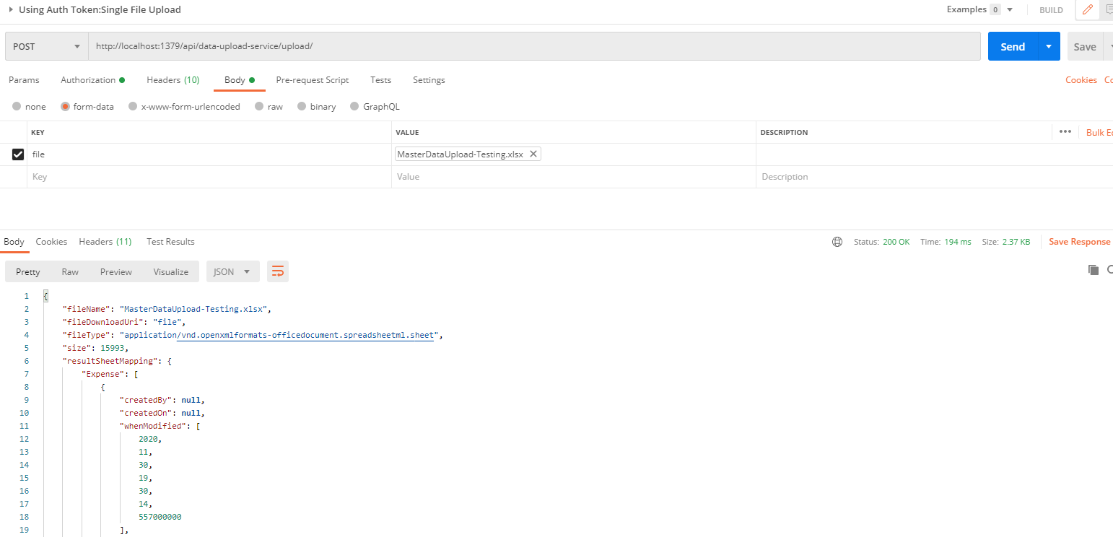

## **Cache Service**

This service will be used by other microservices to cache the reference entities. For example, this service will communicate with the people-mgmt-service, project-mgmt-service and user-mgmt-service using feign client to cache its entities.

Caching is a technique that involves the intermediate storage of data in very fast memory, usually. This means that this data can be made available much more quickly for subsequent requests since it does not have to be retrieved or recalculated from the primary and usually slower memory first.

Ehcache is an open source library implemented in Java for implementing caches in Java programs, especially local and distributed caches in main memory or on the hard disk. Thanks to the implementation of JSR-107, Ehcache is fully compatible with the javax.cache API.

* Create the Project using spring Starter Project.

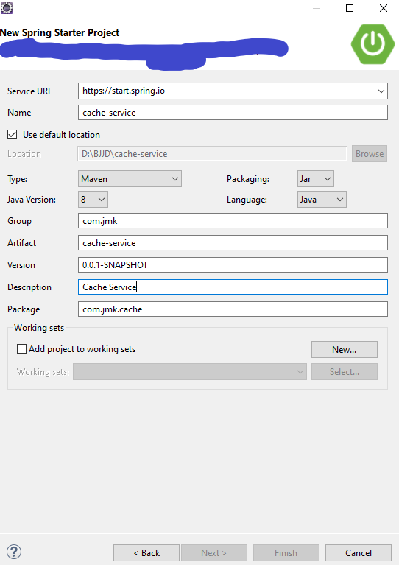

* Click on Next and Finish.
* Import the project.

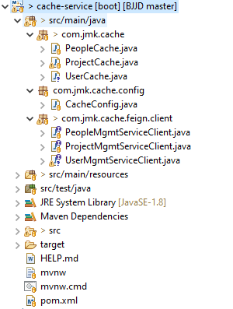

* Add the following dependencies in pom.xml with the following considerations:
  + Spring Boot Starter Parent: update the version: 2.2.4.RELEASE highlighted in yellow colour.
  + Spring Cloud version: upgraded to Hoston.SR4. It is highlighted in yellow colour.
  + Maven Jar Plugin Version: After the above updates, pom is giving compiler error in pom.xml so downgraded version of maven jar plugin to 3.1.1. It is highlighted in yellow colour.
  + Ehcache dependencies-api: ehcache, spring-boot-starter-cache and cache-api used to cache the entities.
  + Fiegn-Client: used to communicate with other microservices.

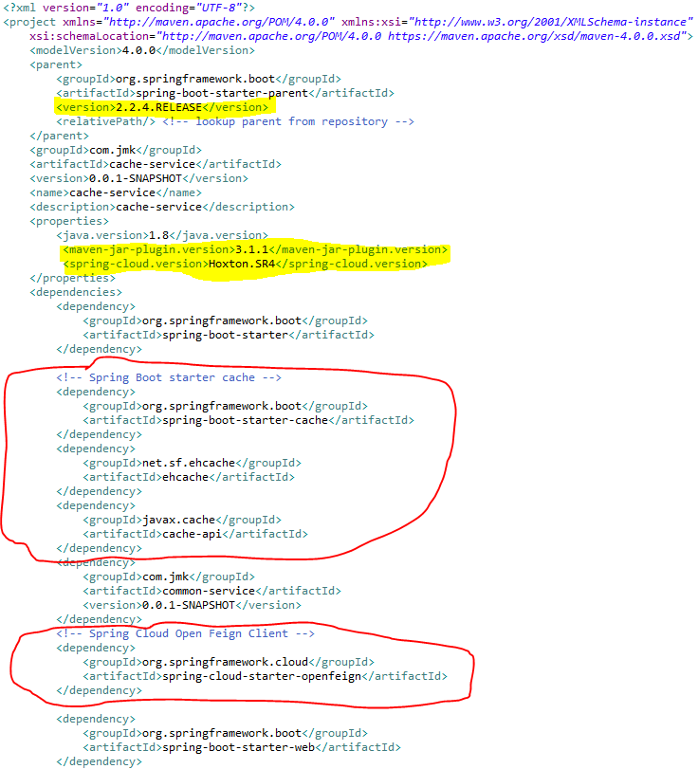

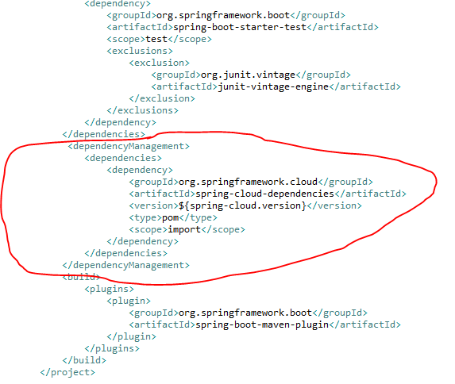

* Make application.properties empty as it is not required and will be referred by other microservices.
* Enable caching: To enable caching support in Spring Boot, we need a simple configuration class that must be annotated with @EnableCaching. Up to this point, we don’t need to do anything more as the following code shows:

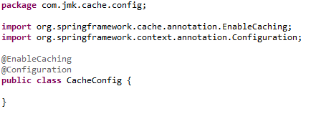

* **Cacheable operations**

Caching in Spring is basically applied to methods so that especially the calls of very costly operations can be reduced. We now want to add the result of this calculation to a cache depending on the radius passed by parameter, so that the calculation does not have to be repeated every time. To do this, we annotate the method with the @Cachable annotation:

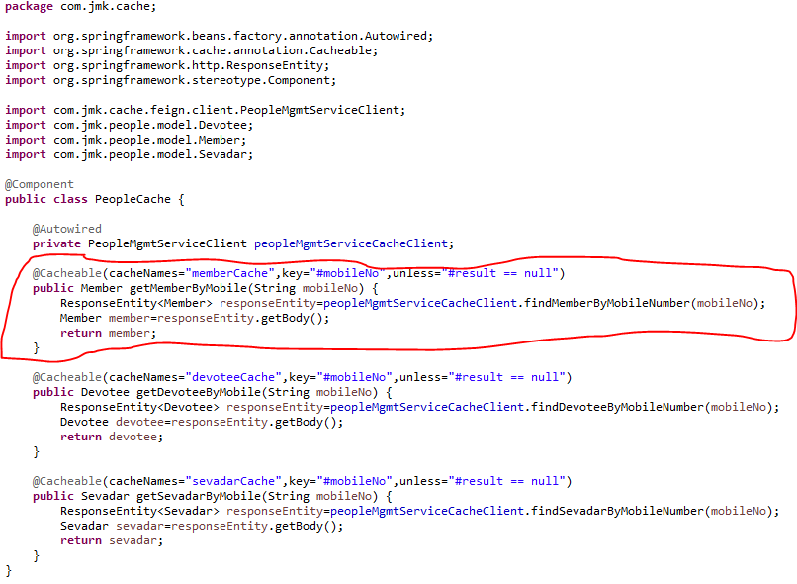

Each time this method is called with a radius greater than 5, the caching behavior is applied. This checks whether the method has already been called once for the specified parameter. If so, the result is returned from the cache and the method is not executed. If no, then the method is executed and the result is returned and stored in the cache.

The following parameters, among others, are available for annotation:

|  |  |
| --- | --- |
| **Annotation parameter** | **Description** |
| value / cacheNames | Name of the cache in which the results of the method execution are to be stored. |
| Key | The key for the cache entries as [Spring Expression Language (SpEL)](https://springframework.guru/introduction-spring-expression-language-spel/" \t "_blank). If the parameter is not specified, a key is created for all method parameters by default. |
| keyGenerator | Name of a bean that implements the KeyGenerator interface and thus allows the creation of a user-defined cache key. |
| Condition | Condition as Spring Expression Language (SpEL) that specifies when a result is to be cached. |
| Unless | Condition as Spring Expression Language (SpEL) that specifies when a result should not be cached. |

**Similar way, we have written cacheable operations for ProjectCache and UserCache**

**Project Cache**

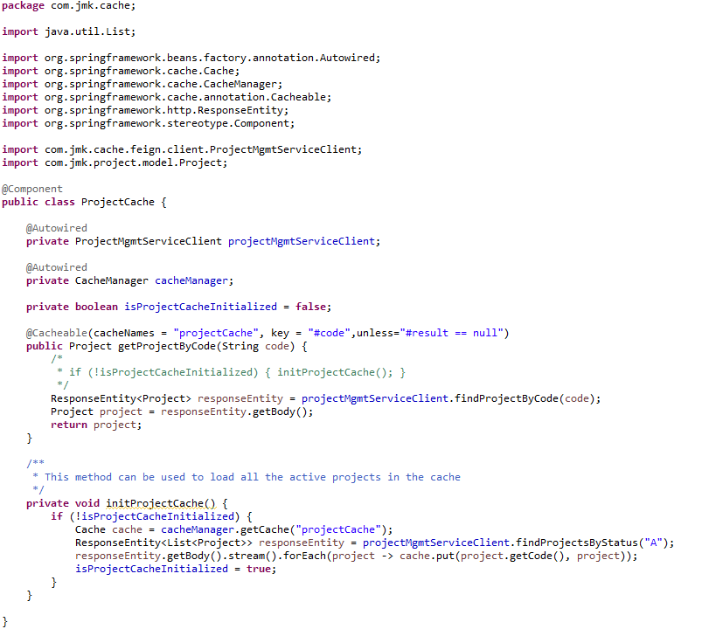

**UserCache**

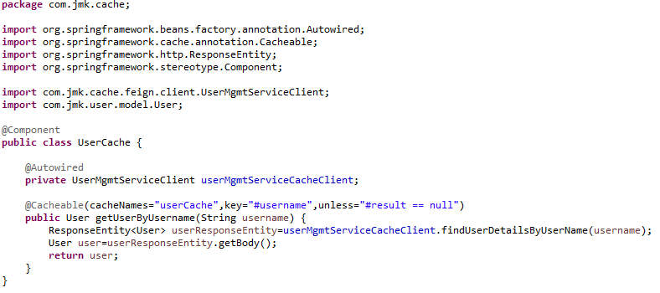

* **Ehcache Cache Configuration**

Now the configuration of the Ehcache cache has to be done. The configuration is XML-based. We create the XML file ehcache.xml in the resource folder of our application.

ehcache.xml is the configuration file used to configure the cache of entities.

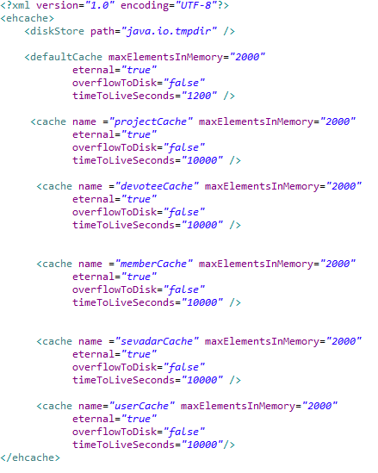

* Feign Client is being used to cache entities.
  + **FeignClient: ProjectMgmtServiceClient**

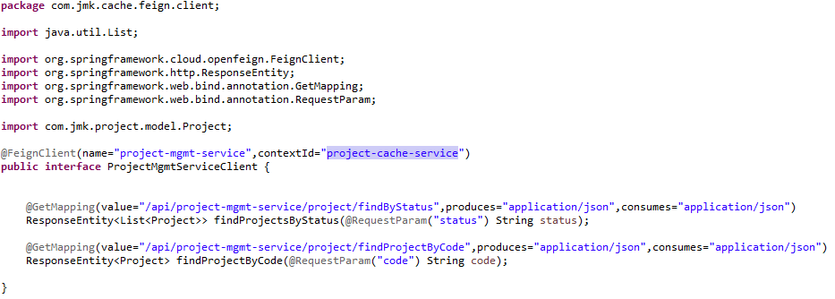

* + **FeignClient: PeopleMgmtServiceClient**

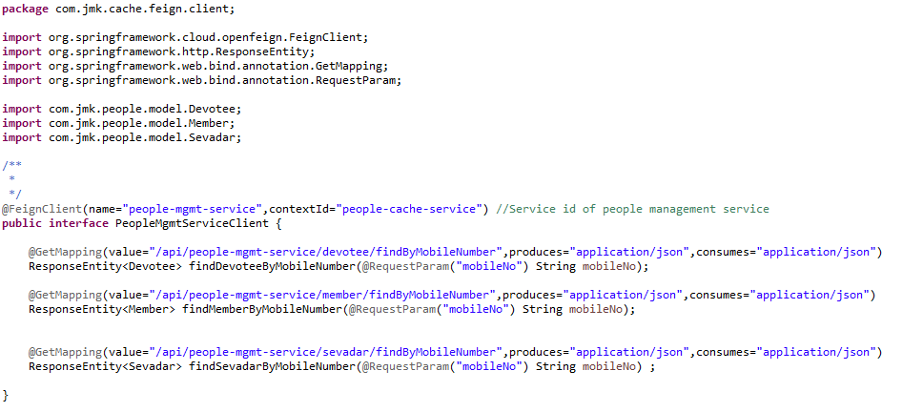

* + **FeignClient: UserMgmtServiceClient**

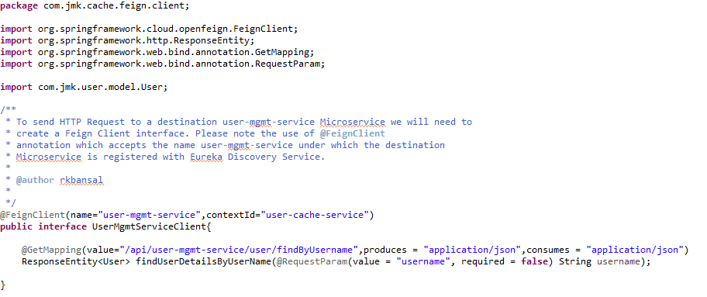

* **How to use the Cache in other projects.**

For example: darshan-mgmt-service

* + Import the dependency of cache-service

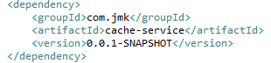

* + Enable the package scan of FeignClient which is used by cache class.

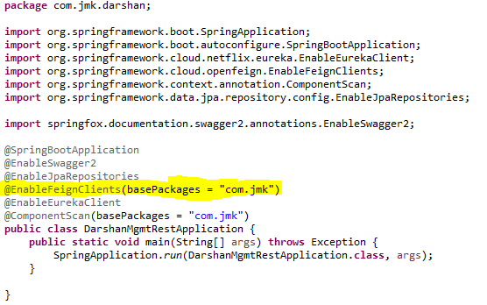

* + **Cache used In DarshanApiController**

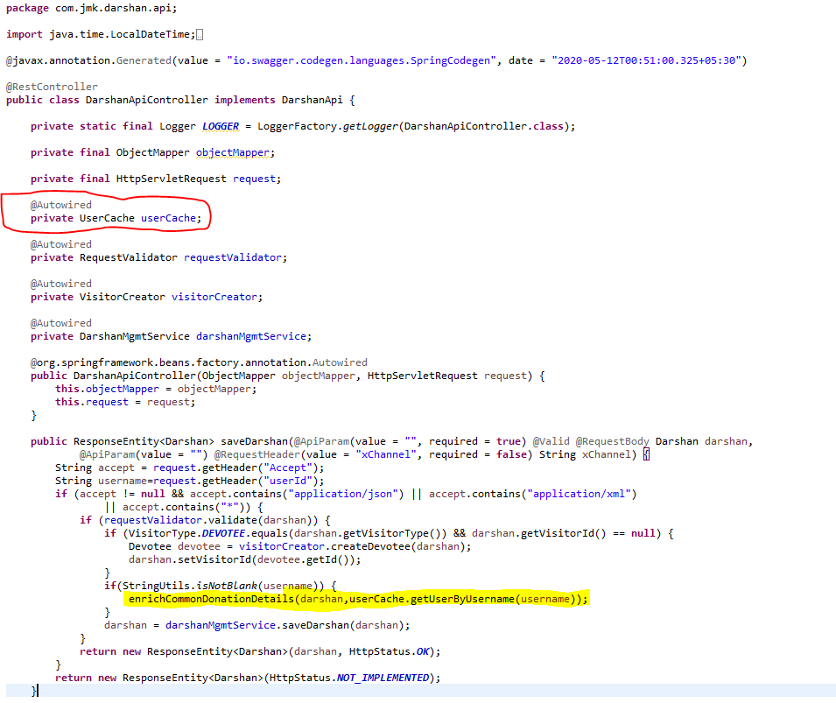

## **Message Sender Service (Kafka)**

**Why Kafka?**

Traditional messaging queues like ActiveMQ, RabbitMQ can handle high throughput usually used for long-running or background jobs and communicating between services.

Kafka is a stream-processing platform built by LinkedIn and currently developed under the umbrella of the Apache Software Foundation. Kafka aims to provide low-latency ingestion of large amounts of event data.

**We can use Kafka when we have to move a large amount of data and process it in real-time**. An example would be when we want to process user behavior on our website to generate product suggestions or monitor events produced by our micro-services.

Kafka is built from ground up with horizontal scaling in mind. We can scale by adding more brokers to the existing Kafka cluster.

**Kafka Vocabulary**

Let’s look at the key terminologies of Kafka:

* **Producer**: A producer is a client that sends messages to the Kafka server to the specified topic.
* **Consumer**: Consumers are the recipients who receive messages from the Kafka server.
* **Broker**: Brokers can create a Kafka cluster by sharing information using Zookeeper. A broker receives messages from producers and consumers fetch messages from the broker by topic, partition, and offset.
* **Cluster**: Kafka is a distributed system. A Kafka cluster contains multiple brokers sharing the workload.
* **Topic**: A topic is a category name to which messages are published and from which consumers can receive messages.
* **Partition**: Messages published to a topic are spread across a Kafka cluster into several partitions. Each partition can be associated with a broker to allow consumers to read from a topic in parallel.
* **Offset**: Offset is a pointer to the last message that Kafka has already sent to a consumer.
* To work with Kafka, need to install and setup Kafka.

1. To download and install Kafka, please refer the official guide [https://kafka.apache.org/quickstart](https://kafka.apache.org/quickstart" \t "_blank) . Click on the following selected link.

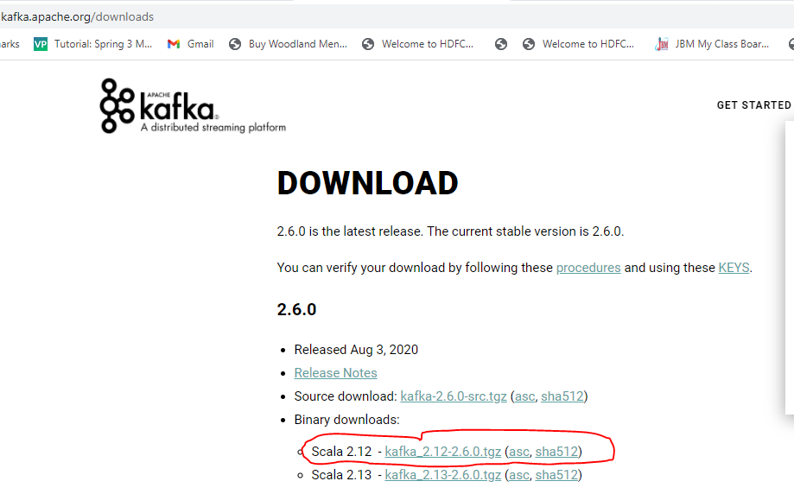

1. Unzip the kafka\_2.12-2.6.0.tgz file.
2. **Create data folder and subfolders: zookeeper and kafka in the main directory: kafka\_2.12-2.6.0**

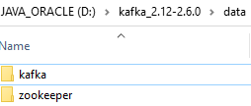

1. **Change the default configuration value**
   1. Update dataDir in zookeeper.properties file located in “D:\kafka\_2.12-2.6.0\config\zookeeper.properties” configuration file.

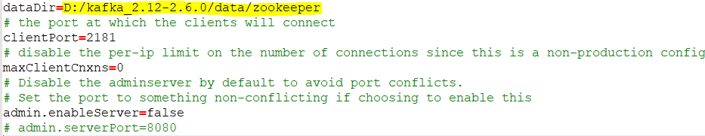

* 1. Update logs.dir in server.properties file located in “D:\kafka\_2.12-2.6.0\config\server.properties” configuration file.

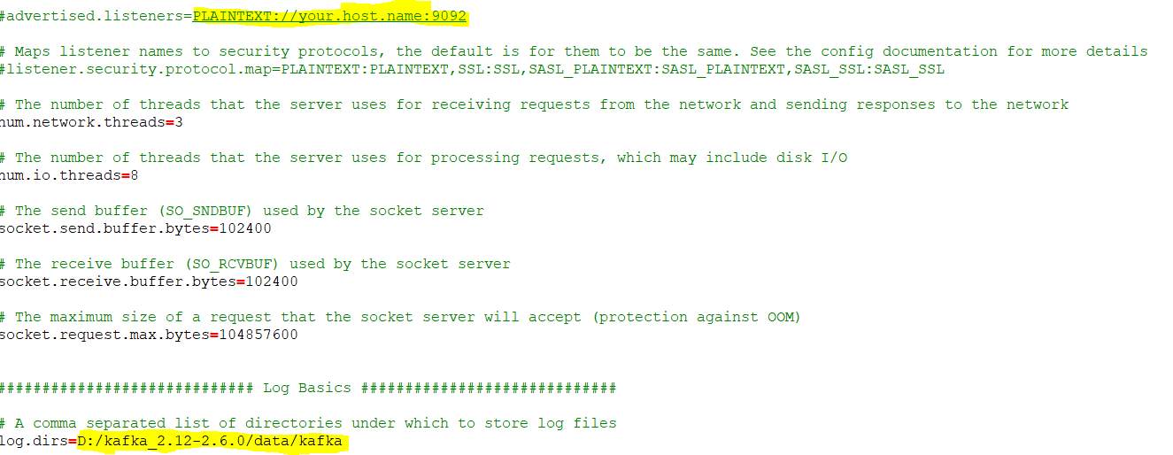

1. **Start Zookeeper**

Now time to start zookeeper from command prompt. Change your directory to **D:\kafka\_2.12-2.6.0\bin\windows** and execute **zookeeper-server-start.bat** command with config/zookeeper.properties configuration file.

D:\kafka\_2.12-2.6.0\bin\windows>zookeeper-server-start.bat ../../config/zookeeper.properties

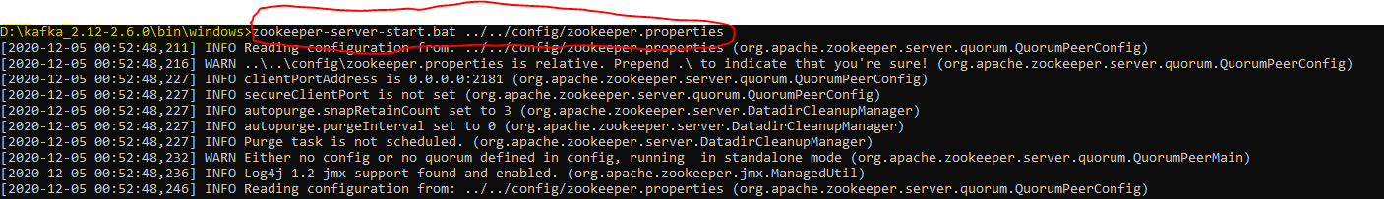

1. **Start Kafka**

Finally time to start Apache Kafka from command prompt. Change your directory to **D:\kafka\_2.12-2.6.0\bin\windows** and run **kafka-server-start.bat**command with kafka config/server.properties configuration file.

D:\kafka\_2.12-2.6.0\bin\windows>kafka-server-start.bat ../../config/server.properties

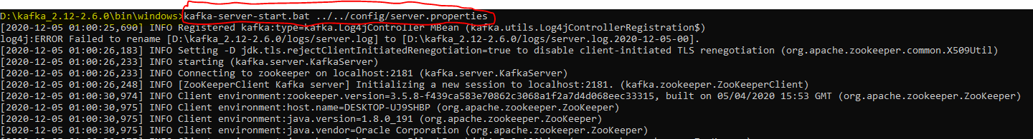

1. Now, by default, the Kafka server starts on localhost:9092.

* Create the Project using spring Starter Project.

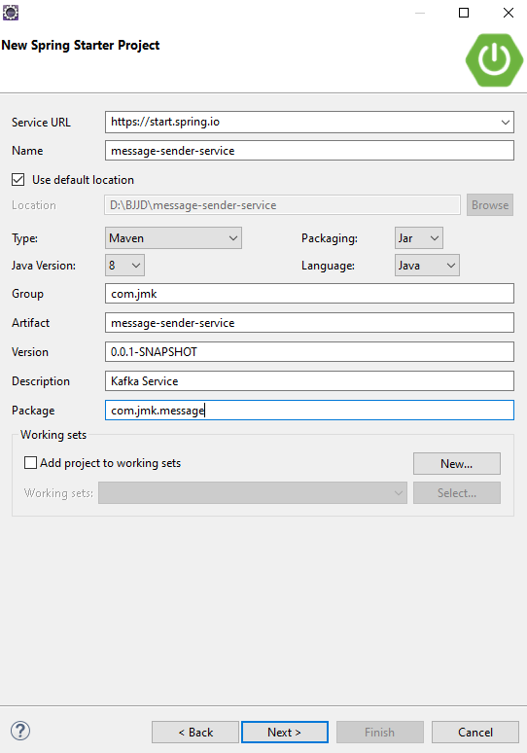

* Click on Next and Finish.

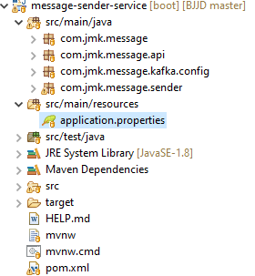

* Import the Project
* Add the following dependencies in pom.xml with the following considerations:
  + Spring Boot Starter Parent: update the version: 2.2.4.RELEASE highlighted in yellow colour.
  + Spring Cloud version: upgraded to Hoston.SR4. It is highlighted in yellow colour.
  + Maven Jar Plugin Version: After the above updates, pom is giving compiler error in pom.xml so downgraded version of maven jar plugin to 3.1.1. It is highlighted in yellow colour.
  + Spring Kafka:  used to publish and subscribe the messages based on the fault-tolerant messaging system.  It is fast, scalable and distributed by design.

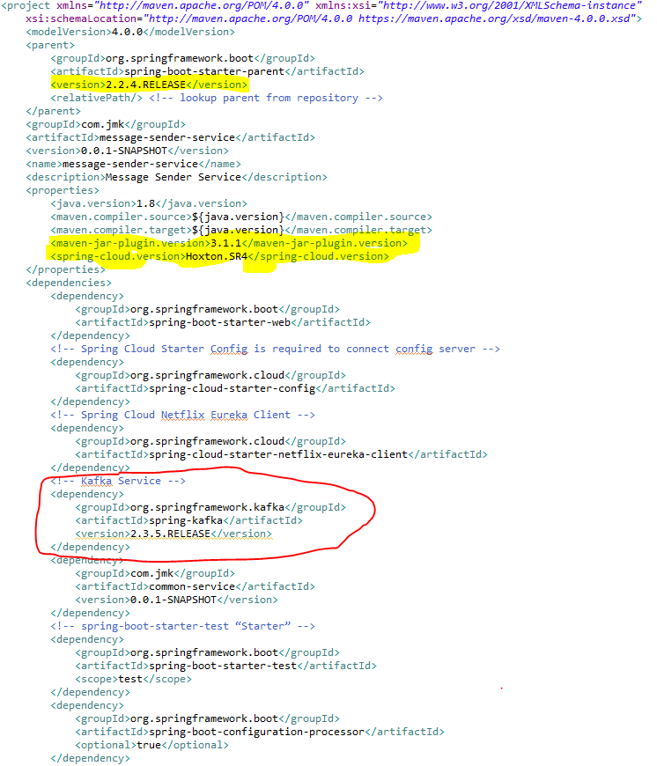

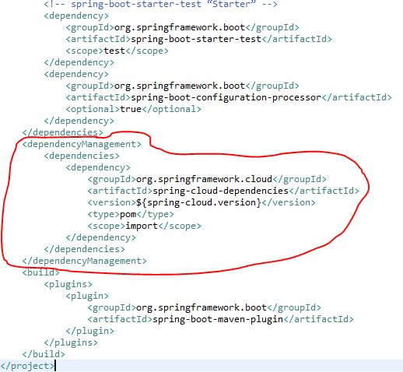

* Update the MessageSenderServiceApplication.java with the following details:
  + Enable Eureka Client so that it can be register with Eureka Server
  + Enable JpaRepositories
  + Enable FeignClient to interact with user-mgmt-service, people-mgmt-service.
  + Enable EnableSwagger2 so that we can view the document api
  + Enable Kafka and Async communication

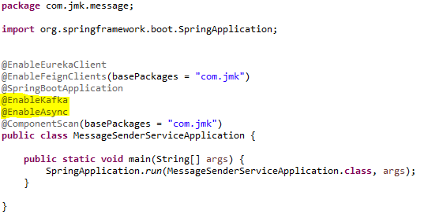

* application.properties : Make application.properties empty as it is not required here and will be referred in other microservices. Will define the properties of spring.kafka in other microservices.
* Spring Boot does most of the configuration automatically, so we can focus on building the listeners and producing the messages. It also provides the option to override the default configuration through application.properties. The Kafka configuration is controlled by the configuration properties with the prefix spring.kafka.\*:

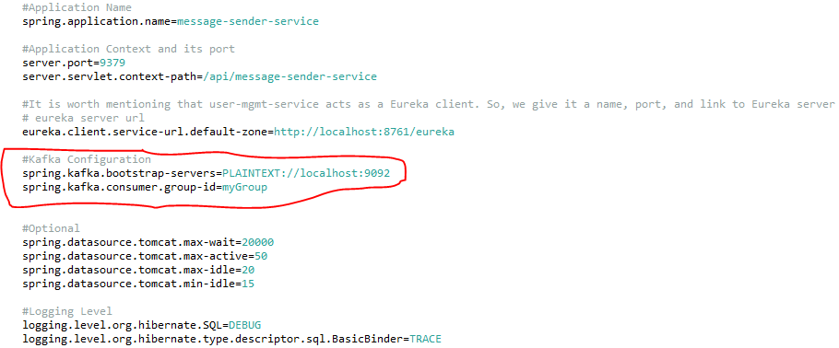

* To split up responsibilities, we have created two projects:
  + Message-sender-service: It is related to pushing the message on the topic using Spring Producer Configuration. i.e. current section going on.
  + Message-consumer-service: It is related to listening the message received on the topic using kafka consumer configuration. It will be the next topic.
* Kafka Message Producer Configuration

Let’s have a look at the producer configuration first.

## **Messaging Consumer Service (Kafka and Twilio)**

This service will send the message to the user using the following medium:

* WhatsApp
* Email
* SMS
* Create the Project using spring Starter Project.

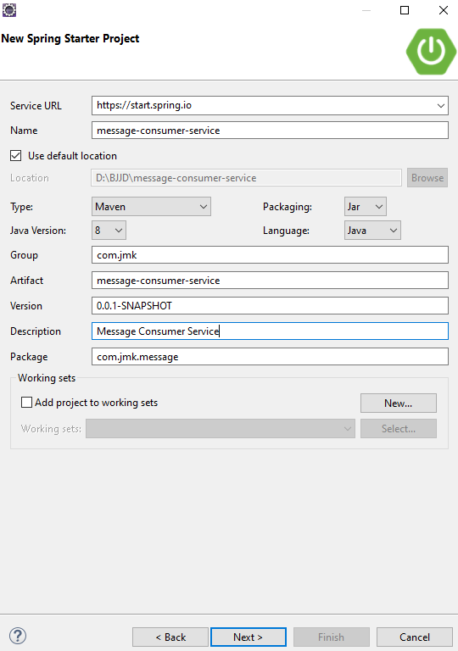

* Click on Next and select the Spring Web Module.

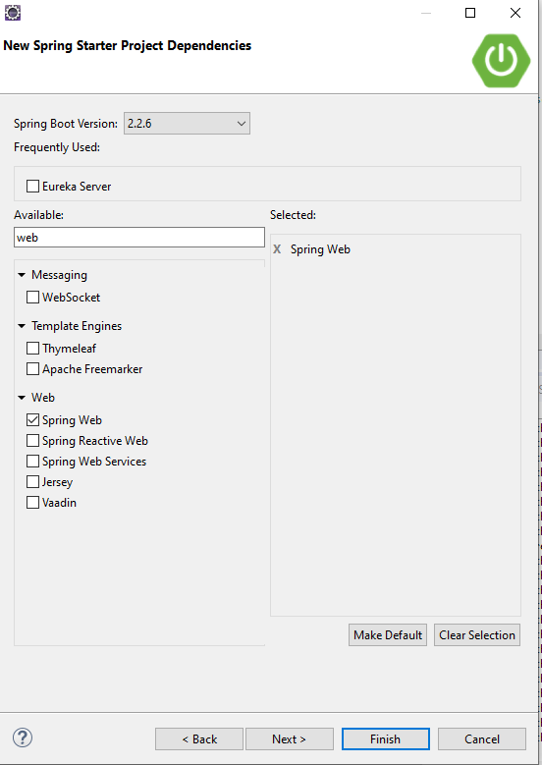

* Click on Finish and import the project.

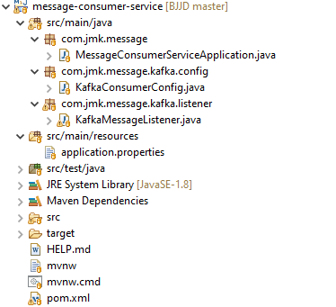

* Import the Project
* Add the following dependencies in pom.xml with the following considerations:
  + Spring Boot Starter Parent: update the version: 2.2.4.RELEASE highlighted in yellow colour.
  + Spring Cloud version: upgraded to Hoston.SR4. It is highlighted in yellow colour.
  + Maven Jar Plugin Version: After the above updates, pom is giving compiler error in pom.xml so downgraded version of maven jar plugin to 3.1.1. It is highlighted in yellow colour.
  + Spring Kafka:  used to publish and subscribe the messages based on the fault-tolerant messaging system.  It is fast, scalable and distributed by design.

## **Get LoggedInUser Details in other microservices**

Please follow the steps to get the user details in other microservices:

* Add pre type Filter in Zuul-gateway application: CurrentUserAuthenticationFilter

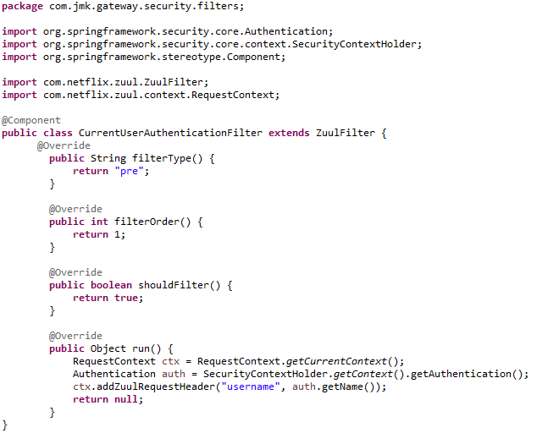

* Now we can retrieve the username by fetching the request header details in any other microservice. And based on the username, we can retrieve the details of user anytime by communicating user-mgmt-service using feign client implemented by cache-service. Please refer cache-service to see the implementation of UserCache and its communication with user-mgmt-service using feign client.

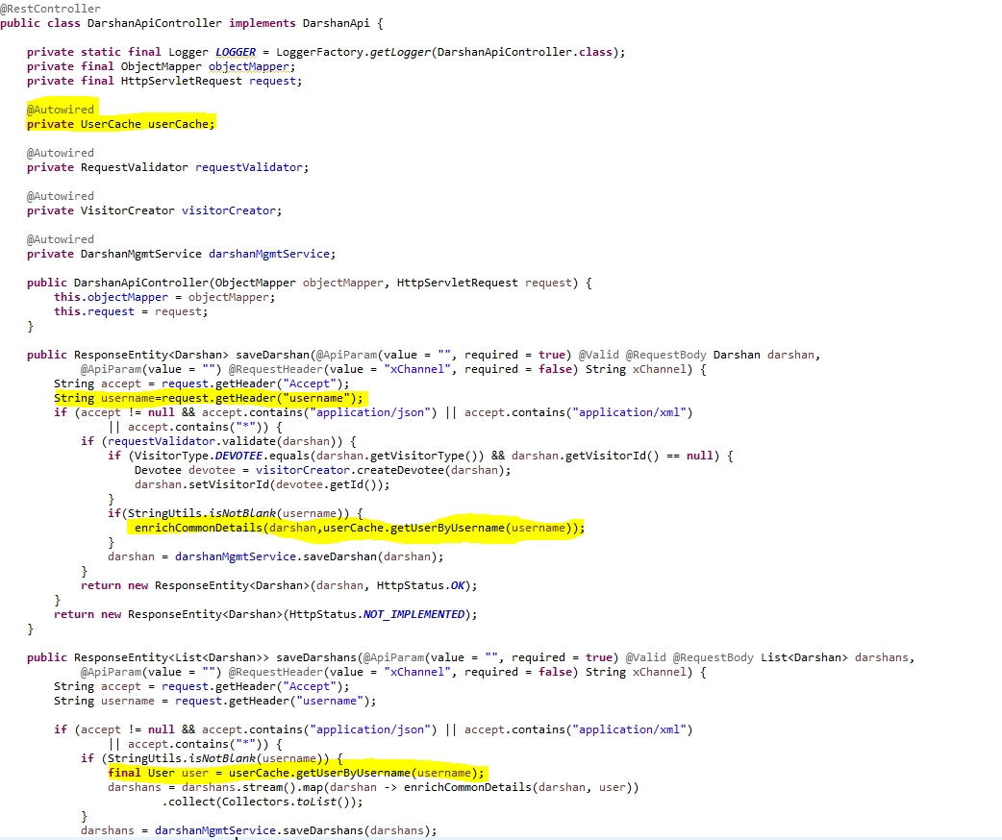

## **Caching using Hazelcast (Embedded Distributed Cache)**

We have used Hazelcast for the embedded distributed cache in our project.

Hazelcast IMDG is a perfect fit for your (micro)services running on Kubernetes since it can be used in the embedded mode and therefore scale in and out together with your service replicas. This blog post presents a step-by-step description of how to embed Hazelcast into a Spring Boot application and deploy it in the Kubernetes cluster.

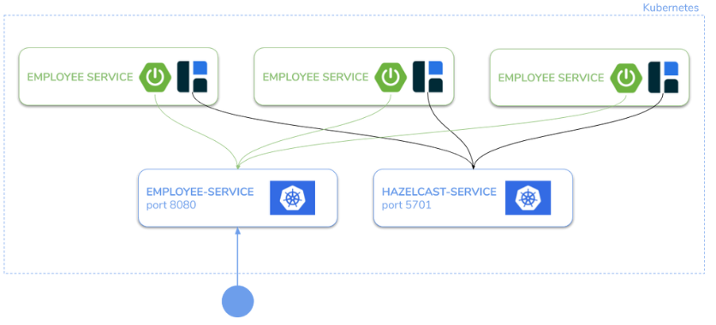

#### **Step 1: Configure Hazelcast to work on Kubernetes**

Make sure you have the following Maven dependencies:

<dependency>

<groupId>com.hazelcast</groupId>

<artifactId>hazelcast-all</artifactId>

<version>4.1</version>

</dependency>

Then, configure the Kubernetes Discovery Strategy. You can do it in 3 different manners: YAML configuration, XML configuration, or Java-based configuration. Let’s use the first approach and create the file src/resources/hazelcast.yaml:

hazelcast:

network:

join:

kubernetes:

enabled: true

The equivalent XML configuration would look as follows:

<?xml version="1.0" encoding="UTF-8"?>

<hazelcast xmlns="http://www.hazelcast.com/schema/config" xmlns:xsi="http://www.w3.org/2001/XMLSchema-instance" xsi:schemaLocation="http://www.hazelcast.com/schema/config hazelcast-config-4.1.xsd">

<network>

<join>

<kubernetes enabled="true"/>

</join>

</network>

</hazelcast>

Note that this configuration will form a Hazelcast with all Hazelcast instances assigned to services in the current namespace. If you want to filter the instances, use the properties described [here](https://github.com/hazelcast/hazelcast-kubernetes).

#### **Step 2: Build an application and Docker image**

Now, you need to build the application and publish it as a Docker image. First, let’s build the project.

mvn package

Then, we can create the following Dockerfile.

FROM openjdk:8-jre-alpine

COPY target/\*.jar app.jar

ENTRYPOINT ["java","-jar","app.jar"]

Finally, we’re ready to build and push our Docker image.

docker build -t leszko/hazelcast-embedded-sample .

docker push leszko/hazelcast-embedded-sample

Note that you need to change leszko to your Docker Hub account name.

#### **Step 3: Grant access to Kubernetes API**

Hazelcast uses Kubernetes API for auto-discovery. That is why you need to grant certain roles to your service account. You can do it by creating the following “rbac.yaml” file.

apiVersion: rbac.authorization.k8s.io/v1

kind: ClusterRoleBinding

metadata:

name: default-cluster

roleRef:

apiGroup: rbac.authorization.k8s.io

kind: ClusterRole

name: view

subjects:

- kind: ServiceAccount

name: default

namespace: default

Then, apply it into your Kubernetes cluster.

kubectl apply -f rbac.yaml

#### **Step 4: Deploy the application**

Create “deployment.yaml” with Deployment and Service which will use the image you pushed to Docker Hub.

apiVersion: apps/v1

kind: Deployment

metadata:

name: hazelcast-embedded

spec:

replicas: 2

selector:

matchLabels:

app: hazelcast-embedded

template:

metadata:

labels:

app: hazelcast-embedded

spec:

containers:

- name: hazelcast-embedded

image: leszko/hazelcast-embedded-sample

imagePullPolicy: Always

ports:

- containerPort: 5701

- containerPort: 8080

---

apiVersion: v1

kind: Service

metadata:

name: hazelcast-embedded

spec:

type: LoadBalancer

selector:

app: hazelcast-embedded

ports:

- name: hazelcast

port: 5701

- name: app

port: 8080

Then, to deploy an application, run the following command:

kubectl apply -f deployment.yaml

#### **Step 5: Verify that the application works correctly**

You can check that the Deployment and Service were created.

$ kubectl get all

NAME READY STATUS RESTARTS AGE

pod/hazelcast-embedded-57f84c545b-64tnk 1/1 Running 0 2m

pod/hazelcast-embedded-57f84c545b-jjhcs 1/1 Running 0 45s

NAME TYPE CLUSTER-IP EXTERNAL-IP PORT(S) AGE

service/hazelcast-embedded LoadBalancer 10.19.251.145 104.154.43.142 5701:32302/TCP,8080:31613/TCP 2m

NAME DESIRED CURRENT UP-TO-DATE AVAILABLE AGE

deployment.extensions/hazelcast-embedded 2 2 2 2 2m

NAME DESIRED CURRENT READY AGE

replicaset.extensions/hazelcast-embedded-57f84c545b 2 2 2 2m

NAME DESIRED CURRENT UP-TO-DATE AVAILABLE AGE

deployment.apps/hazelcast-embedded 2 2 2 2 2m

NAME DESIRED CURRENT READY AGE

replicaset.apps/hazelcast-embedded-57f84c545b 2 2 2 2m

In the logs for PODs, you should see that the Hazelcast members formed a cluster.

$ kubectl logs pod/hazelcast-embedded-57f84c545b-jjhcs

...

Members {size:2, ver:4} [

Member [10.16.2.6]:5701 - 33076b61-e99d-46f2-b5c1-35e0e75f2311

Member [10.16.2.8]:5701 - 9ba9bb61-6e34-460a-9208-c5a644490107 this

]

...

Then, you can access the application, by its EXTERNAL-IP.